

From EVIDENCE to PRACTICE:

Goal Achievement in CalWORKs 2.0 

February 2019

CalWORKs 2.0 Strategic Initiative Team

Participant Packet

Contents

Introduction 1

The Science Underlying CalWORKs 2.0 2

Module One Building Adult Capabilities 3

Building Core Capabilities for Life: Video Viewing Guide 4

Context Matters: How Living in Poverty Impacts Adult Capabilities 7

Adult Capabilities | Real Life Stories 8

What Can Counties Do? 9

Module Two Addressing Scarcity 10

TUNNEL VISION | Scarcity and How it Shapes Us 11

A Mind Map 12

A Scarcity Overview - In Quotes 13

Scarcity Stories 14

Scarcity Scenarios | For Small Groups 15

What We Can Do 17

Module Three Coaching in Client Interactions 18

A Motivational Interviewing Resource: Video Viewing Guide 19

Coaching Methods 20

Strengths-Based Approach 21

Trauma-Informed Care 23

Motivational Interviewing 25

Client Biography 26

Module Four The Art and Science of Goal Achievement 27

The Art and Science of Goal Achievement: Preparation 28

Goal, Plan, Do, Review, and Revise: An Executive-Function Informed Goal Achievement Framework 29

The Path to Goal Achievement: Goal, Plan, Do, Review, and Revise 33

The Language of Goal Achievement 34

Module Five Coaching With the Calworks 2.0 tools 35

How GPDR/R Differs from Common Practices 36

Using Coaching Methods in Meetings with Clients 37

Plan to Use Tools with Clients 42

Introduction

The purpose of this learning series

* The main purpose of this learning series is for CalWORKs employment services and related staff to explore the evidence base that underlies CalWORKs 2.0 and see how it applies to their everyday work. We will look at key concepts related to adult capabilities and behavioral science in order to broaden staff's perspective on the participant experience and how to reduce the burden.
* These modules provide staff with an opportunity for deep discussion about how to best integrate this new approach into their employment service and related programs.
* Through the workshops, staff will be introduced to a select set of the tools that have been developed for CalWORKs 2.0. These workshops will not focus on teaching staff how to use those tools effectively with clients -- however they do intend to set them up for success in using the tools by deeply exploring the “why” behind them.
* All of the modules will be built on effective adult learning principles and practices.

Staff will lead these modules with colleagues in their counties. The workshops are designed to be led in groups, with dialogue among staff. Staff in any position within a program will have an opportunity to reflect on how this evidence translates to practice in their unique setting and role.

Objectives

By the end of the set of workshops, participating staff will have accomplished the following:

* *Described* ways that the evidence underlying CalWORKs 2.0 affirms and validates what you’ve discovered through practice
* *Identified* ways in which the evidence underlying CalWORKs 2.0 expands your understanding of the strengths and the constraints participants face
* *Reflected* on the intent of selected CalWORKs 2.0 (county and frontline) tools
* *Named* concrete ways in which this evidence base might be useful to you in your role currently

The Science Underlying CalWORKs 2.0

As mentioned above, these modules are not the sole training package for CalWORKs 2.0. Rather, they focus specifically on helping staff internalize and apply the evidence that inspired and guided CalWORKs 2.0. The following summary page may be a handy reference to you as facilitator of the modules. We also highly encourage exploring some of the wonderful resources on your website: [calworksnextgen.org](http://calworksnextgen.org/).

The Science Underlying CalWORKs 2.0

Adult Capabilities

* Core adult capabilities support our ability to focus, plan for and achieve goals, adapt to changing situations, and resist impulsive behaviors. We need these skills to manage life, work, and relationships successfully.
* No one is born with these skills; they are developed over time through coaching and practice.
* We all have strengths and weaknesses in these core skills - the more we know about them, the better we can support our own goal achievement.
* Stress affects these skills in both the short term and long term (how well we can organize, plan, and monitor our actions).
* Truly supportive relationships (instead of directive or transactional) help us make choices that are meaningful and that lower our stress.

Scarcity of Resources and Time (from Behavioral Science)

* We can only perceive, process, and act on a fixed amount of information at any given moment. (This is described as “limited bandwidth.”)
* When we have too much going on, we can lose sight of important future concerns and tasks to laser-focus on whatever is most urgent today.
* When we focus on the immediate, important things get neglected and it is hard to see clearly or plan for the future.
* When we are really stressed, it is helpful for others to remind us to step back and look at the bigger picture. It is also helpful for them to provide support such as helping with paperwork or reducing the steps we have to take to fulfill a goal.
* We can see and digest important information better when it is brief and stands out from the “noise.”
* Organizations have a role to play in simplifying processes, providing resources to reduce scarcity, and being very careful of how and what information is presented.

Goal Achievement

* How we approach goal achievement matters.
* Choosing goals that are meaningful to us bolsters our motivation.
* We are more likely to achieve a goal if (1) it is specific and short-term and (2) we think through pitfalls *before* they happen.
* We build skills and confidence by achieving goals of any sort.

How Adults Learn

* In order to learn something new, we need to do something with it.
* Learning happens when we are free to focus on what is most relevant to us right now.
* Modeling is a key strategy for us to teach different behavior to someone else.

Module One  
Building Adult Capabilities

Building Core Capabilities for Life: Video Viewing Guide

Center on the Developing Child is a national leader in moving from evidence to practice. In their words:

Every day we take on the ordinary, sometimes challenging, tasks of work, school, parenting, relationships, and just managing our busy lives. How do we navigate these tasks successfully? And what can send us off course? Science offers an explanation. This 5-minute video explores the development and use of core capabilities — known as executive function and self-regulation skills — from early childhood into adolescence and adulthood.

Watch their video alone or with colleagues. As you watch (or immediately after), highlight words or images that stood out for you. Below is a sample of quotes and graphics from the video. Click [here](https://developingchild.harvard.edu/resources/video-building-core-capabilities-life/) for the video.[1]

“We all need a set of core capabilities that we practice over time. The skills help us manage whatever life throws at us, and still keep heading where we need to go. They help us resist impulsive behaviors, and change course when we need to.”

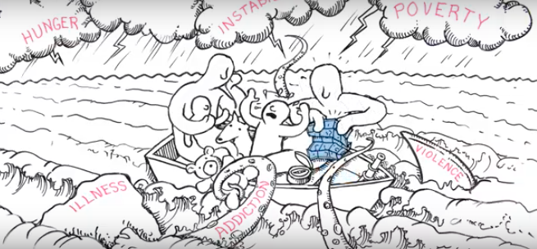“We build these skills by making connection within and among regions of the brain. Early simple circuits form a foundation that more complex circuits and skills build on as we grow. These connections make our core capabilities possible. The more we use them, the faster they become. The circuits manage incoming information and help us respond with intention–not on impulse.”

“Threatening or stressful circumstances activate other circuits, and trigger automatic responses (flight, fight, freeze). When stresses are constant, these automatic responses become stronger and faster than our intentional responses. For anyone under stress, it’s hard to call on our intentional skills. Under a chaotic environment, it’s even harder!”

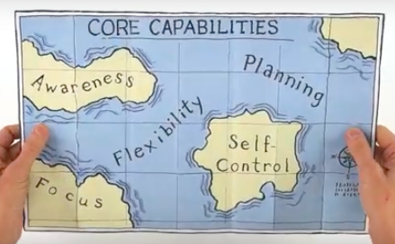“The key is counterbalancing our automatic responses by building up our intentional ones. How? By redesigning our systems so that they reduce the sources of stress in people’s lives

* Simplify how services are provided
* Help them respond to basic needs
* Build on strengths

“Small successes lead to bigger ones. Core capabilities are built through practice in situations that matter. That’s true for children, adolescents, and adults. When our communities work together to help children and adults build these skills, we create a positive cycle as one generation passes them on to the next. And that helps us all.”

**What Are Adult Capabilities?**

***Planning***

***Self-Control***

***Monitoring***

**Planning & Prioritization**

**Organization**

**Time Management**

**Sustained Attention**

**Task Initiation**

**Response Inhibition**

**Emotional Control**

**Goal-Directed Persistence**

**Stress Tolerance**

**Working Memory**

**Flexibility**

**Metacognition**

**12 Adult Capabilities (aka Executive Skills)**

|  |  |  |
| --- | --- | --- |
| Executive Skills Defined | | |
| Planning and Prioritization  Deciding what steps to take. The ability to create a road map to reach a goal or to complete a task. It also involves being able to make decisions about what is important to focus on and what is not. | Task Initiation  Getting started without a delay. The ability to begin projects without undue procrastination, in an efficient or timely fashion. | Stress Tolerance  Managing your stress. The ability to work in stressful situations and to cope with uncertainty, change, and performance demands. |
| Organization  Knowing where I put things. The ability to create and maintain systems to keep track of information or materials. | Response Inhibition  Seeing the consequence before I say or do something. The capacity to think before you act–this ability to resist the urge to say or do something allows us the time to evaluate a situation and how our behavior might impact it. | Working Memory  Remembering what I did and what I need to do. The ability to hold information in memory while performing complex tasks. It incorporates the ability to draw on past learning or experience to apply to the situation at hand or to project into the future. |
| Time Management  Know about how long a task will take and what the deadline is. The capacity to estimate how much time one has, how to allocate it, and how to stay within time limits and deadlines. It also involves a sense that time is important. | Emotional Control  Keeping my cool when frustrated. The ability to manage emotions in order to achieve goals, complete tasks, or control and direct behavior. | Metacognition  Evaluating how you’re doing. The ability to step back and take a bird's eye view of yourself in a situation, to observe how you problem-solve. It also includes self-monitoring and self-evaluative skills (e.g., asking yourself "How am I doing?" or "How did I do?") |
| Sustained Attention  Paying attention, even when I don’t feel like it. The capacity to maintain attention to a situation or task in spite of distractibility, fatigue, or boredom. | Goal-Directed Persistence  Sticking with your goal. The capacity to have a goal, follow through to the completion of that goal, and not be put off or distracted by competing interests. | Flexibility  Going with the flow, accepting change. The ability to revise plans in the face of obstacles, setbacks, new information, or mistakes. It relates to adaptability to changing conditions. |

**Note:** We use the term Executive Skills when drawing on the work of researchers and practitioners who use that term. For example, the categories on the previous page, and definitions on this page, draw from the work of Dr. Richard Guare and Dr. Peg Dawson, authors of *The Smart but Scattered Guide to Success, (Guilford Press, 2016).*

Context Matters: How Living in Poverty Impacts Adult Capabilities

Here are four ways poverty impacts adult capabilities:

* Exposure to high levels of stress in childhood. One of the hallmarks of living in poverty as a child is that it exposes children to high levels of stress caused by not having enough to eat, not having a stable place to live, or being exposed to violence, for example. When children experience too much ongoing stress–commonly referred to as toxic stress–it changes their brain architecture which impairs the development of executive function skills. This, in turn, can have a lifelong impact on their health and economic outcomes as adults.
* Living under conditions of scarcity—the “bandwidth” tax.[2] Living in poverty often means living without enough resources to make ends meet–under conditions of chronic scarcity–imposes a “bandwidth tax.” This reduces individuals’ capacity to think logically, solve new problems, and process information. It also diminishes their ability to evaluate options to make productive decisions and impairs their self-control, which can cause them to act impulsively.
* Increased exposure to situations that compromise executive functions kills. Living in poverty puts individuals at greater risk of experiencing situational factors that impair their executive function skills. Some situational factors include stress, lack of exercise, lack of sleep, lack of social connections and poor nutrition.
* Added complexity of accomplishing common adult tasks. Limited transportation and child care options, constantly changing work hours and schedules, unstable pay, and complicated processes for obtaining and maintaining public benefits all require highly developed executive function skills. For example, it takes much greater planning, organization and time management skills if you have to get your kids to daycare and yourself to work via public transportation than via a car.

Adult Capabilities | Real Life Stories

Here are 12 stories about how adult capabilities (also known as executive skills) can show up in the day-to-day. For each story, decide on one skill that you see operating strongly.

1. **Kisha** knew her week was going to be busy. She needed to register for school, take her daughter to the doctor, pick up a prescription for her elderly mother and attend a two-day goal-setting workshop. She got out her calendar and mapped out on what day and time she would do each task.
2. After looking for a job for three months, **John** finally found a job working at a busy restaurant with a very demanding boss. He quit after a week because he couldn’t keep up with all the demands placed on him and the added stress was affecting his ability to be a good father to his young children.
3. After months of submitting applications, **Merida** finally got a job interview. She made a list of everything she needed to do to get to the interview and prioritized it. She immediately called her aunt to ask if she would watch her daughter.
4. **Luke** has his heart set on being an airplane mechanic. He took the entrance exam and didn’t score high enough to get into the program. His case manager suggests that he consider training to be an auto mechanic instead. Luke is disappointed but submits an application to the next auto mechanic training.
5. **Marianna** has wanted to work in a medical office for as long as she can remember. After her daughter started school, she decided to enroll in a medical coding program. She finds it overwhelming to balance being a parent and a student, but she’s decided she’s come too far to give up. She decides she’ll ask her mother to watch her kids one night a week so she can focus on school.
6. **Michael** was prepped and ready to take the GED test, but when it was time to leave he couldn’t find his ID, which he later found at his mother’s house. He had to wait another month to get on the schedule again.
7. **Evelyn** is a hard worker and very conscientious about doing a good job. One day, a fellow co-worker said something she found offensive. Although her initial reaction was to curse at her, she turned and walked away.
8. **Troi’s** case manager told her she could apply for childcare and transportation assistance so she could participate in a short-term training program. She gave Troi the applications and told her where she needed to submit them. When Troi got home she couldn’t remember where she was supposed to go so she never got the assistance she needed and never enrolled in the training program.
9. **Carolyn** found looking for a job demoralizing, but in order to keep her benefits, she had to spend at least 20 hours a week looking for a job. She found it especially hard to get started every day, knowing she was going to face lots of rejections. She decided she would ask a friend she met in her job search workshop to meet at the library so they could work on their job search together.
10. **Devin** was frustrated with his boss because near the end of every day, his boss would come to his office and ask him to complete a task that couldn’t be done before quitting time. He scheduled a time to talk with his boss and told him that he was happy to help with tasks that needed to be done but he could not continue to stay late. He suggested that he check in every day at 2 p.m. for tasks that needed to be completed by the end of the day.
11. **Jesse** had been attending group job search for two weeks. His goal was to get a job as a security guard. After two weeks, he got bored with the workshops and tired of looking for a job so he stopped going.
12. Every Friday in **Lynette’s** four-week job search class, the instructor asks them to review what they accomplished during the week and to compare it to what they had hoped they would accomplish. She then asks them to make any adjustments to their goals or plans for the remainder of the program.

What Can Counties Do?

Recognizing the toll poverty takes on adult capabilities provides a starting point for redesigning employment and human service programs to achieve better outcomes. There are a number of steps organizations can take to redesign their approach to service delivery including:

* Work to build supportive relationships instead of directive relationships with customers
* Set realistic expectations and make tasks easier by breaking down common tasks into smaller steps and doing some of the tasks with the customer before they leave the office
* Change the environment and modify tasks to reduce the demand on individuals’ executive function skills
* Address issues that impair executive functions such as stress, lack of connections, and lack of exercise
* Create routines that help individuals to set goals and prioritize how to deploy their attentional resources to achieve them
* Work on explicitly building executive skills by providing regular opportunities to train them, challenge them and practice them in the context in which they will be used
* Provide income support and transportation, child care, and housing assistance to help reduce scarcity for customers and the toll poverty takes on individual’s executive function skills

Module Two  
Addressing Scarcity

TUNNEL VISION | Scarcity and How it Shapes Us

From the *Hidden Brain* Podcast: A Listening Guide

You may listen to the podcast in parts, below, or in full [here](https://www.npr.org/2017/03/20/520587241/the-scarcity-trap-why-we-keep-digging-when-were-stuck-in-a-hole).[3] The full podcast is 36:40 in length.

PART 1 | A STORY ABOUT SCARCITY

Listen to Part 1. Run time is approximately 06:52.

Overview

Part 1 tells the story of a woman’s experience with one type of scarcity–poverty–and how it led her to make uncharacteristic decisions that worsened her situation.

Questions to Consider After Listening

1. Can you think of a time when you have fallen into a scarcity trap?
2. How did the scarcity mindset influence your decisions?

PART 2 | SCARCITY: WHAT IT IS + HOW IT SHAPES US

Listen to Part 2. Run time is approximately 12:45.

Overview

Part 2 looks at the many types of scarcity, and how a lack of a basic need re-shapes our thinking, our decisions, and our ability to see the bigger picture.

Questions to Consider After Listening

1. What thoughts do you have about identifying “scarcity traps” in clients or staff?

How might looking at people through this scarcity lens influence our perspectives?

PART 3 | HOW TO FREE OURSELVES + OTHERS FROM THE SCARCITY TRAP

Listen to Part 3. Run time is approximately 15:06.

Overview

Part 3 tells the story of a woman’s experience with scarcity of *time*, and how she was able to step back and manage the effects of scarcity. This part also discusses ways that we can reframe our perceptions of those who experience scarcity in order to address their situation more effectively.

Questions to Consider After Listening

1. How might using a scarcity lens influence the types of goals set by clients or staff, and the strategies they use to pursue those goals?
2. How do you see programs could better address scarcity and the effects if scarcity on clients or staff?

A Mind Map

As you listen, you may find it helpful to jot down reactions and questions that arise for you.

**TUNNEL VISION**

Scarcity and How

it Shapes Us

**General Thoughts + Curiosities**

**PART 3 | How to Free Ourselves**

**PART 2 | What it is + How it Shapes Us**

**PART 1 | A Story About Scarcity**

A Scarcity Overview - In Quotes

SCARCITY EXPLAINED

“Not having enough of what you need can become the only thing that matters to you. When you feel that something important is missing in your life, your brain starts to focus on that missing thing.”

“When we are busy juggling a resource –worrying “*should I pay for dinner and, if so, will I have money for the kids’ school trip?”* It taxes our bandwidth. It’s like trying to hold an eight-digit number in our head all the time.”

EFFECTS OF SCARCITY

“When you have scarcity, it creates a …mindset that leads to… behaviors which, in the short term, help you to manage scarcity – but in the long term only make matters worse.”

“Scarcity is a trap. Scarcity today can beget behaviors that lead to more scarcity tomorrow.”

“It’s not that poor people focus on the short term because that’s all they want to think about; it’s often all they *can* think about.”

SOME IMPLICATIONS

“This lens offers a new way of thinking. What if it’s not that poor people are somehow deficient but that poverty … changes our minds?

“To manage scarcity, …recognize when you’re trying to do something to address your scarcity–and when you want to focus on something, and not let it intrude. Avoid tunnel vision. Be present.

*Watch how we confound efforts to help the poor with efforts to educate them. Create “fault tolerant” programs so that when people in poverty make mistakes, respond as we would to airline pilots: alert them of the mistake and diminish the consequences.*

Scarcity Stories

**BRANDY |** SCARCITY OF MONEY

Brandy worked for a company for over a decade. One day, in a rush to pick up her baby she accidentally used her company card to purchase diapers-she was terminated. Without Brandy’s income, her marriage was strained and she left her spouse. Without steady employment, her household supplies dwindled. Brandy ordered a new credit card to make ends meet, and stocked up immediately on supplies, maxing out the card. She forgot to factor in costs for gas and the credit card bill itself–soon, she was trapped by debt. In retrospect, she can see her mistake in not budgeting for the whole month, but in the moment it was either “pay the bills” or “feed the kids.”

**MINNESOTA HUNGER STUDY |** SCARCITY OF FOOD

During WWII, aid workers needed guidance on how to bring people back from the brink of starvation. Researchers at the University of Minnesota launched a yearlong experiment on hunger. Thirty-six young men went on a starvation diet –the effects on their bodies were clear, but it impacted their minds as well. The subjects’ conversations were fixated on food–they planned to open restaurants and memorized recipes. In the absence of food, they could not focus on anything else.

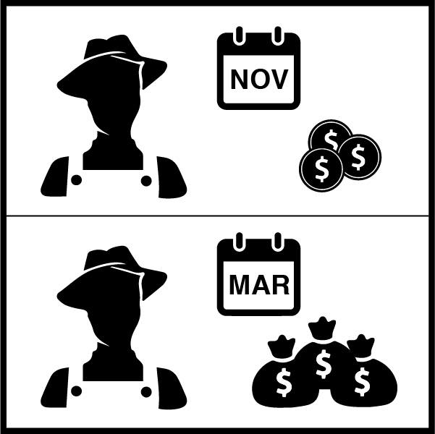**SUGARCANE FARMERS |** SCARCITY OF MONEY

Sugarcane farmers in India are paid only once per year. In the months after a harvest they are well off, but by the end of the harvest cycle they are relatively poor. Researchers tested the farmers on their long-term thinking at both points, and found that post-harvest they had strong impulse control and thought long-term. The same farmers at the end of the harvest cycle were focused on how to make it to the next week.

**KATY |** SCARCITY OF TIME

Katy is a driven person. She graduated top of her class in medical school, but when she started her residency her new schedule was grueling. In her free time, Katy became fixated on exercise, and gradually her home-life fell apart–she had no groceries, a messy home, and forgot to pay a bill. Katy previously battled anorexia–when she was trapped in this scarcity tunnel, old habits returned. Katy only realized the path she was on when it started impacting her work–the final straw was when she almost forgot to order insulin for a diabetic patient. She entered a residential treatment center and finally emerged from the tunnel. Katy started scheduling time to do “nothing” and this freed up bandwidth and allowed her to enjoy her work and perform better.

Scarcity Scenarios | For Small Groups

Scarcity Scenario 1: Sick Child, and More….

**Morning:**You get up in the morning to a sick child. After going through your normal routine to get ready for work (which you can’t miss), you have to call babysitters to see if someone can come over on short notice, which you’ll pay more for.

Someone is able to come, but you’re already running late for work and traffic is bad. You feel bad leaving your sick child, but if you miss work you might lose your job.

**Afternoon:** You’ve been busy with customers all day at work and haven’t had time to check in with the babysitter. Your boss was mad that you were a few minutes late. He tells you that if you leave to meet with your case manager, like you planned, your pay will be docked (and that babysitter cost a lot more than you have). You decide not to go, putting your government benefits at risk.

**Evening:** On your way home you remember that your child needs medicine picked up from the pharmacy, so you have to turn around. You get home and realize there’s nothing for dinner, so you take your child with you to the store, even though you’re both exhausted. Now that you missed your meeting, you’re constantly worrying about what will happen with your benefits and whether you’ll be able to reschedule your meeting.

Scarcity Scenario 2: Clocking in Late, and More….

**Morning:** You wake up, get the kids ready for school, drop them off at the bus stop, get ready for work, and make it out of your apartment with just enough time to make it to your work placement. On your way, you get a flat tire and have to wait for the bus, which is late (as always). You get written up for clocking in to your shift late.

**Afternoon:** Because of your hectic morning, you’ve felt anxious and depressed all day. You feel like juggling work and kids is too hard and can’t see how you’ll keep doing it, but you need money to fix your flat tire and get school supplies for the kids. You call your therapist for support but she’s not in the office. Your boss asks if you can come in early the next day and you say yes, fearing what will happen if you decline.

**Evening:** You pick the kids up and are trying to help them do their homework when you notice something slipped under the door. It’s a notice from the water company that you have five days to pay your past due balance or your water will be cut off. Now you know you have to keep going to work, even though it’s getting harder every day. A reminder pops up on your phone that you need to meet with your case worker tomorrow morning, but you already told your boss you would come in to work early.

Scarcity Scenario 3: Needing an Apartment, and More….

**Morning:** You and your children have been living with your sister since moving out of your boyfriend’s apartment. You are scheduled to go into work at 9 a.m., after getting the kids ready and taking them to school and daycare. However, at 8 a.m., your case manager calls and tells you an apartment is open to view but only if you can go this morning at 10 a.m. You don’t want to miss work, but you also really need to find a place to move.

**Afternoon:** You decided to go into work instead of going to see the apartment since you didn’t want to risk losing your job. Now all you can think about is the chance you’ve missed out on and you feel distracted at work, causing you to give poor customer service, which your supervisor mentions.

**Evening:** As soon as you get off work you pick the kids up from after-school and take them home to do their homework and get dinner started. Your sister comes home and you tell her about the apartment you didn’t go see. She gets mad and tells you that you need to get serious about moving and gives you 30 days to find a place or you can’t stay with her.

Scarcity Scenario 4: Traffic, and more….

**Morning:** You wake up, get ready for work, get the kids ready for school, and start to leave the house. You are getting ready to go into your job as a case manager when your phone pops up with a calendar alert and you realize you have two clients scheduled for the same time, as soon as you get into the office. After making your way through traffic, you arrive to find both clients agitated. You explain your mistake, but both want to see you immediately and neither will reschedule.

**Afternoon:** Between your scheduling mix-up and a team meeting that went late, you didn’t have time for lunch and are feeling stressed out. Your daughter’s school calls and says she got in trouble and needs to be picked up early. You can’t leave work, so you have to call a friend to get your daughter and plan on talking more to her about this when you get home. You also have to meet with a co-worker to do a peer evaluation today and are anxious because you have a lot of constructive feedback to give.

**Evening:** When you finally make it home, your daughter won’t talk to you about what happened at school and your son tells you he has a project due for school tomorrow that he hasn’t started yet. You don’t want to reward his procrastination, but you are exhausted so you end up doing most of the work for him just to make sure it gets done. You don’t get to bed until much later than planned and will only get a few hours of sleep before starting all over again.

What We Can Do

Your program can help alleviate as well as unknowingly contribute to scarcity experienced by families that you serve.

Examine the sample experiences below. Choose 3 that you see often. Think creatively about how your program–or you personally–might take steps to help customers who are experiencing these kinds of scarcity of time and resources. Remember, as always, to focus on maximizing the innate strengths and resourcefulness of these families.

Think about families you serve and name one challenging experience that was not included in our list of sample experiences. Jot down your ideas about how you–or your program–might respond.

|  |  |
| --- | --- |
| **Experiences that Contribute to Scarcity of Time and Resources** | **What We Could Do–or Do More (Jot down your ideas in this column)** |
| Limited transportation options |  |
| Limited and low-quality child care options |  |
| Endless search for affordable housing |  |
| One parent doing the job of two |  |
| Constantly changing work hours and schedules |  |
| Competing demands for limited time: work, parenting, program requirements |  |
| Inflexible appointment times and requirements |  |
| Long waits in public offices |  |
| Paperwork, paperwork, and more paperwork |  |
| **One challenging experience not listed above:** | **What we could do – or do more of:** |

Module Three  
Coaching in Client Interactions

A Motivational Interviewing Resource: Video Viewing Guide

[Watch this video](http://calworksnextgen.org/introduction-to-motivational-interviewing-video/) alone or with colleagues. As you watch, use the prompts below to reflect.

Write your notes about the video below.

What information in the video surprised you?

After viewing the video, write below about a time that you struggled to change something you wanted to change. Include your thoughts and feelings at that time.

Coaching Methods[4]

Even if we do not use these terms, most of us have past experience in using these methods in conversations with our friends, family members, or clients. For each method, write down a time when you saw this method in action or used it yourself. Write down the result.

|  |  |  |
| --- | --- | --- |
| **Method** | **Time when you saw this method in action or used it yourself** | **What was the result?** |
| **Asking powerful questions**  Open-ended questions evoke clarity, action, discovery, and insight. |  |  |
| **Holding the client’s agenda**  The goal is to follow the client without knowing the right answer, giving solutions, or telling the client what to do. |  |  |
| **Visioning**  Create a strong mental image that inspires action and creates a picture for the client's future life. |  |  |
| **Active listening**  Listen for the client’s vision, values, and purpose as expressed by words and demeanor. |  |  |
| **Clearing**  Allow the person to vent or clear a situation that might be interfering with his or her ability to be present without showing judgment or attachment. |  |  |
| **Bottom-lining**  Get to the essence of the communication, rather than engaging in long descriptive stories. |  |  |
| **Referring**  Make a referral for issues that therapy or services from another organization might be better able to address. |  |  |

Strengths-Based Approach[5]

**Key components of a strengths-based approach:**

* Actively explore each client’s strengths
* Acknowledge and validate the client’s strengths and resources
* Encourage the client to lead the conversation and decision-making process

**What does this approach look like in practice?**

|  |  |
| --- | --- |
| **Questions to ask the client as you are getting to know him or her (first meeting):** | **Questions to ask when you are checking in with the client (future meetings):** |
| Tell me about something you are really proud of.  What’s something you are particularly good at?  What do you like to do for fun?  What are the things in your life you really value?  What does a good day look like for you? | What are you doing/managing well?  What are you feeling good about?  What strategies, tools, resources, or supports are working for you right now?  What have you learned so far that can help you moving forward?  How can we build on where you are now?  What one thing could you do to take a step in the right direction? |

What’s different about a strengths-based approach?

|  |  |  |
| --- | --- | --- |
|  | **Deficit/problems-based approach** | **Strengths-based approach** |
| Roles | Conversation led by staff  Staff are the experts and can help fix the problem  Clients are passive receivers of services | Client and staff collaborate during meetings  Clients are the experts and can solve their problems (perhaps with some support)  Staff empower clients to identify solutions |
| Focus | Problem and past oriented | Goal and future oriented |
| Key questions | What is the problem?  What is wrong?  What does the client need? | What resources, knowledge, and skills does the client have?  How can we build on existing strengths to move forward?  What could the future look like, or how could the client’s life be different (for the better)? |

In this space, write down some of your strengths. Write down at least one personal strength and one professional strength.

When everyone at your table is done, go around the table and share your strengths with others.

Trauma-Informed Care

**Trauma Defined**

Individual trauma results from an event, series of events, or set of circumstances that the person experiences as physically or emotionally harmful or life threatening, and that has lasting adverse effects on the individual’s functioning and mental, physical, social, emotional, or spiritual well-being. The following are some examples of trauma:

* Experiencing or observing physical, sexual, and emotional abuse
* Childhood neglect
* Having a family member with a mental health or substance use disorder
* Experiencing or witnessing violence in the community or while serving in the military
* Poverty and systemic discrimination, including racial discrimination

The spirit of trauma-informed care

Trauma-informed approaches to care shift the focus from “What’s wrong with you?” to “What happened to you?” by focusing on the following:[6]

**Understanding trauma:** Appreciating that many problem behaviors began as understandable attempts to cope with past traumatic experiences

**Promoting safety:** Establishing a safe physical and emotional environment for clients and staff, which includes using language that is neutral, objective, and always avoids shaming

**Supporting client control, choice, and autonomy:** Giving clients maximum choices and control over the process to help them regain a sense of control over their daily lives

**Sharing power and governance:** Sharing power and decision making across all levels of an organization

**Ensuring cultural competence:** Understanding each client in the context of his or her life experiences and cultural background, and seeking growth opportunities specific to cultural backgrounds

**Integrating care:** Maintaining a holistic view of clients that acknowledges the interrelated nature of emotional, physical, relational, and spiritual health

**Promoting healing in relationships:** Believing that establishing safe, authentic, and positive relationships can be corrective and restorative to trauma survivors

**Understanding that recovery is possible:** Understanding that recovery is possible for everyone, regardless of how vulnerable he or she may appear

Core skills in trauma-informed care

The following practices reflect the principles of a trauma-informed approach:[7]

* Use individuals’ strengths to empower them as you help develop their plans and activities.
* Inform clients of their choices regarding activities so they can choose the options they prefer.
* Maximize collaboration among staff, clients, and their families in goal setting, planning, and doing.
* Create office settings and activities that ensure clients’ physical and emotional safety.
* Promote trustworthiness by creating clear expectations with clients about their options and activities.

Motivational Interviewing[8]

**The following are the four guiding principles of MI:**

* **Express empathy:** Coaches must attempt to see the world through the eyes of the client by asking themselves, “How might I feel or act in this situation?”
* **Develop discrepancy:** Coaches should notice and point out “gaps” between what clients say they want and their behavior(s).
* **Roll with resistance**: Rather than reciprocating, calling out a client’s resistance, or using a confrontational tone, coaches should invite (not impose) new perspectives.
* **Support self-efficacy:** Coaches should encourage clients to focus on their ability to control their own behavior and events that affect their lives.

What this approach looks like in a meeting:

**Step 1: Engage.** Using a client-centered approach, strive to fully understand the situation from the client’s perspective without having a preconceived agenda.

**Step 2: Focus.** Guide the client toward a change that is important to them (setting a meaningful goal).

**Step 3: Evoke.** Draw out the client’s intrinsic motivation (reasons/importance for change) and her/his own ideas for change.

**Step 4: Plan.** Create a “bridge” to change by reinforcing commitment language and assisting the client with creating a plan for change.

**Step 5: Follow-up.** In future interactions with the client, ask about his or her progress towards change. If the client made progress, celebrate the progress. If needed, loop back to previous techniques to point out any gaps in clients’ desires and behaviors.

What to say to clients:

* **Open-ended questions** cannot be answered with a single word. Asking open-ended questions invites collaboration and deeper thinking around an issue.
  + **Example:_____________________________________________________________**
* **Affirmations** are statements that highlight a person’s resources, such as a specific trait, attribute, or strength.
  + **Example:______________________________________________________________**
* **Reflective listening** involves stating back to the client what he/she said in an accurate, empathetic way.
  + **Example:______________________________________________________________**
* **Summarizing** involves collecting and summarizing statements from parts of the conversation to clarify and confirm the client’s views.
  + **Example:______________________________________________________________**

Client Biography

Divide into pairs. Read this brief bio about a CalWORKs client:

Drew is a single father who does not have a high school diploma and currently is unemployed. He has faced bouts of homelessness in the past; however, for the last six months has been able to secure housing for himself and his 6-year-old son. He is confused about where to start but knows that he cannot make it unless he has some help.

Imagine it is your first meeting with Drew. Remembering what we have talked about so far, what would you say to Drew?

Review what you wrote down. How well are your ideas aligned with a strengths-based approach? How well aligned are they with a trauma-informed care approach? How do your ideas line up with the guiding principles of motivational interviewing? Make changes to align your ideas more closely with these three concepts.

Now, do a quick role-play activity. One person will be the client and one will be the frontline worker.

Maria lives in an apartment with her two school-age kids. She does not want to talk about her children’s father; he is not in their lives. Maria has a high school diploma but is unemployed. She is very connected to her extended family and enjoys cooking for them. Maria is content with her life and does not seem particularly motivated to make a change.

After the role play, reflect on what went well and what could have gone better. Share these takeaways with others at your table.

Module Four  
The Art and Science of Goal Achievement

The Art and Science of Goal Achievement: Preparation

We set and achieve goals all the time–often without paying attention to all the steps in the process. This week, we invite you to be a bit more mindful of the natural process you follow so that we can draw on that personal experience when looking at the art and science of goal achievement together.

Pay special attention to your goals (your wishes, aims, desires)–the things you envision achieving for yourself this week. Jot down responses to the following questions and bring it to the workshop with you. It is private but will be a useful reference.

**ONE:**

*What is one goal you set for yourself this week?*

**TWO:**

*What was your plan for how you would achieve the goal? Did you write it down? Set any reminders? Share it with anyone?*

**THREE:**

*How did you do? What, if anything, got you off track? What did you find helpful to keep you on track?*

**FOUR:**

*What did you discover about your goal, or yourself, along the way?*

**FIVE:**

*What’s next?*

Goal, Plan, Do, Review, and Revise:  
An Executive-Function Informed Goal Achievement Framework

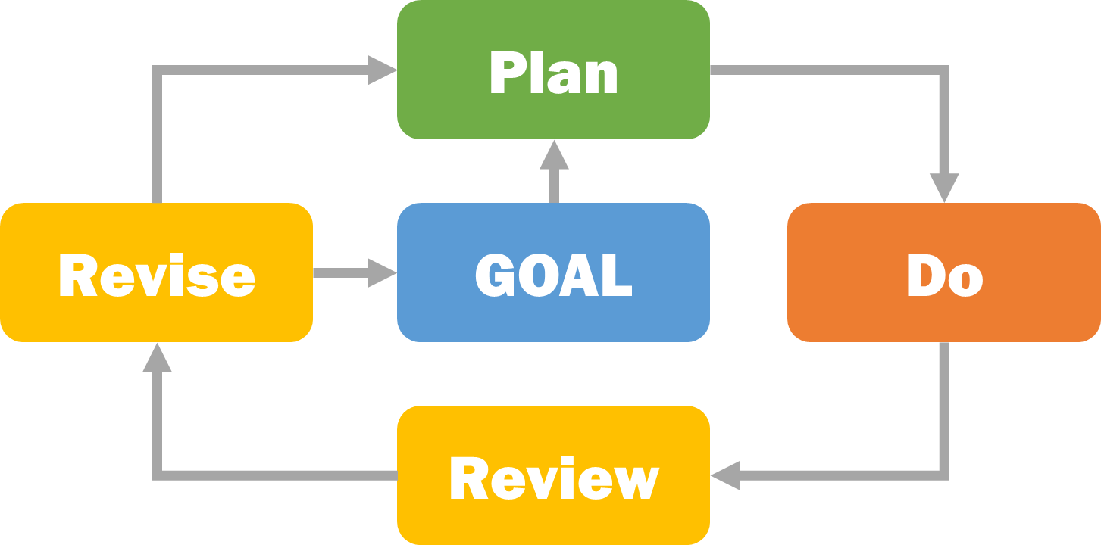

**Step #1: Set a Goal – something you want to accomplish**

**Step #2: Develop a Plan for how to get from here to there**

**Step #3: Do the Plan – put it into action**

**Step #4a: Review and assess your progress**

**Step #4b: Revise – take the next step, make a new plan, or set a new goal**





|  |  |  |
| --- | --- | --- |
| Executive Skills and Goal Achievement | | |
| Goal | **Metacognition, working memory** |
| Plan | **Planning/prioritization, organization, time management, working memory** |
| Do | **Task initiation, response inhibition, time management, sustained attention, working memory, flexibility, organization, goal-directed persistence, stress tolerance, emotional control** |
| Review/ Revise | **Metacognition, working memory, and flexibility** |

* **Goal:** We use working memory to remember experiences and metacognition to evaluate those experiences. That is what helps us come up with meaningful goals – we avoid things that we do not like and do more of what motivates us to move forward.

* **Plan:** Our planning and prioritization skills help us break goals into the small steps. We use organization skills to gather resources we need to complete a task and to keep them in a place where we can find them. We use time management skills to help estimate how long a task will take and decide when we will do it. We draw on working memory to identify what else we need to do and to remember the steps so we can prioritize them.

* **Do:** Executing a plan draws on many executive function skills, but mostly involves practicing self-control to direct our behavior in a purposeful way. Task initiation allows us to get started (remember, success is starting). Time management allows us to wisely use time we have available. Response inhibition allows us to avoid distractions and stay focused. Sustained attention helps us stick with a task until it is complete. Goal-directed persistence helps us to complete each step along the way and to stick with the goal even when the going gets rough. Stress management helps us stay calm when we face competing demands and aids us in proactively identifying ways to reduce stressors. Emotional control helps us keep emotions in check, and cognitive flexibility allows us to problem-solve around potholes (obstacles).
* **Review & Revise:** When reviewing our progress towards a goal, we are once again draw on working memory and metacognition skills which help us remember what we did (or didn’t do) and why. Then we can assess what did and did not work. Cognitive flexibility allows us to abandon goals that are too hard or no longer meaningful and come up with new goals. We may also find that a plan is in order if the previous one did not produce the results we wanted.

The Path to Goal Achievement: Goal, Plan, Do, Review, and Revise

Step #1: Set a **Goal** – something you want to accomplish

* Set a goal that is:
  + something you truly care about
  + challenging but within your reach
* Your chances of being successful increase when you:
  + imagine how you would feel if you accomplished your goal
  + write it down and post it in a prominent place

Step #2: Develop a **Plan** for how to get from here to there

* Characteristics of a good plan:
  + *Specific*, with the steps you need to take, the resources you need to complete them, and the details of where and when you’ll complete the steps clearly laid out
  + *Identifies obstacles and solutions* for addressing them
  + 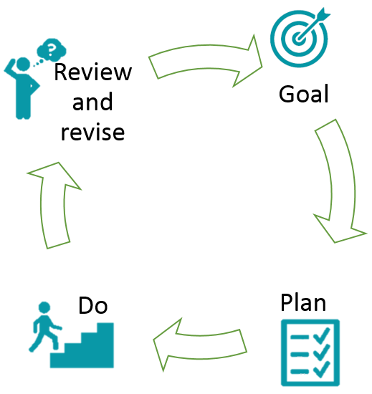*Written down*

Step #3: **Do** the Plan – put it into action

* To successfully complete a plan:
* Stay focused; follow the plan
* Remember what you need to do when
* Manage your time and stay organized
* Manage your stress
* Ask for help when you need it
* Stick with it until it is done

Step #4a:  **Review** and assess your progress

* What worked well?
* What got in the way? How did I respond?
* Did I follow my plan?
* What steps remain?
* What do I need to do next?

Step #4b: **Revise** – take the next action steps, make a new plan, or set a new goal

* Look back, move forward
* Recognize change as a regular part of the goal achievement process
* Embrace change as a learning opportunity

The Language of Goal Achievement

A critical part of supporting people through the GPDR/R framework is changing how we talk about goals, plans, and next steps. The following are some prompts you can use to help facilitate a goal-achievement:

**GOAL**

* What are your hopes and dreams for the future?
* What is something meaningful to you that you want to achieve? Is it within your control?
* What matters deeply to you that you could see yourself working towards in the next month?
* What keeps you motivated even when things get hard?

**PLAN**

* Let’s work backward and think about what steps you need to take to get where you want to go. What resources you will need?
* Let’s map out an action plan for the next week. When will you do each step, how long do you think it will take, where will you do it?
* What might get in the way? What can you do if that happens?

**DO**

* Let’s create a reminder system to help you put your plan into action.
* How can we support you as you move to the next step in your plan?
* It can be hard to do this alone—who might be able to help you with your next steps?
* Let’s try doing the first part of your plan together. I’m here to help if you get stuck.

**REVIEW**

* How did things go this week? What went according to plan?
* What got in your way? How did you respond?
* What could you have done differently?
* What did you learn about yourself?

**REVISE**

* Does your goal still feel like the right goal? It is achievable?
* What would you like to do next?
* What would help you to move forward?
* How can I support you in coming up with a new plan or goal?



Module Five  
Coaching With the Calworks 2.0 tools

How GPDR/R Differs from Common Practices

|  |  |  |
| --- | --- | --- |
| **Common Practices** | **GPDR/R Steps** | **CalWORKs 2.0 Approach** |
| * Programs tell clients what to do (beyond what is required to be compliant) * Staff act as problem fixers * Staff tell clients about everything the program offers, even if they don’t need or want a feature | **GOAL** | * Clients set goals * Staff act as facilitators * Staff guide clients to personally set meaningful goals within the client’s control * Staff help clients build confidence through success in achieving feasible short-term goals * Staff suggest only ways the program can help that are tailored to the client’s goals |
| * Client plans have generic activities and tasks that may not relate to the client’s goals * Support services are not strategically aligned to clients’ goals * Staff write the plans down for the client and then give a copy to the client, along with many other forms | **PLAN** | * Staff guide clients in specific yet simple plans (including what, when, where, and how) * Staff work with clients to write their plans down and rehearse them * Staff help clients identify strategies to overcome potential obstacles *before they happen* |
| * Staff contact with clients is limited * Staff-client interactions focus on obtaining required documentation (transactional) * Few opportunities exist for clients to support and encourage each other * Limited opportunities are available to build and practice skills | **DO** | * Staff check in with clients while they implement their plans to offer support and encouragement (relational) * Staff design opportunities for clients to support and encourage each other * Program components with frequent contact (job search, work experience, or subsidized employment) offer skill building related to goal achievement |
| * Staff focus client check-ins on whether clients have met their activity requirements * Plans are reviewed and changed only at required intervals | **REVIEW/**  **REVISE** | * Check-ins focus on assessing how things went * Plans are revised regularly as goals, needs, and circumstances change |

Using Coaching Methods in Meetings with Clients

For each cell below, write a statement or question you could use when meeting with a client during each type of meeting. As you do so, notice which cells are easy for you to fill in and which are hard.

|  |  |  |  |
| --- | --- | --- | --- |
|  | **Strengths-based approach** | **Trauma-informed care** | **Motivational interviewing** |
| Meeting a client for the first time |  |  |  |
| Creating a welfare-to-work plan |  |  |  |
| Checking in with a client |  |  |  |
| Trying to re-engage a client |  |  |  |

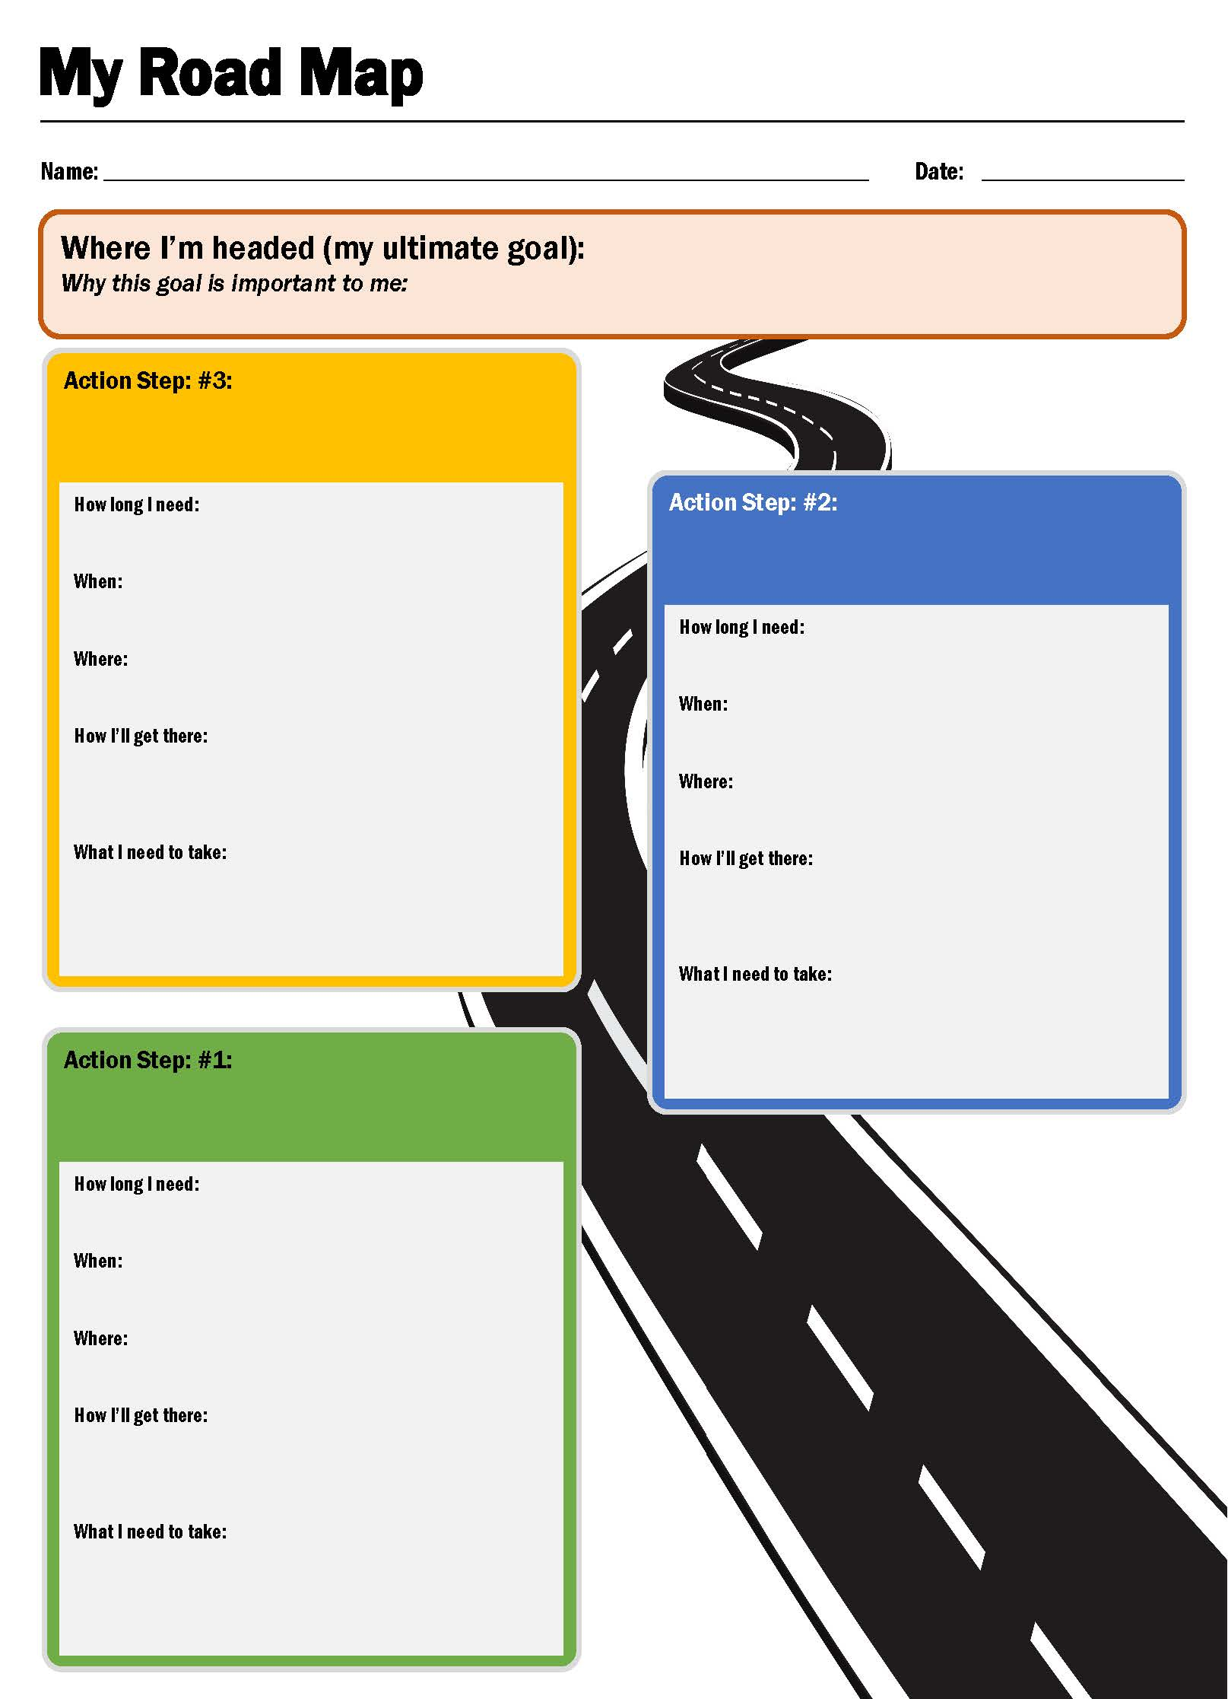



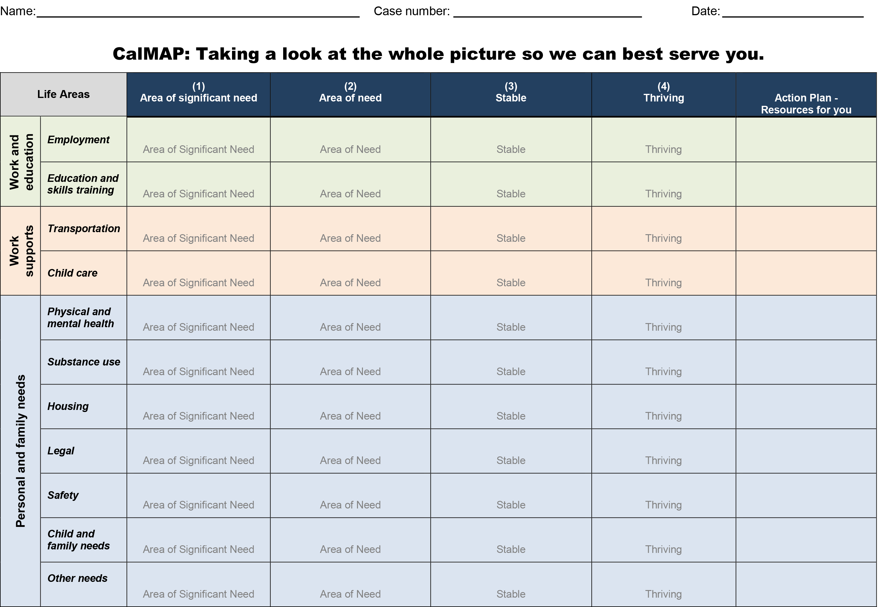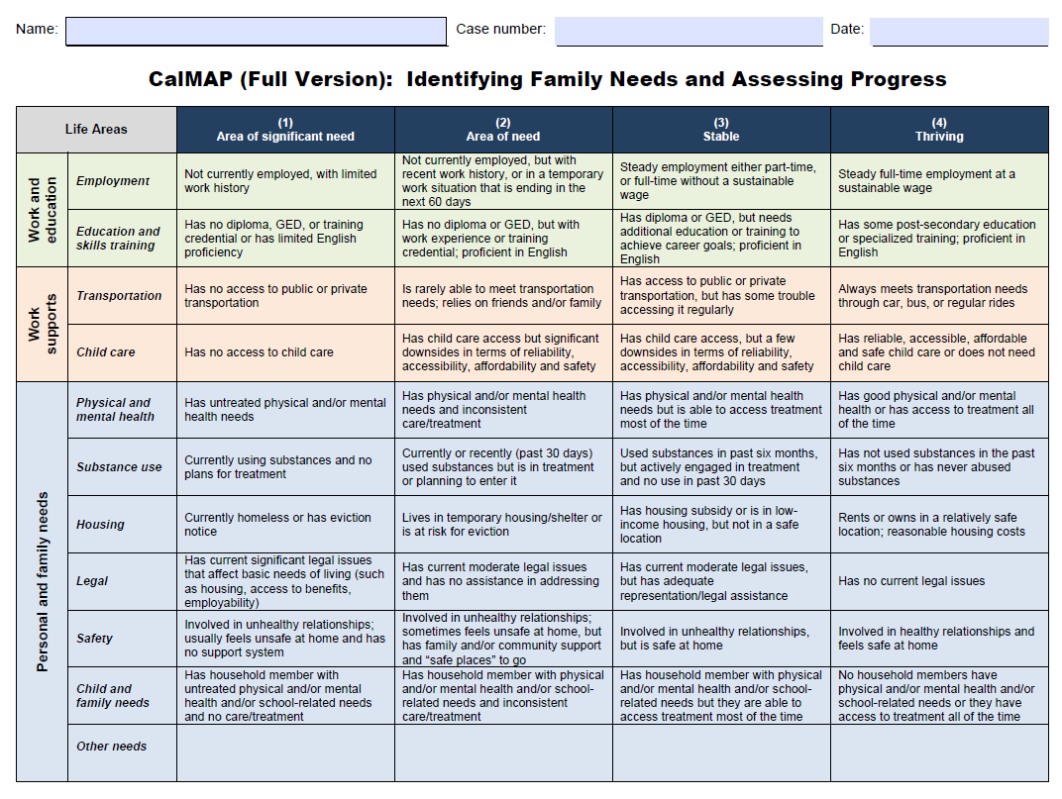



Plan to Use Tools with Clients

|  |  |  |
| --- | --- | --- |
|  | **My Road Map/Potholes & Detours** | **CalMAP** |
| Client first name |  |  |
| Why this client will benefit from the tool |  |  |
| One next step you will take to make sure the client gets to use this tool |  |  |

1. Center on the Developing Child, Harvard University, with Frontiers of Innovation. Vital Pictures, 2017. Developingchild.harvard.edu
2. See CalWORKs 2.0 Evidence-to-Practice companion modules on scarcity for a deeper dive.
3. Vedantam, Shankar. “Hidden Brain.” *Tunnel Vision*. NPR, 20 Mar. 2017. Web. https://www.npr.org/2017/03/20/520587241/the-scarcity-trap-why-we-keep-digging-when-were-stuck-in-a-hole
4. Adapted from “Family-Centered Coaching: A Toolkit to Transform Practice and Empower Families” by the Building Better Programs, a special initiative of the Center for Budget and Policy Priorities. Available at <http://www.buildingbetterprograms.org/wp-content/uploads/2016/12/Family-Centered-Coaching-Toolkit-Draft-Version.pdf>.
5. Material adapted from “Embedding a Strengths Based Approach in Client Conversations” by Kate Pascale and Associates. Available at <https://www.emralliance.org/uploads/9/7/7/9/97794766/embedding_a_strengths_based_approach_in_client_conversations.pdf>.
6. DeCandia, C., K. Guarino, and R. Clervil. “Trauma-Informed Care and Trauma-Specific Services: A Comprehensive Approach to Trauma Intervention.” Washington, DC: American Institutes for Research, 2014. Available at <https://www.air.org/sites/default/files/downloads/report/Trauma-Informed%20Care%20White%20Paper_October%202014.pdf>.
7. Menschner C., and A. Maul. “Key Ingredients for Successful Trauma-Informed Care Implementation.” Center for Health Care Strategies and the Robert Wood Johnson Foundation, 2016. Available at <http://www.chcs.org/media/ATC_whitepaper_040616.pdf>.
8. Adapted from “Goal4 It!TM Motivational Interviewing” by Mathematica Policy Research.