Road Test Work Plan 4

Findings:
- Leadership and staff are highly capable and motivated
- Staff are committed to the work and believe in clients’ ability to change
- Thoughtful segmentation of the caseload
- Some goal-setting is taking place already
- Good balance of case management and other work
- Some operations could be streamlined or simplified
  - Orientation
  - All case managers holding orientation slot
  - Assigning case managers before an assessment of client needs
  - Redundant assessments
  - Rotating workshops across units and staff

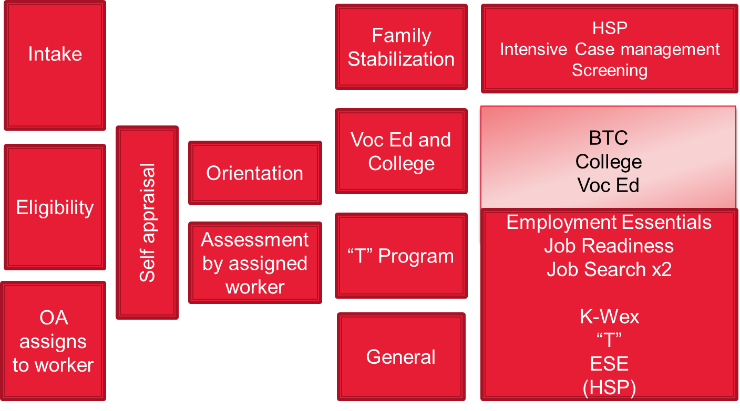

Opportunities:
- Workload analysis—figure out what to offload, what to streamline, what to specialize
- Clarify outcomes, targets, strategies
- Service delivery could be more tailored, beyond current segmentation
  - Define progress benchmarks within caseload segmentation
- Opportunities to bolster the goal-setting
  - Gain consistency across staff
  - Expand beyond career-related goals
- More frequent, shorter touches with clients
- More thoughtful about resource investment
  - Examine county contracts and associated benchmarks for performance
- Job search for JTO clients
- Manage change process throughout

Road Map for Change: Road Test Round 1
Learning objectives:
(1) How can workers/clients effectively and efficiently use the tools?
(2) How does worker experience influence the integration of the tool?
(3) Does a goal-achievement framework influence the quality of the engagement?
(4) Does a goal-achievement framework affect the worker’s investment in clients and improve
buy-in?

Strategies: What we will do | Targets: What we will change  (attitudes, behaviors, skills) | What success will look like
Training staff to ask for feedback and shift the process of orientation and other interactions to end activities with an open conversation with customers or a feedback mechanism. | Have staff more involved in providing meaningful feedback and getting ideas from both peers and from the customers. Shift in communication to increase openness to customer feedback. Attitude change in the dynamic with the customer to be less imbalanced. | Connection to the program – client feels genuine aid from the county
Asking or explaining the “why” questions more often and communicating with customers in a way that they feel that they are involved in program choices and activity participation. | Communication – ask customers what they want and do not project staff goals/impression on customers. Change the dynamic/attitude to give clients ownership of their pathway and involvement. | Customer cares about the activities they engage in – incentive to keep making progress
Provide some guidelines and resources (such as a script) for staff to make a shift in the conversational structure to enter more meaningful dialogue with customers. Daily reminders or tips to help staff to make this the culture shift through supervisor assistance and habit formation. | Staff need to think differently about how they lay out contracts with the customers – this is time consuming. Commit to a culture shift that comes from the top down. Ask different types of questions during engagements and be more “genuinely interested” in clients to build rapport outside of rules and regulations. Build up the clients. | Meaningful engagement – quality not quantity
Establishing benchmarks for each segment. Consider how progress or success will look different based on where customers are starting from.  Develop meaningful measures for these different client “segments”  Takes the broad goal of self-sufficiency and makes it more meaningful for each caseload segment. | Identify success in each category/service pathway (just a guide – success can look different in each segment). Pinpoint the range of possible successes – have staff see this range and have more flexibility/ideas about where they should direct clients. Culture shift around possible outcomes – but also adding a structure for tracking and measuring | Progress within segmented caseload – guidelines for activities and benchmarks
More integral case management involvement by the WtW staff – not such a cold hand off (washing the hands of a case) to the contractor. Change the workshops to increase individual preparation and attention to better guidance for what clients need to work on as they progress to “T” and SE– increase the ownership of clients in their goals/work skills for ESE placement. | Having staff more motivated to co-case manage with the contractor. Focus on client outcomes and success in the end of ESE. Focus client efforts more around the transition out of ESE and into an independent job. Have staff thinking about engagement during the initial ESE preparation, and then stay in touch/engaging clients after a few months. | Move the needle 10% up on successful job placement in “T” and ESE
Reframing all client interactions around goal-achievement | Decrease emphasis on requirements/regulation (which does not motivate the customer) and increase client investment | Increased staff engagement and motivation to connect with clients

What | Who | How | When
Goal Setting with Clients – one on one (GPDR and My Pathway) | 1 worker from each supervisor group: | 10 clients for each worker | Each interaction, 1x/week for each client
Goal Setting with Workers | All supervisors | With all workers | Bi-weekly individual meetings
Group Goal setting | 1 worker running workshop for housing search/support | GPDR each session and the Roadmap/Potholes and Detours | At weekly workshop (Th)
Consider:  -County Goal Setting  -Pathway Guidelines | Supervisors/Management

Week 1; April 3 – Implementation site visit and Strategic Planning; Send Materials
Week 2; April 10 – Phone call check in about materials and roadmap to change
Week 3; April 17 – Finalize tools/ determine final learning objectives
Week 4; April 24 – Conduct training in-person for tools and road test data collection
Week 5; May 1 – Launch road test Round 1

Week 5-8; Road Test 1

Week 9-10; Analyze data, feedback to County, plan for Round 2 Test

Week 11; June 12 – Webinar training for Round 2

Week 12; June 19 - Launch Road test Round 2

Week 12-15; Road Test 2
