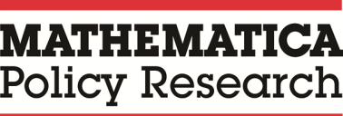

CalWORKs 2.0 County-Level Guide
July 2018

Strategic Initiative Team

This page has been left blank for double-sided copying.

Contents
CalWORKs 2.0 County-Level Guide 1
Information about this Guide 4
Section 1: CalWORKs 2.0 county context 5
A. Goal-achievement framework 6
B. Intentional service selection 9
C. A policy note 10
D. CalWORKs 2.0 tools 11
Section 2: CalWORKs 2.0 County Tools and How to Use Them 12
Step-by-step process for using the tools for strategic planning: 12
County Self-Assessment 13
County Resource Map 21
Introduction to County Goal Setting 23
Choosing Frontline Tools 27
Staff Skills And Attributes 29
Fidelity Assessment Tool 33

Information about this Guide
Description: This guide is for county administrative staff. It includes two sections:
- A background section on CalWORKs 2.0, including the goal-achievement framework and intentional service selection concepts underlying it, as well as CalWORKs policy context.
Directions on how to use the CalWORKs 2.0 framework for planning and goal setting in your county to help manage staff, program development, and allocation of resources. The guide describes tools that help facilitate a strategic planning process that can aid programs in moving toward a more family-centered, goal-achievement approach to serving families.
Purpose: This guide describes the components of CalWORKs 2.0 and the constructs behind them, and provides instructions for using a set of tools in a regular county planning and improvement process.
When to use this guide: The tools in this guide are designed to support critical reflection on program design and a structured, forward-thinking process for program change through goal setting. Counties may find it beneficial to use the tools in this guide annually, semiannually, or quarterly to review progress toward goals, update plans, and set new goals.
How to use this guide: Read through this guide when you first receive it. Make sure you understand the principles behind CalWORKs 2.0 and the culture change indicated by the background and contextual information. When you have a foundational understanding of CalWORKs 2.0, review the tools and how to use them. It is a good idea to involve multiple key staff at different levels in the county goal-setting and change process. Have all staff involved in that process read this guide, and then reference the guide while working together as a team to create change and program improvement.
What successful use of this guide looks like: You can describe the CalWORKs 2.0 principles to co-workers and customers and how it differs from your work in the past. You understand the principles behind good goal-setting and can apply them broadly (that is, for any type of goal). You have a good understanding of program goals to move toward full implementation of CalWORKs 2.0 and how the program will look in your county. You refer to the guide whenever needed to make decisions about how and when to use specific tools with customers.
How to get more information: Visit the CalWORKs 2.0 Next Generation website (http://calworksnextgen.org/). There, you can:
- Refer to training videos to see how the frontline tools are ideally used with customers.
- View webinars that provide a deeper background on the science behind CalWORKs 2.0 and the goal-setting framework.

Section 1: CalWORKs 2.0 county context
The CalWORKs program has made significant changes over the past 25 years in response to economic, budgetary, and political forces. Some of these changes have expanded the options available for helping customers and even resulted in customer success, but there is room for additional improvement. The current compliance-oriented, directive case management approach has had limited success. Recognizing this situation, the County Welfare Directors Association (CWDA) of California launched an initiative to incorporate emerging research evidence on brain science, behavioral science, and best practices on how adults learn and build critical skills.
CalWORKs 2.0 is a new framework for delivering CalWORKs services that emphasizes goal-achievement, intentional service selection, and considers the circumstances and needs of the whole family.
Known as CalWORKs 2.0, this new approach focuses on helping people set and achieve their goals, which requires an environment with flexibility and a shift from directive case management to customer-led case management focused on goals. The redesigned approach will help families set goals that align with program aims while taking into account families’ strengths and the obstacles they face. With CalWORKs supports and services, some customers can begin immediately, but others need time to resolve crises and address significant challenges before they can progress. CalWORKs 2.0 emphasizes the importance of engaging in activities on the way to full employment. Although this approach is a fundamental shift for some counties, other counties might already be implementing some of these concepts into their current work.
The design of CalWORKs 2.0 draws from emerging research in several complementary fields:
- Adult capabilities: Long-term exposure to the stresses of poverty affects adults’ core capabilities (that is, organizing, planning, self-control, and monitoring). Core adult capabilities are best improved through supportive relationships that empower people to make choices that are meaningful to them.
- Goal achievement: Working on goal achievement can have positive impact on self-sufficiency. Adults are more likely to achieve goals when (1) they set goals that are meaningful to them; (2) the goals are specific, short-term, and within their reach; and (3) plans are in place to address roadblocks before they occur.
- Behavioral science: Living in poverty imposes a “bandwidth tax” that limits individuals’ ability to see and plan for the future. Programs can increase success by streamlining requirements, removing unnecessary hassles, and ensuring that communications focus only on the most important information.
- How adults learn: Adults need to do something with new information to learn that information. Learning happens when people focus on what is most relevant to their lives now. Adults are more likely to make changes in their lives when staff engage in supportive (rather than directive) relationships.

A. Goal-achievement framework
In a goal-achievement framework, families set individual goals that are meaningful to them and aligned with program aims, but are realistic, given the families’ strengths and challenges. When customers work on goals that are meaningful to them and within their reach, they are more likely to participate and stay engaged long enough to make progress. In contrast, when customers are required to participate in activities that do not directly address their current circumstances, they are unlikely to follow through. The clear messaging of each interaction should be, “CalWORKs is here to help you set and achieve your goals.”
The message for customers is: “CalWORKs is here to help you set and achieve your goals.”
The CalWORKs 2.0 goal-achievement framework is built on a four-step process that, if practiced regularly and with fidelity, will build skills and make setting and achieving goals easier and more effective. Any meeting with a customer can cover one or more steps. The four steps always happen in the same sequence:
- Goal: Set a goal—something that the customer wants to accomplish and is within his or her reach.
- Plan: Create a road map for how to achieve the goal and identify obstacles and solutions.
- Do: Put the plan into action.
- Review/revise: Assess what was achieved and what wasn’t; make a new plan, modify an existing goal, or set a new one.
The framework relies on the idea that successful small steps will lead to better long-term outcomes. Using the CalWORKs 2.0 tools, customers can set and achieve goals and benchmarks (for example, showing up to appointments, calling and connecting to service referrals, completing job readiness training, attending job fairs, and attending mental health counseling) on the way to meeting longer-term goals such as full-time employment. Applying a customer-driven goal achievement approach is more motivating for customers than a compliance-driven approach and will help customers stick with their planned activities.

GOAL-ACHIEVEMENT PRINCIPLES
GOAL-SETTING
- Goals need to be personally meaningful and motivating
- Visualizing the outcome makes the goal feel real and builds motivation to achieve it
- Goals must be challenging, but still within reach—goals that are too easy are un-motivating, and goals that are too difficult are abandoned out of frustration
- Goals must be specific and have a clear target and timeline
- To develop a goal habit, set (and review) goals daily or weekly
- If needed, reframe CalWORKs activities as opportunities to pursue goals that are meaningful to the customer
GOAL-PLANNING
- Write down plans to make them stick
- Commit to goals by sharing them with others, an action that holds us accountable
- Break long-term goals into shorter, more manageable goals or steps; short-term goals are more motivating that longer-term goals
- Be specific and include the details of when you will complete each step
- Encourge the customer to think about the support and resources needed to reach the goal
- Identify obstacles that may get in the way of achieving the goal and develop solutions for each obstacle
GOAL-DOING
- Help customers achieve their goals by:
- Walking customers through their action plan at the end of the planning session
- Helping customers develop their own reminder system
- Providing regular reminders
- Providing opportunities to practice working on their goal
- Reducing program burden on participants
- Helping participants address and manage stress
- Providing lots of encouragement and feedback
GOAL-REVIEWING AND REVISING
- Review: How did it go?
- Revise: What did you learn? What will you do moving forward?
- Create a learning environment:
- Be strengths-based: What went well?
- Emphasize the learning: What did you learn about yourself or your obstacles?
- Be forward-looking: What can I do differently next time?
- Convey these messages to build skills:
- Success is starting!
- There is no failure only feedback
- We rarely get goals or plans right the first time we try

Why this approach to goal achievement is different
Most human service programs touch on goal-setting and planning with customers, along with activities such as removing barriers (for example, child care referral), job search, and training referrals. Research suggests that a focus on these common activities is likely not enough to accomplish real change. Instead of requiring every customer to do the same activities at the same pace, the goal, plan, do, review/revise (GPDR/R) framework focuses on empowering customers to set and achieve their own goals. With use, interactions between staff and customers can become more relational and less transactional. Here are highlights of how each stage of the GPDR/R process differs from current practice.
Goal | - Customers—not the program or staff—set goals  - Staff act as facilitators, not fixers  - Staff guide clients beyond generic goals to personally meaningful goals within the client’s control  - Staff help clients build confidence with success in achieving feasible short-term goals  - Staff suggest ways clients can use program activities and services to help clients achieve their goals
Plan | - Staff guide clients to develop specific, yet simple plans (including what, when, where, and how)  - Staff help clients identify strategies to overcome potential obstacles before they happen  - Staff work with clients to write down clients’ plans and rehearse them the plans
Do | - Staff provide support and encouragement when clients are doing their plans  - Staff design opportunities for clients to support and encourage each other  - Staff offer opportunities for clients to build and practice skills they need to remain focused on goals and do their plans  - Program components with frequent contact (job search, work experience, or subsidized employment) offer skill-building opportunities related to goal achievement
Review/revise | - Staff focus client check-ins on assessing how things went and how the “doing” experience relates to moving forward  - Plans are viewed as living documents that change as clients learn more about their strengths and become clearer about what matters most to them

B. Intentional service selection
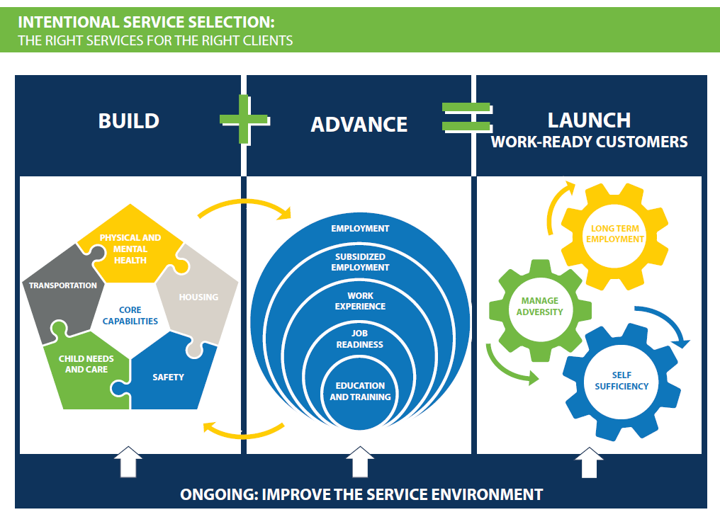
For goal-achievement to be successful, counties must provide services in a reimagined service environment that takes into account a family’s circumstances, strengths, challenges, and goals. Through intentional service selection (ISS), county administrators consider their unique county circumstances and goals as a starting point for updating their service delivery model and setting county goals to make progress and continually improve the program to best meet the needs of customers within the policy and resource constraints of the locality.
Counties should determine their starting point by completing the county self-assessment tool to evaluate the state of the current organizational environment relative to the vision of CalWORKs 2.0. Then, administrators can intentionally prioritize areas for making changes that will move the county culture forward towards the desired “to be” state. When counties have chosen their desired CalWORKs overarching program goals, administrators can work through the goal-setting guide to reflect on these priorities and set program activity, staff management, and customer outcome goals accordingly.
Finally, the culture change and practice of intentionality must come from the top down. Administrators should clearly communicate to staff that it is okay to think more broadly about the paths that might lead clients to full program participation and to encourage staff to align their behavior with the updated CalWORKs 2.0 program goals. These priorities may look a little different in every county, but in general, staff should be encouraged to think beyond the work participation rate (WPR) as a way of measuring their own performance and the success of customers.
ISS PRINCIPLES for the County
Communication with staff
- Avoid sending mixed messages, for example, by focusing exclusively on WPR as the measure of staff performance
- Complete the resource map
- Use the resource map as a guide to help identify gaps in services in your county.
- Ensure that resources are designed to meet clients where they are and help them find a path toward full participation and, eventually, employment.
- Consciously make funding decisions about where resources are allocated, acknowledging explicitly when one resource is provided at the exclusion of another.
- Identify areas to expand service offerings, potentially through partnerships if new resources are unavailable.
- Develop a plan for regularly updating the resource map.
Program planning and partnerships
- Maximize partnerships and specify contract requirements around the ISS model.
- Use contract negotiations as opportunities to outline how you want staff (in-house and contracted) to engage customers and place them in activities based on their unique needs and circumstances.
- Prioritize partnership and contract decisions based on findings from self-assessment and resource mapping to fill gaps or expand services for the needs of the largest CalWORKs population segments.

C. A policy note
The breadth of services available to CalWORKs participants sets CalWORKs apart from nearly every other welfare employment program in the country. The distinguishing features are as follows: (1) a strong commitment to serving a greater proportion of low-income families; (2) access to a range of personal and work supports, including mental health and substance abuse treatment; and (3) investments in education and training opportunities that are much more substantial than in other programs nationwide.
CalWORKs 2.0 enhances the program by drawing on the latest research on the important role that adult capabilities play in parenting and employment success, and emerging evidence of effective employment practices. It differs from the current CalWORKs approach in several key ways:
- Rather than focusing on putting all participants on the same path to work, it emphasizes the importance of intentionally selecting services that are appropriate, given participants’ unique needs and circumstances.
- It focuses on helping participants to identify goals that are feasible and personally meaningful to them, breaking down goals into small steps, and developing detailed action plans that they can complete within relatively short time frames.
- Rather than focusing on addressing barriers generally, CalWORKS 2.0 considers barriers and solutions to overcoming them in relationship to completing the steps outlined in the action plan.
- It assumes that plans will be reviewed and revised regularly and frequently, as participants learn more about themselves, the goals they would like to achieve, and how they would like to use their time while they are receiving CalWORKs benefits.
- Rather than place heavy emphasis on achieving WPR, it allows staff to develop performance measures that can be used to gauge clients’ progress, even if clients are not fully meeting requirements related to hours. This approach is more realistic for families and more motivating to them and to staff, who can track incremental progress and critical intermediate steps in skill building and program participation.

D. CalWORKs 2.0 tools
You can use several tools as you reflect on your program successes and challenges and strategically plan for continuous quality improvement over time. Work to demonstrate the behavior you expect to see from staff by using goal-oriented language and encouraging regular, crticial reflection on how program activities, worker behavior, and client experiences align with the established county vision for a successful CalWORKs 2.0 program. The tools in this guide are designed to work as a package of resources that provide concrete information to aid you and your staff to reflect on program design and success, as well as establish forward-looking outcomes through culture change and goals setting.
Table 1.A: Suggested tools for county strategic planning
Process | Planning goal | Suggested tools to use
Assessment | Review current program design elements in five key areas, as well as current program resource allocation, and prioritize places for county change | County self-assessment
 |  | County resource map
Culture change | Develop a comprehensive understanding of the vision for CalWORKs 2.0 and think critically about how county program design and implementation might change to reflect that vision | Goal achievement framework
 |  | ISS
 |  | County goal-setting guide
Reflection | Examine how program and staff performance aligns with updated concepts and expectations for CalWORKs 2.0 | CW 2.0 staff attributes matrix
 |  | CW 2.0 fidelity tool

Section 2: CalWORKs 2.0 County Tools and How to Use Them
This section describes the CalWORKs 2.0 tools and presents detailed guidance on how to use them. The process described below shows the order in which each tool should be used. The following sections provide more details about how to use the individual tools.

Step-by-step process for using the tools for strategic planning:
- Gather and review key program materials, including anything related to your program’s mission, your goals, past strategic planning efforts, and other overall information about your program.
- Conduct the county self-assessment. Ideally, have several staff members fill out the county self-assessment and then compare results and decide on a final version. Consider including staff at multiple levels in the county self-assessment process, because they can often have different perspectives.
- Complete the county resource map. The county resource map is a useful place to gather a list of all the resources and services available in your county. Gathering and organizing this information in one place allows counties to identify areas where more services might be needed.
- Building on the work during the first three steps, use the county goal setting guide to set goals for your program. Reflect on any priority areas for improvement that you noticed during the first three steps. You may need a series of meetings with staff at multiple levels to complete this step.
- Determine which of the CalWORKs 2.0 frontline tools will help your county achieve its goals.
- If needed, use the staff skills and attributes matrix to improve staff materials and the quality of staff over time.
- Re-visit the county self-assessment periodically to assess and track your county’s progress toward achieving its goals.
- When you feel that your implementation of CalWORKs 2.0 is strong, use the fidelity assessment to determine your county’s alignment with the CalWORKs 2.0 model.

County Self-Assessment
Purpose. The county self-assessment is designed to guide county administrators and managers in a reflective exercise about their current CalWORKs implementation. The self-assessment focuses on five areas: (1) program approach, (2) program environment, (3) administration and staffing, (4) service delivery process, and (5) performance management. By completing the self-assessment, counties will gain an understanding of how their current implementation aligns with the CalWORKs 2.0 vision. This assessment can help counties decide where there is interest in making changes to better align with that vision. The self-assessment can be completed at regular intervals to identify changes over time.
People involved. County program administrators, managers, and frontline staff should complete the self-assessment using input from supervisors and other staff, as needed. Engaging staff at multiple levels in the self-assessment process can mean the results are more reflective of the range of viewpoints on implementation. One person can coordinate soliciting feedback from all sources and compiling it, or copies of the self-assessment could be distributed to multiple people with one person tallying the results.
How to complete the assessment. In each of the five focus areas, the first column of the self-assessment lists components that are aligned with the CalWORKs 2.0 vision. The remaining columns contain space for check marks to capture the extent to which the county’s approach is consistent with each of the following states:
- In place: The component exists and is concretely observable and/or measurable
- Room for improvement: The component has been partially established, the component has been conceptualized but not fully used, or the component exists, but is not being utilized on a regular basis. This state is further broken down into three subcategories to capture the extent of implementation.
- Not in place: The component does not exist or has not yet been initiated. This status is further broken down into three subcategories to capture the level of interest in implementing the component.
How to use the results. County administrators and program managers can use this tool to identify the areas in which they believe the county is strong and areas where they perceive the most opportunity for improvement. This self-assessment should be viewed as an iterative process. It is not possible to take on everything at once (and usually not wise to do so). Start with one or two priority areas in which you want to focus improvement efforts and then come back to the assessment when you believe you have made adequate progress. This information can be combined with the resource mapping activity to generate a comprehensive view of the current state of the CalWORKs program, and should inform the county goal-setting process.
The County Self-Assessment
Instructions: Add check marks to the column(s) that best represent your current implementation of CalWORKs.
In place = Item is part of the system and “evidence” of this component is observable and/or measurable.
Partially in place = Part of the component has been established, the component has been conceptualized but not fully used, or the component exists, but is not being utilized on a regular basis. Indicate extent of implementation.
Not in place = The component does not exist or has not yet been initiated. Indicate level of interest in implementing the component.

 | In place | Room for improvement |  |  | Not in place
 |  | Almost fully  in place | Partly in place | A few steps taken | Very interested | Somewhat interested | Not at all interested
I. Program approach
- Evidence-informed, goal-focused achievement program framework
- System design and actions are aligned and framed around explicit achievable goals
- Well-defined services are aligned with the characteristics, needs, and aspirations of the caseload
- Draws upon behavioral science theory and best available research evidence (e.g., self-regulation, executive functioning, behavioral insights, and trauma-informed care)
- Institutionalization of program framework
- Clarity and consistency between the program vision, guiding principles, staff expectations, and program outcomes with regard to goal achievement
- Recommendations for incorporating the needs of TANF youth and children into service delivery
- Strength-based, family-focused approach
- Staff recognizes and builds on client strengths
- Administrators and staff believe in clients’ inherent ability to succeed
- Program provides services and supports that benefit the family unit, including children
- Well-defined, customized service approach
- Program mission, core values, and program framework encourage and support setting and achieving goals
- Client and staff collaborate to customize services for each client and family
- Program embraces a culture and practice of equal input from both clients and staff in planning
II. Program environment
- Clear, positive, action-oriented program messaging
- Program materials, including letters and notices, are clear, simple, encouraging, and action-oriented
- Information is relevant and accessible in multiple formats
- Accessible, inviting, and family-friendly physical space
- Waiting rooms include positive messaging about the program and are clean, well-decorated, and child-friendly
- Front desk staff are visible, face clients, and welcome all clients immediately upon entry with a friendly and approachable tone
- Security and other personnel are held to the same expectations as agency staff (unconditional positive regard for clients, inclusive and culturally sensitive, respectful, adherence to program mission and core values, etc.)
- Professional customer service approach
- Wait times in the lobby and on the telephone are short
- Clients flow easily through the application process
- Client needs are resolved within one worker whenever possible; otherwise, hand-offs between workers are efficient and friendly
- Program minimizes need for clients to repeat their circumstances to multiple workers
III. Administrative infrastructure and program staffing
- Well-defined list of core competencies to guide hiring and development of staff
- Staff believe in the parent’s ability and potential to accomplish his or her goals
- Staff are collaborative rather than directive
- Staff hold clients accountable for making progress
- Staff have unconditional positive regard for the client
- Inclusive, culturally-sensitive staff
- Staff work effectively with diverse populations (e.g., inclusion-focused, culturally-inclusive language)
- Staff are aware of and manage their cultural biases and judgments toward low-income parents
- Staff training and development
- The agency has developed clear job descriptions and expectations for staff
- Staff are provided training and tools to support desired job performance
- Staff performance measures map to overall program outcomes and core competencies
- Management and supervisors create and support a healthy peer-to-peer coaching environment among staff
- Knowledge of policies, state initiatives, and community resources
- Program managers and supervisors clearly communicate how staff can use all the policies, specialized services, and supports offered through CalWORKs
- Program managers and supervisors clearly communicate how staff can help clients achieve federally-defined work activities within a goal-achievement framework
- Staff are provided training and tools to simplify the process of helping clients access all available services and supports
- Staff are provided up-to-date information about community resources available to CalWORKs families
- Staff are provided a clear process and tools for timely, accurate tracking of the 24- and 48-month time clocks
- Approach of contracted service providers and community partners
- Contracted service providers and community partners who work with CalWORKs families have received training and support on client goal-setting
- The expectations and performance measures for contracted service providers and community partners who work with CalWORKs families are clearly defined and support client goal achievement
- Performance-based contracts reward clients’ progress toward and achievement of goals
IV. Service delivery process (case flow)
- Clear, simple, and engaging orientation
- Orientation generates enthusiasm about the program and introduces goal achievement and family focus
- Orientation includes relevant, accessible, and useful information and does not flood the client with too much information
- Participants understand the options available to them under CalWORKs and the initial steps they need to take to exercise those options
- Initial and ongoing assessment of skills, abilities, and service needs
- Initial assessment is used to identify client strengths and needs and to create an individualized service plan
- Initial assessment process is used to inform client goal-setting
- Ongoing assessment process includes reviewing and revising client goals and updating client strengths and needs
- Clear, user-friendly, adaptable goal achievement process
- Goal-setting and achievement are embedded into all aspects of the program, including individual sessions with clients, group job search, and early engagement initiatives including family stabilization and enhanced subsidized employment
- Goals are meaningful to the clients and reflect their interests and abilities
- Goals have a short time horizon with practical, specific, concrete, and sequential steps for achieving them
- Staff use short-term and intermediate steps to monitor and track client goal progress
- Staff are skilled at identifying and troubleshooting potential challenges that interfere with goal achievement
- Staff meet regularly and frequently with clients to review and revise their goals
- Staff are encouraging and supportive of goal achievement
- Staff have knowledge of internal and community resources and strategize with clients about how to access them
- Accountability
- Accountability measures for staff and clients are clearly defined and tied to progress toward goals
- Staff troubleshoot with clients who are not making progress toward their goals
V. Performance management and measures
- Relevant and appropriate short-, intermediate-, and long-term measures for tracking goal progress and achievement are in place
- Outcome targets are clearly defined and map to the expectations for the agency and contracted service providers
- Clear and useful process for administrators, supervisors, and direct service staff to use performance management data

County Resource Map
Purpose: The county resource map is designed to make it easy for program administrators to identify how program resource allocations align with program services priorities and the community needs. The result of the resource mapping activity is an easy-to-reference guide for all staff to access that provides an up-to-date menu of what activities and services are available. The guide simultaneously allows administrators to reflect on intentionality in resources allocation and to facilitate staff demonstration of intentionality in activity selection.
Description: The CalWORKs resource map is an Excel file that automatically suggests activities, resources, and services for customers. The resources available to support a family are determined by the family’s circumstances and the length of time the family has been receiving assistance. When you enter these two pieces of information into the county resource map, the map returns a list of available resources for each of four service areas: (1) work experience and job placement; (2) education and training; (3) child care; and (4) work, personal, and family supports.
How to use: A program administrator with the greatest depth of knowledge of the services and activities available in the county will populate the resource by following the instructions in the first tab of the Excel sheet. Then, at regular intervals determined by the county, the resources should be updated. Provide the map output to staff for reference when staff make ISS decisions. As part of the county assessment and goal setting process, review the map alongside the county self-assessment tool to analyze areas for continuous quality improvement.
What successful use looks like: The county administrators and frontline staff all have access to a comprehensive list of services and activities available in the county. Staff are familiar with the services and resources available, and administrators feel confident that resource allocation decisions reflect program goals and customer needs. Customers are connected with the best services and resources available to meet their needs.

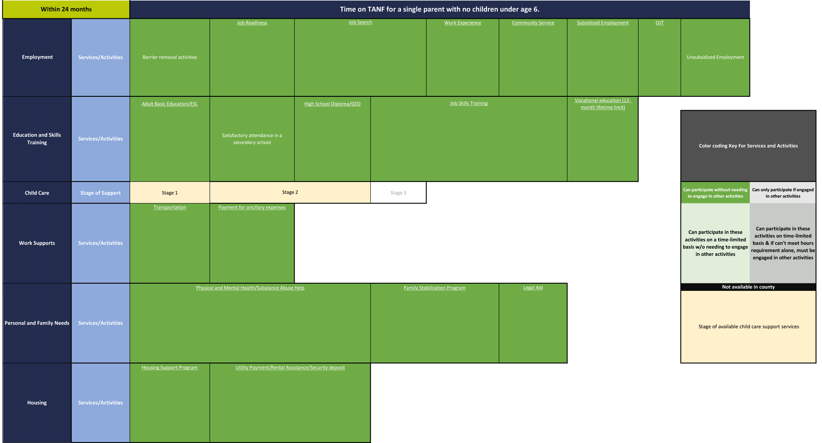

Introduction to County Goal Setting
Purpose: This goal setting overview is designed to help counties start explicitly outlining program outcomes of interest to the county. This guide provides a simple stepwise process for counties to complete in order to derive those outcomes of interest and then set appropriate goals related to them.
Description: This is a brief document that introduces county goal setting, and provides framing for thinking about county, program and client goals. The graphics and stepwise process succinctly walk counties through initiating the goal setting process.
When to use: This goal setting guide can be used with whatever frequency the county would like to reflect on progress and update goals. The county may choose to examine their program at quarterly, semi-annual, or annual intervals depending on the continuous quality improvement desires and the magnitude of the change expected as well as how long that change is anticipated to take.
How to use: County CalWORKs leadership and other key staff involved in the county assessment and reflection process should read the goal setting guide completely before engaging in a reflective and analytic conversation. The guide should be used to facilitate the conversation amongst team staff members designated to set and reflect on goals for continuous quality improvement.
What successful use looks like: Counties will establish a regular process for engaging in county reflection, assessment, and goal achievement. Counties will record, distribute, and follow up with staff on goals. Goals will be easy to understand and applicable to regular staff activities such that county team members can use them as part of a framework for making service delivery decisions and engage customers with intentionality in a goal-achievement framework.
Why setting overall CalWORKs goals is an important component of CalWORKs 2.0
Effective overall CalWORKs goals can keep everyone focused on the same destination, help create clarity about how each of the program activities contributes to the county’s overall goals, and identify how to target limited resources. Given the structure of CalWORKs, it is quite likely that counties will have goals in similar domains (e.g., engagement, employment, education, and family well-being) but their actual goals within those domains may differ, reflecting their unique priorities and caseloads.
Effective goals are also a critical component of creating better programs. If you know where you’re heading and where you are now, it is much easier to think specifically and strategically about how to get from point A to point B—and to figure out whether the strategies you’ve implemented are helping to get you there. It also helps to target limited resources to the components of your program where you believe you have the best chance of making improvements.
Also, effective goals can keep staff engaged because they know what they are aiming for and what is expected of them—and allows them to celebrate their successes along the way.
Effective goals should be SMART—specific, measurable, attainable, realistic, and time-bound. There also should be a manageable number of them. It is better to have a few goals you can realistically strive to achieve than to have many goals that fail to support a clear road map for what you hope to achieve.
Effective overall CalWORKs goals provide the foundation for program and client-level goals
County Level: What are our overall CalWORKs goals and how do we communicate them? How might we allocate resources and train staff to ensure the greatest chance of success?
Program Level

How can we set goals for each of our core program components to achieve our overall goals?
Client Level

How can we measure clients’ progress towards achieving their goals?
Steps to successful goal-setting
Counties can use a five-step process to create a goal-achievement foundation for their programs. The primary aim of this process is to encourage counties to take a systematic look at their program through the lens of CalWORKs 2.0, which aims to encourage staff at all levels to think about the goals of CalWORKs as broader than meeting the TANF WPR. The steps do not need to be completed all at one time. You can start with establishing overall CalWORKs goals and add the other components as time and resources permit.
If your program has a mission statement or recently completed a visioning process, review those materials before beginning the goal-setting process. Doing so can help you jump-start the goal-setting process and ensure you are building on past work.

- Define customer success. Start by being explicit about how you define client success in your county. Think broadly about what a successful client would be doing several months or even a few years after receiving services. For example, do you define success as any of the following: Improving executive functioning skills? Getting a job? Increasing education or skills? Improving well-being (e.g., providing stable housing)? Engaging clients in program activities? Write down your county’s vision for success for your customers.
- Establish overall CalWORKs goals. Overall goals should directly tie to how you define success for your customers. Work backward from your definition of success to identify the short-term outcomes of your program that would help customers achieve success. Consider goals beyond WPR. For example, goals could be related to engagement, participation, customer satisfaction, access to services, customer executive functioning skills, and customer goal-achievement.
Examples of overall CalWORKs goals
- Increase participation in post-secondary education by 10 percent within the next year
- Increase program engagement by 10 percent within the next six months
- Place 50 percent of clients assigned to group job search in paid employment within three months
Note that the first two goals are improvement goals and the last goal is an absolute target; both are acceptable types of goals.
- Identify goals for each core program activity within CalWORKs. CalWORKs uses a broad range of strategies to guide participants toward economic and life success. This component of the goal-setting process encourages counties to think strategically and specifically about what constitutes success within each program activity, providing staff with clearer direction on the purpose of each program activity. Also, it helps to clarify how each component contributes to the overall county goals. Again, think beyond WPR and identify alternative goals.
Examples of core program activity goals
- Increase the percentage of clients in subsidized employment who move into unsubsidized jobs within six months by 20 percent by January 2019
- Increase the percentage of clients who participate in a program activity after orientation by 50 percent by the end of fiscal year 2018
- 50 percent of clients who enter a postsecondary education program complete it
- Develop a process for regular review of progress towards county and program goals. Counties can model the importance of reviewing and revising goals for customers by establishing a formal process for writing, distributing, and assessing achievement of goals. These regular review periods should also inform whether goals need to be revised and what next steps to take for counties, programs, and customers to achieve success.
- Develop a system for measuring clients’ progress toward achieving their goals. Lastly, once the county goal-setting process is in place, work on creating a staff and customer goal-setting system. Creating a system to measure progress toward achieving longer-term goals can help instill in staff and clients the importance of achieving small steps. There are various ways in which progress and/or interim steps could be captured. For example, you might track movement from no participation to any participation to substantial participation to full participation. Alternatively, you might use the CalMAP (included in the frontline guide) as a framework for measuring progress in specific domains. Still another approach would be to track the status of goals that clients set and identify whether those goals have been achieved, revised, or replaced with a different goal.

Choosing Frontline Tools
Purpose: To achieve your county’s goals and to implement CalWORKs 2.0, frontline staff may need to change how they are interacting with customers. To do so, staff may need some concrete resources and tools. The CalWORKs 2.0 frontline tools were designed to help staff implement the goal achievement framework and intentional service selection. Staff at multiple levels will need to collectively identify which tools will most help the county achieve its goals. Try out the tools with a select group of staff first using a “road test” to hone the use of the tools (see the Road Test manual on the CalWORKSNextGen website for more information). Once you feel confident about how the tools fit into your existing case flow and have identified how best to use the tools, roll out the tools to the entire county.
When to use: When you begin implementing CalWORKs 2.0 consider which tools will help your county achieve its goals. In the future, as you set more goals, re-consider which tools will help your county achieve those goals.
How to use: Follow the steps below to choose the frontline tools.
- Review the purpose of each tool (below). The frontline guide includes more details about each.
  - Assessment tools:
    - Triage tool: Helps counties with specialized staff and programs quickly collect key information to identify what (if any) specialized support the customer needs
    - Quality of Life index: A validated benchmark for quickly learning about how a customer currently feels about his or her quality of life
    - CalMAP: A holistic picture of a customer’s areas of strength and needs that can be completed in just a few minutes (unlike the OCAT)
  - Goal-achievement tools:
    - Goal-storming activity: Helps customers who are having a hard time identifying a goal
    - GPDR/R worksheet: Walks customers through the goal-achievement process for daily goals
    - My Roadmap: Helps customers document a long-term or complicated goal, identify their motivation for this goal, and name some progress goals on the way to achieving the long-term goal
    - Potholes and Detours: Help customers identify potential challenges and possible solutions to those challenges
    - Postcard reminder: Reminds customers about their goals and the next appointment
    - Pocket reminder: A reminder customers can carry with them
  - Business process tools:
    - 24-month counter: A tool to track how long a customer has been receiving services
    - County resource map: A tool that helps frontline staff identify appropriate services and referrals for customers
- Review how the tools interact. The figure below shows how the three different types of tools relate to one another. Keep this information in mind when deciding which tools to use.
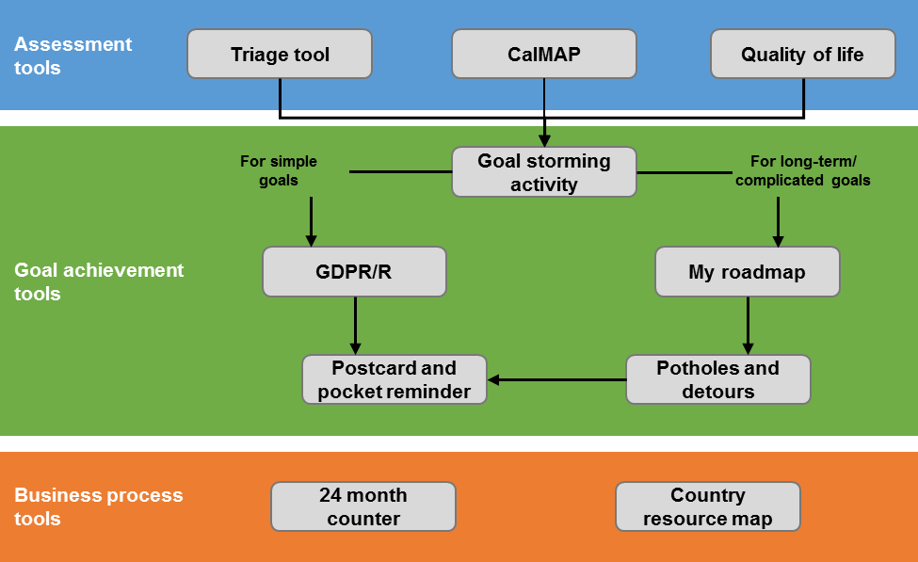
Decide which tools to use. Reflect deeply on your county’s goals and potential areas of improvement. Using this information, identify tools that will help your county achieve its goals or improve.
Create materials for frontline staff describing how and when to use the tools. The frontline staff guide provides a template for you to modify to fit your county’s needs. Delete directions for tools that you will not use, and modify the directions for the tools you will use. Include sufficient information for frontline staff so they clearly understand what is expected of them. Leave room for frontline staff to adjust or tweak based on the customer’s unique situation.
What success use looks like: The county is able to identify the tools that are most likely to help it achieve its goals. The county can articulate when and how to use the tool in its case flow. The county can describe how and why it thinks the tool will help it achieve its goals.

Staff Skills And Attributes
Purpose: For the county’s vision and program approach to be executed successfully, staff require clear expectations and guidelines about how to perform their job, engage customers, and deliver CalWORKs services. The staff skills and attributes matrix outlines a set of staff performance expectations reflective of the CalWORKs 2.0 goal-achievement framework.
Description: The staff skills and attributes matrix outlines critical skills and attributes for implementing CalWORKs 2.0. The top of the matrix highlights four key areas of staff performance: (1) general skills and attributes for direct work with customers; (2) CalWORKs goal achievement framework; (3) professional goal-setting, well-being, and self-care practices for service workers; and (4) skills for managing daily tasks. Within each key area, specific skills or attributes are outlined, and under each there is a description of what ideal worker performance might look like.
How to use: The information contained in the matrix can be used for staff training purposes, to generate updated staff position descriptions as part of a regular county reflection process, to inform goal setting and continuous quality improvement planning, or reviewed as a menu of options to consider in future program and staffing decisions.

I. General skills and attributes for direct work with customers
Skills and attributes | Mind-set in working with clients |  | Meeting facilitation skills
 | Demonstrates ability to see a person’s potential and helps him or her achieve it | Non-judgmental | Facilitates, rather than directs, a natural and focused conversation with the client | Asks open-ended, reflective questions | Detects and addresses an individual’s ambivalence about change | Redirects conversation when it goes off task | Sets clear and consistent meeting structure with clients
Ideal performance | - Consistently affirms and encourages client, regardless of circumstance  - Guides client in viewing challenges as opportunities for improvement  - Envisions role as helping clients reach their full potential  - Lives with and instills in others a sense of hope | - Demonstrates unconditional positive regard in all interactions with client  - Accepts the client as he or she is and with all his or her limitations | - Asks questions to guide discussion, rarely gives direct advice  - Maintains two-way dialogue  - Client decides meeting topic(s)  - Observable rapport with client | Consistently asks open-ended questions that are highly responsive to client’s prior statements and that promote client self-awareness | - Detects the client’s ambivalence (unsure, fearful, or indecisive) about making a change and asks reflective questions that draw out the root of the client’s ambivalence  - Leads to observable shift in client’s readiness to change | Effectively redirects client telling by connecting the issue to the client’s goal(s) | - Meeting structure and length is highly consistent across clients  - Never steps in to complete a task for the client  - Most “next steps” are assigned to the client

II. CalWORKs goal achievement framework
Skills and attributes | Customer appraisal and  client coaching skills |  | CalWORKs action plan development and  client coaching skills |  |  |  | Regular case management and goal review  client coaching skills
 | Uses assessment to help client identify areas for change and frame goals | Helps client to brainstorm potential goals | Helps client identify goals that are meaningful | Helps client break goals/ tasks into smaller, more feasible steps | Helps client articulate specific, time-bound action plans | Helps client identify obstacles and solutions | Helps client assess their progress toward goal(s) and revise accordingly | Provides clear expectations and holds client accountable | Maintains timely and consistent contact with client
Ideal performance | - Consistently reflective questions help client identify 1–2 key areas of need  - Guides client in prioritizing services and opportunities and linking to potential goals | - Encourages client-led brainstorming on aspects of work and life that they would like to change  - Guides client in articulating 2–3 challenging, but achievable goals | - Elicits client’s goal(s) through conversation about what client cares about/wants to accomplish  - Consistently asks about the difficulty of goal  - Prompts client to visualize accomplishing goal | - Engages the client in dialogue about steps  - Asks reflective questions on effort/ feasibility  - Summarizes steps back to client | - Asks reflective questions to help client articulate plan and consider necessary skills/ resources  - Prompts client to specify exact timelines  - Guides client to complete my goal plan, summarizes back to client | - Asks reflective questions to prompt client to identify at least one obstacle and one solution  - Encourages client to focus on internal obstacles  - Helps client formulate concrete plan | - Guides client through review/revise boxes on my goal plan  - Asks reflective questions on lessons learned to promote client’s self-awareness  - Celebrates progress; encourages the client if goal has not been reached  - Helps client revise his or her goal and plan as needed | - Guides client through reflection on effort and progress  - Focuses expectations on client’s goals  - Connects progress to the client’s motivation | - Proactively checks in with clients on goal progress  - Uses various methods of check-in depending on client preference  - Tailors frequency of contacts to client need

III. Professional goal-setting, well-being, and self-care practices for service workers
Skills and attributes | Professional goal-setting practices for service workers |  |  | Worker well-being and self-care practices
 | Applies goal achievement principles in assessing  his or her own professional development goals | Applies goal achievement principles in planning steps to take toward his or her own professional development goals | Applies goal achievement principles in reviewing successes and challenges his/her own professional development goals | Demonstrates awareness of and attends to his or her own emotional reactions to clients and their circumstances | Promotes a culture of wellness in the workplace
Ideal Performance | Begins process of setting professional goals by the following steps:  - Examining his or her professional strengths and needs for further development  - Brainstorming a few key areas of work where he or she would like to develop professionally and achieve success  - Beginning to narrow in on a professional goal that is meaningful and motivating to him or her | Engages in an ongoing cycle of professional development that includes the following goal-planning steps:  - Setting his or her own meaningful professional goals based on what he or she values, cares about, and wants to accomplish  - Breaking down professional goals into smaller, more feasible steps  - Creating a concrete plan for achieving professional goals and considers necessary skills and resources for achieving those goals (whether training or guidance is needed, support from co-workers, etc.)  - Identifying obstacles that might get in the way of achieving goal and solutions for addressing each obstacle | Continually engages in a cycle of reflection and improvement by undertaking the following activities:  - Regularly assessing progress toward professional goal(s)  - As necessary, adjusting or setting new goals based upon process of reflection  - Consistently taking time to review experiences and behaviors and gain new understanding from them  - Deriving lessons learned from experiences and turning them into concrete action steps for the future  - When old goals are accomplished, setting new goals and beginning the process again | - Consistently maintains healthy boundaries with clients  - Proactively develops responsive relationships and networks to deal with work stress | - Actively initiates group wellness activities within the workplace  - Plays active role in discussing issues of community wellness  - Participates in group wellness activities  - Model healthy behaviors for co-workers and clients  - Engages in personal wellness behaviors  - Regularly engages in self-care behaviors

IV. Skills for managing daily tasks
Skills and attributes | Effectively organizes work | Effectively manages time | Adaptable and flexible | Knowledgeable about community resources and how to access them | Works well with others/ collegial
Ideal performance | - Excellent organizational skills  - Focuses on developing and following effective routines and procedures, and on identifying priorities  - Work is of excellent quality | - Utilizes work time in a highly responsible and productive manner  - Tasks are completed on or before deadlines | - Consistently demonstrates willingness and ability to adapt to changing demands | - Regularly seeks up-to-date information on community resources that are available to clients and how to access them  - Shares additional information on new resources with co-workers and supervisors | - Consistently respects and is respected by co-workers  - Highly cooperative and helpful  - Consistently demonstrates courtesy, tact, and discretion when interacting with others  - Seeks to serve others in a positive manner

Fidelity Assessment Tool
Purpose: This tool is a definitive list of what full adherence to each component of CalWORKs 2.0 looks like in each program area. The fidelity assessment aligns directly with the county self-assessment guide; it is simply a more detailed list. The tool can assist counties by adding clarity to the CalWORKs 2.0 culture change vision, by aiding with regular assessment through a CalWORKs 2.0 piloting effort, or through evaluating program implementation at regular intervals following the launch of CalWORKs 2.0.
Description: The fidelity assessment tool systematically breaks down the key CalWORKs 2.0 components listed in the county self-assessment tool and provides discrete examples and descriptions of what those components look like when implemented fully. In the first column, the shaded rows align with the information from the county self-assessment tool. Each shaded row is followed by a subset of descriptors that illustrate full-fidelity implementation of the specified CalWORKs 2.0 element. The remaining columns on the fidelity assessment contain space for check marks to capture the extent to which the county or worker’s approach is consistent with what is defined as full fidelity.
How to complete the assessment. The assessment can be completed based on reviewing program materials, observing internal meetings and operations, and observing interactions with clients. A neutral individual should conduct these observations and systematically review the elements listed in the assessment to determine if the program is adhering to the listed expectation with high, medium, or low fidelity.
- High fidelity: The staff person’s actions align with the description and are concretely observable and/or measurable.
- Medium fidelity: The staff person’s actions partially align with the component as described in the tool. Some portion of the action is demonstrated, but not to the full extent.
- Low fidelity: The staff person’s actions minimally reflect implementation as described in the tool.
- Not in place: The component does not exist or has not yet been initiated.
How to use the results. County administrators and program managers can use this tool to identify the areas for improvement in worker performance or in program design and implementation. The results may demonstrate county strengths in program delivery and adherence to CalWORKs 2.0 as well as areas where the most opportunity for improvement exists. This fidelity assessment should be viewed as an iterative process. This information can be combined with other information and reviewed by supervisors and/or be used alongside the staff skills and attributes matrix. In tandem, the fidelity tool and staff skills matrix will help supervisors and staff set professional goals, and can help the county think critically about additional staff training opportunities.
The Fidelity Assessment
Instructions: Add a check mark to the column(s) that best represent your current implementation of CalWORKs 2.0.
Completely in place (high fidelity) = Item is part of the system, and “evidence” of this component is observable and/or measurable.
Mostly in place (medium fidelity) = A large part of the item has been established and is being utilized on a regular basis.
Somewhat in place (low fidelity) = A small part of the item has been established, or the item is not being utilized on a regular basis.
Not in place = The component does not exist or has not yet been initiated.

 | Completely in place—  high fidelity | Mostly  in place—medium fidelity | Somewhat in place—low fidelity | Not in place
I. Program approach
- Evidence-informed, goal-achievement focused program framework
- Program design and actions are aligned and framed around explicit, achievable program goals
- County has set specific, attainable goals
- County materials frequently reference overall CalWORKs goals
- Internal meetings reference CalWORKs goals
- Well-defined services are aligned with the characteristics, needs, and aspirations of the population served
- County services and resources are tailored to the needs and aspirations of the population served
- Frontline staff are aware of the county’s services and resources
- County maintains a list of services and resources in the county
- Program mission, core values, and program framework encourage and support clients’ setting and achieving goals
- Program draws upon the self-regulation, executive functioning, and behavioral nudges research
- County materials appropriately apply these concepts (for example, reference executive-functioning skills that clients need or mailings use nudge principles to increase effectiveness)
- Frontline staff appropriately use these techniques and language when meeting with clients
- During internal meetings, staff discuss these concepts and their application in your program
- Institutionalization of program framework
- Clarity and consistency between the program vision, guiding principles, staff expectations, and program outcomes with regard to goal achievement
- Program vision and guiding principles describe the same goal achievement principles and expectations
- Staff expectations and program outcomes align with overall CalWORKs goals and account for focus on goal achievement at the client level
- County has a logic model that shows how the program inputs, activities, and outputs relate to client outcomes in the context of goal achievement
- Program gives staff specific recommendations for incorporating the needs of TANF youth and children into service delivery
- Strength-based, family-focused approach
- Staff members recognize and build on client strengths
- Services are framed by staff as “skill-building” (positive) and are not framed as “barrier removal” (negative)
- Staff use a standardized process to identify client strengths
- Staff assess client strengths on a regular basis
- Staff refer clients to services that are appropriate for the client’s current skills and will build on the client’s strengths
- Administrators and staff believe in clients’ ability to develop and use skills to help them succeed
- Senior staff communicate in trainings and meetings a belief in clients’ ability to succeed
- Staff use positive language and an encouraging approach when working with clients
- Program provides services and supports that benefit the family unit, including children
- Staff regularly discuss children’s needs with clients
- Staff provide services or referrals to services for children
- Well-defined, customized service approach
- Client and staff collaborate to customize services for each client and family
- Client and staff regularly discuss client service needs
- Client and staff collaboratively consider appropriate services
- Client plans vary from one client to the next, depending on individual client needs
- Program leaders support a culture and practice of equal input from both clients and staff in planning
- County leaders consult with staff when planning
- County leaders consult with clients when planning
- Staff and clients have a way to submit comments/feedback at any time
II. Program environment
- Clear, positive, action-oriented program messaging
- Program materials, including letters and notices, are clear, simple, encouraging, and action-oriented
- Information is relevant and accessible in multiple formats
- Accessible, inviting, and family-friendly physical space
- Waiting rooms include positive messaging about clients and the program, and are clean, well-decorated, and child friendly
- The front desk is visible and easily identifiable from the entrance
- Professional customer service approach
- Front desk staff are visible, face clients, and welcome all clients immediately upon entry with a friendly and approachable tone
- Wait times in the lobby and on the telephone are short
- Security and other personnel are held to the same expectations as agency staff (positive regard for clients, inclusive and culturally sensitive, respectful, adhering to program mission and core values, etc.)
- Clients understand and are able to easily self-navigate the application process
- Clients understand what resources are available to them and who can help them access those resources
- Client needs are resolved by one worker when possible (hand-offs are minimized); otherwise, hand-offs between workers are efficient and friendly
- Staff share information about clients and reference information already collected to minimize the need for clients to repeat their life circumstances or other information to multiple workers
III. Administrative infrastructure and program staffing
- Well-defined list of staff core competencies to guide hiring and staff development
- Staff believe in the parent’s ability and potential to accomplish his or her goals
- Staff believe that clients can develop skills for success
- Staff can see a client’s potential
- Staff are collaborative rather than directive
- Staff facilitate, rather than direct, the work with clients
- Staff ask clients open-ended, reflective questions
- Staff are able to work with clients to determine the services that would be useful
- Staff have knowledge of internal and community resources and strategize with clients about how to access them
- Staff are encouraging and supportive of goal achievement
- Staff are skilled at identifying and troubleshooting potential challenges that interfere with goal achievement
- Staff hold clients accountable for making progress
- Staff follow up with clients to see if they are making progress on their goals
- Staff take appropriate action based on client’s progress
- Staff have positive regard for the client, as shown through positive language in private and public settings
- Inclusive, culturally sensitive staff
- Staff work effectively with diverse populations
- Staff use culturally inclusive language
- Staff are attuned to strengths and needs of different communities
- Staff proactively work to ensure everyone is treated with respect
- Through training and materials, staff are made aware of and are able to manage any cultural biases and judgments they may have toward low-income parents
- Staff training and development
- Staff have access to clear job descriptions and expectations for their role
- Staff are provided training and tools to support desired job performance
- Staff performance measures are tied to overall program and client outcomes
- Supervisors coach frontline staff on working with clients
- Management and supervisors create and support a healthy peer-to-peer coaching environment among staff
- Staff have formal opportunities to discuss challenges and possible solutions with their peers
- Staff have informal opportunities to discuss challenges and possible solutions with their peers
- Internal communication about policies, state initiatives, and community resources
- Program managers and supervisors clearly communicate how staff should implement and utilize the policies, specialized services, and supports offered through CalWORKs
- Program managers and supervisors clearly communicate how staff can help clients achieve federally-defined work activities within a goal achievement framework
- Staff are provided regular training and tools to simplify the process of helping clients access all available services and supports
- Staff are regularly provided up-to-date information about community resources available to CalWORKs families
- Staff are provided a clear process and tools for timely, accurate tracking of the 24- and 48-month time clocks
- Approach of contracted service providers and community partners
- Contracted service providers and community partners who work with CalWORKs families have received training and support on client goal setting
- The expectations and performance measures for contracted service providers and community partners who work with CalWORKs families are clearly defined and support client goal achievement
- Performance-based contracts reward clients’ progress toward goal achievement
IV. Service delivery process (case flow)
- Clear, simple, and engaging orientation
- Orientation introduces goal achievement and family focus of CalWORKs 2.0
- Orientation uses positive language designed to encourage and excite participants
- Orientation includes relevant, accessible, and useful information, but does not flood the client with too much information
- When participants leave the orientation, they understand the options available to them under CalWORKs and the initial steps they need to take to exercise those options
- Initial and ongoing assessment of skills, abilities, and service needs
- Initial assessment is used to identify each client’s strengths and needs, and create an individualized service plan
- Initial assessment process is used to inform clients’ initial goal setting
- Ongoing assessment process includes reviewing and revising clients’ goals and updating clients’ strengths and needs
- Through the goal-setting process, staff informally assess clients’ self-regulation and executive function skills
- Clear, user-friendly, adaptable goal achievement process
- Goal setting and achievement are embedded into all aspects of the program, including individual sessions with clients, group job search, and early engagement initiatives including family stabilization and enhanced subsidized employment
- Goals are meaningful to the clients and reflect their interests and abilities
- Goals are broken down into practical, specific, concrete, and sequential steps
- Staff use short-term and intermediate steps to monitor and track clients’ goal progress
- Staff meet regularly and frequently with clients to review and revise their goals
- Frontline staff troubleshoot with clients who are not making progress toward their goals
V. Performance management and measures
- Relevant and appropriate short-, intermediate-, and long-term measures for tracking county goal progress and achievement are in place
- Outcome targets are clearly defined and map to the expectations for the agency and contracted service providers
- Staff have access to performance management data, and are given direction about how to use the data to improve their work
- Accountability measures for staff and clients are clearly defined and tied to a client’s progress toward goals

www.mathematica-mpr.com
Improving public well-being by conducting high-quality,
objective research and data collection
Princeton, NJ ■ Ann Arbor, MI ■ Cambridge, MA ■ Chicago, IL ■ Oakland, CA ■ SeATTLE, WA ■ TUCSON, AZ ■ Washington, DC ■ wOODLAWN, MD
Mathematica® is a registered trademark
of Mathematica Policy Research, Inc.

Note: Adapted from Blasé, Karen, Melissa van Dyke, and Dean Fixsen. Implementation Drivers: Assessing Best Practices. Chapel Hill, NC: National Implementation Research Network, University of North Carolina, 2013.
Note: Adapted from Blasé, Karen, Melissa van Dyke, and Dean Fixsen. Implementation Drivers: Assessing Best Practices. Chapel Hill, NC: National Implementation Research Network, University of North Carolina, (2013).

