

**CalWORKs 2.0 | Questions, Poll Results, and Participant Responses**

**Webinar #2**

**August 4, 2017**

|  |  |
| --- | --- |
| **Question** | **Answer** |
| Would the goal setting and planning be part of the hourly requirement, or would they be on top of the hourly requirement, considered extra work by customers? | The goal-setting and planning activities should be integrated into existing meetings and activities. Using them as part of your regular interactions with customers provides an opportunity to change the nature of worker-customer interactions, to focus more on achieving goals that are meaningful to the customer and structuring customers’ required activities as a means to achieving those goals. They are not required (a customer can decline to use them).  Counties have flexibility regarding when and how to incorporate the goal-setting tools. Although time spent on checks-ins with a caseworker doesn’t generally count toward work participation, counties could consider creative ways of integrating the goal-setting framework into countable welfare-to-work activities (as specified in Welfare and Institutions Code, section 11322.6, and further defined in ACL 17-08, attachment 1). For example:   * Use the tools in the context of a job club to have customers set goals related to a job search * Have your mental health or domestic violence service provider use the tools with customers to stay on track with their barrier remediation plan * Incorporate the tools to have customers set goals related to securing child care or housing as part of a job readiness activity * Adapt the CalMAP for use during countable assessment and appraisal activities   Regardless of whether the activity counts toward the WPR (work participation rate), counties should integrate goal achievement tools and framing into meetings the customer is already required to attend, so it shouldn’t feel like something extra. |
| How about a signature field for the goal worksheets? | A few of the road-test counties added a signature line and a case number field to both the CalMAP and the goal-setting tools. Modifications like this are expected, and the design of the tools should allow for any customizations individual counties would like to make. |
| Is there a tool for feedback from customers who have used these tools? | Yes. As part of the road tests, each county is collecting survey feedback after a customer is first introduced to any of the CalWORKs 2.0 tools. In some counties, this is a brief paper survey, and in other counties it is an online survey (given on-site from a county computer). All responses are anonymous and are not available to county staff individually. The aggregate findings from customer feedback, which are very positive, are presented back to the counties and considered when collaborating with counties to modify the tools. |
| It would be helpful to see results and experiences from road-test counties. | We agree that sharing the insights from road-test counties and their experiences is an important step in this process. We are accomplishing this in two ways: (1) As part of the newsletter series (subsequently available on the website [www.CalWORKsNextGen.org](http://www.CalWORKsNextGen.org)), we have recorded interviews with road-test county staff sharing their experiences; and (2) the CalWORKs Strategic Initiative team will be making a presentation at the CWDA annual conference in a panel discussion with participating county staff on October 5 in Sacramento, CA. We can share the slides from the presentation on the website for interested individuals who are unable to attend the conference. |
| Can we obtain copies of these tools now? | When the road-test counties finish the vetting process for the CalWORKs 2.0 tools and the tools are finalized, they will become available along with informational and instructional material at [www.CalWORKsNextGen.org](http://www.CalWORKsNextGen.org) |
| I have not heard much about CalWORKs 2.0 in my county—this is the first time I have seen the material and I’m a line worker. How can I get access to the information and material to try and implement some of the info provided today? | Over the course of the next few months, the strategic initiative team will be finalizing materials for dissemination to all county staff through the website (see above). We will also roll out a sequence of in-person trainings that will most likely begin in late fall or early winter. The trainings, which will be available to all counties, will target staff at different levels of the CalWORKs program. We suggest that you speak with management in your county if you are interested in learning more about how your local program is planning to engage with the CalWORKs 2.0 framework. |
| How often do you anticipate we should be using these tools or reviewing with customers? | We expect this answer to vary some from county to county. The tools and the goal-achievement framework are designed to be adaptable to existing county case flows and processes. Part of the CalWORKs 2.0 effort is to reframe the messaging about what the CalWORKs program does for customers. We hope to deliver the clear message to a customer that “CalWORKs is here to help you set and achieve your goals.” Thus, it is important that actions occurring throughout program activities and case management align with that message. Goal setting or goal reviewing can be part of any existing customer contact. |
| What size caseload have these tools been used on? How long does it typically take to use each tool? | Current caseloads of road-test counties are approximately 700 to 22,000. Cases per worker range from around 15 (highly specialized cases) to 90 (mixed caseload). However, the tools are being implemented with only a subset of customers right now, about 5 to 10 per worker. On average, staff report spending 10 to 15 minutes with the goal-setting tools as part of regular meetings with customers. We have consistently seen that the tools take a little longer when staff are first starting to use them, but the staff get faster over time. We have heard from a couple of road-test counties that follow-up meetings with customers who have already been introduced to the goal-setting tools are shorter because they are more structured (around the goals). |
| Do you have training developed that teach staff to use “backwards method”? | Yes. The strategic team will finalize a set of resources that accompany the tools for training purposes. These materials will include additional information, instructions, recommendations, and talking points related to the tools. Instructions and recommendations will include assistance in backward mapping. Additional training will include videos through the CalWORKs Next Gen website as well as in-person trainings. |

During the second webinar, attendees were asked a number of questions and polled. This section contains the responses to those questions, as well as the poll results. The strategic initiative team categorized responses but did not alter them.

**Participant Responses to Questions**

**1. When you envision using the tools, where do you anticipate facing challenges? What are some proposed *solutions*?**

***(****Solutions in italics are directly from webinar participants. Additional ideas and solutions from the strategic initiative team will be incorporated into training materials and future presentations.)*

Customer mental barriers

* Speaking about these concepts in language that customers can understand
* Customers with learning challenges may have difficulty understanding some of these concepts
* Participants remembering the goals they are working on, along with the action steps toward them
* Criminal background
* Encouraging customers to think independently
* Uncooperative customers or those unwilling to engage and participate
* Mental health problems, depression
* Dealing with the unforeseen, what might get in the way

Motivation

* Motivating customers to participate, getting buy-in
* Time and lack of motivation
* Lost motivation, especially when new barriers come up
* Keeping people motivated if they are not making progress toward their goal(s)

*Solution: regular encouragement, help with problem-solving*

* The challenge will be to motivate the participant once the goal is set. We do this already, but our rate of “do” is small. Customers can set goals, develop plans, and know what needs to be done to get there, but the issue is getting them to do the work/effort to accomplish that goal
* The main challenge may be engaging participants in looking at the big picture, since they are usually very focused on the current challenges they are facing. Maintaining motivation during the process
* Attainable rewards for the customer and sharing of those rewards

Staff issues

* Training staff how to teach customers about goal setting
* To put responsibility on customer to provide labor market information data, for example, job leads in order for WTW to assist with start of education plan

Goals related

* Customers feeling a sense of failure/defeat if they don't meet goal

*Solution: reassess goal or review and revise*

* What if proposed goals are not consistent with WTW regulatory requirements?
* Challenge for some customers is identifying a goal. Some are only participating because it is a requirement

*Solution: remembering the goals and working on action steps*

*Solution: preprinted steps in color to give participant when coming for subsequent appointments with you*

* Workers are conducting assessments using OCAT, which is rather lengthy. How can we incorporate OCAT into goal-setting, which is valuable when developing WTW plans

*Solution: translation of these concepts into understandable language for customers (use of CalMAP)*

* I believe some of the challenges that will arise when setting goals for most of our customers will be not believing their goals can be achieved
* Some comments from customers include that the plans and goals are not being covered by Supportive Services—for example, mileage and child care coverage

Time

* A challenge I see is having the time in my schedule to be able to implement a new process

*Solution: block time in my calendar to work on the new process*

* Time, identifying steps, fostering rapport, finding resources
* The time span that it will take in developing a plan with achievable goals
* Time constraints, as well as enabling customers to depend on workers or the program more, as opposed to empowering them to become self-sufficient

Follow-up and persistence

* Sustained follow-through when they return home and life's problems get in the way

*Solution: begin with the end in mind and work backward*

* Lack of follow-through on customers’ behalf, lack of follow-up
* A big majority of challenges from participants that I encounter is the non-structure of a plan of execution or follow-through
* The challenge is usually the follow-through by the customer. I feel like the process of revision of the plan and making certain the workers do this early so the connection made in development of the initial plan isn’t a loss

**2. Which of the steps in Goal-Plan-Do-Review/Revise do you think will be the most challenging for customers?**

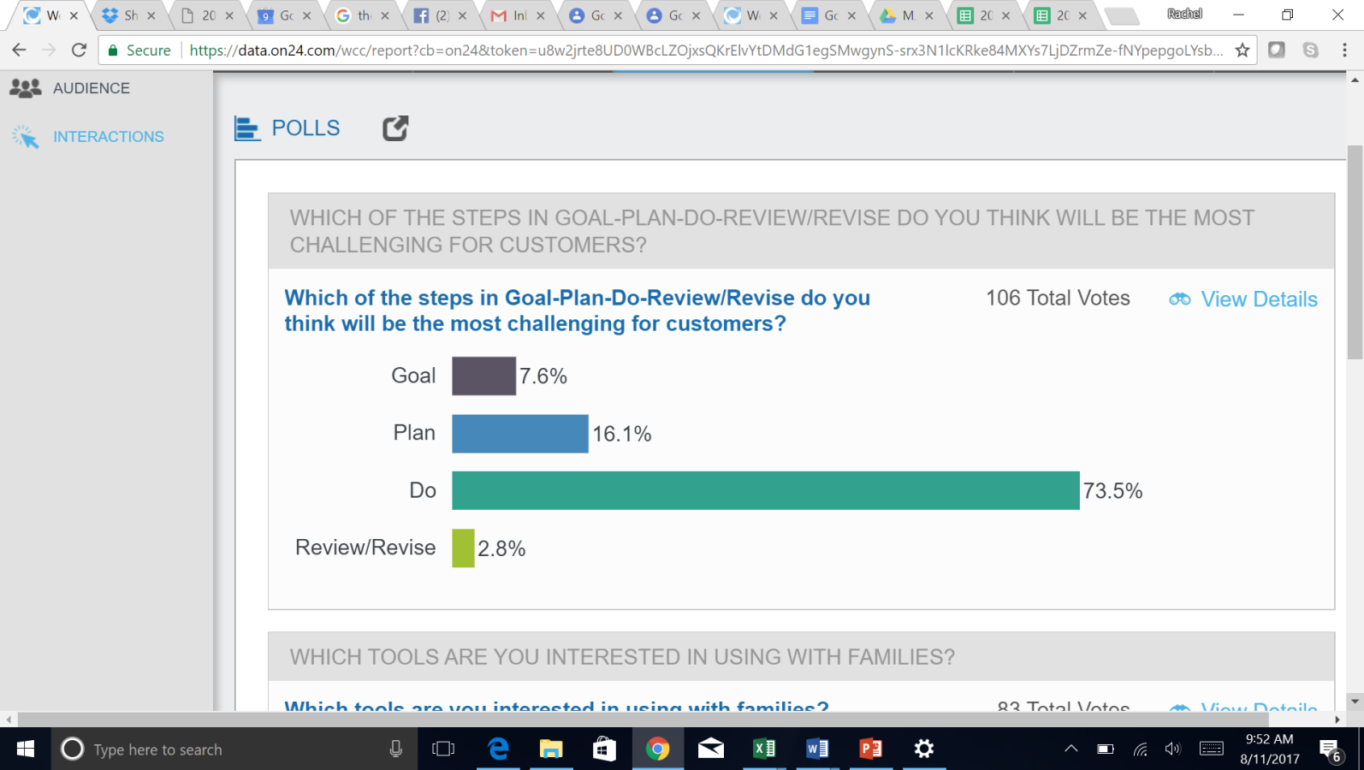

**3. Which tools are you interested in using with families?**

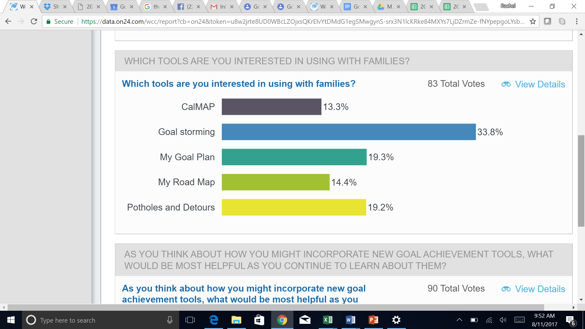

Additional responses to question 3:

* Road map
* The less paperwork the better
* Fresno County would like the goal storming tool
* Any tools we can use to build customer relations or rapport
* The tools would be great and helpful. We're actually using some already, just a little different but the same in thought
* Like the variety for staff and customer to use
* Goal/Plan/Do/Review does not work on phones; a computer is needed. Customers don’t have computers
* Really excited about the goal storming, participants really being able to put all their thoughts down on what they want to work on, then the road map and potholes and detours, for the participant to plan for derailing and getting back on track with the detours around the potholes
* Visuals along with explanation and engagement work well
* It would be good to have a phone app that customers can use to help with goal setting, et cetera. Paper is hard to track
* I would like to see expanded or expandable text boxes to use electronically with our younger participants
* I see the Goal/Plan/Do/Review and potholes and detours as tools that could quickly be incorporated as less intimidating for staff and easily understandable for participants

**4. As you think about how you might incorporate new goal-achievement tools, what would be most helpful as you continue to learn about them?**

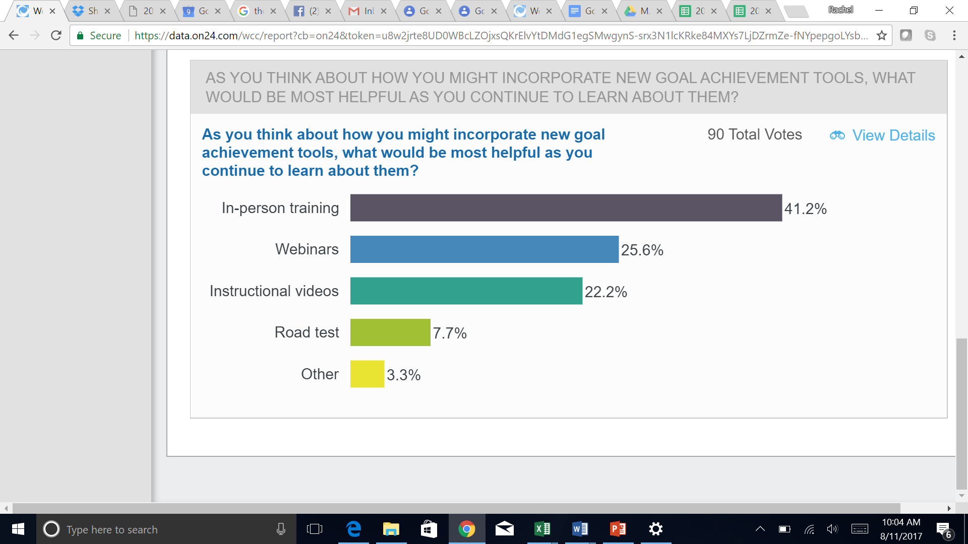

Comments:

* It would be helpful to have a demonstration on the tools being used in the context of working with families. I'm excited about getting started with goal storming, my road map, and potholes and detours