How to Plan and Implement a Road Test
February 2018

Mathematica Policy Research

This page has been left blank for double-sided copying.

CONTENTS
Introduction 1
What is a road test? 1
Why conduct a road test? 1
How does a road test work? 1
When should we do a road test? How do we know if we are ready for a road test? 2
Who should be involved in the road test? 2
Sections of this guide 2
A Learn, Innovate, Improve (LI²) 3
B Road Test Steps 5
1. Plan for a road test 5
2. Plan for data collection 8
3. Train and prepare the implementation team 12
4. Conduct road test 12
5. Analyze data 13
6. Review data, revise strategies, and plan for the next learning cycle 14
C Road Test Assistance Available to Counties 15
Road test webinars 15
Road test office hours 15
Additional help 15
D Tips for Success 16
1. Commit to active leadership and efficient coordination 16
2. Articulate a timeline, including opportunities for discussion, to foster staff buy-in and ensure everyone is on the same page 16
3. Keep in mind what a road test is and is not 16
Appendix: Resources 17
Work plan template 17
Road map for change template 20
Examples from other counties 21

This manual was adapted from the following sources: McCay, Jonathan, Michelle Derr, and Ann Person. “Using a ‘Road Test’ to Improve Human Services Programs: A Primer.” OPRE Report 2018-25. Washington, DC: U.S. Department of Health and Human Services, Administration for Children and Families, Office of Planning, Research, and Evaluation, February 2018; and McCay, Jonathan, Michelle Derr, and Ann Person. “Using a ‘Road Test’ to Improve Human Services Programs.” OPRE Report 2017-107. Washington, DC: U.S. Department of Health and Human Services, Administration for Children and Families, Office of Planning, Research, and Evaluation, December 2017.

Introduction

What is a road test?
A road test is a structured process that helps strengthen the design and implementation of a new program strategy before scaling. It begins by implementing the new approach on a small scale, in a contained practice setting. Often, small numbers of staff and clients participate over a short period and provide structured feedback about their experience. This feedback is then used to refine the strategy itself, improve its implementation, and examine the contextual factors that might influence outcomes.

Why conduct a road test?
A road test enables programs to try out and refine a new idea or strategy on a small scale before committing to a particular approach or scaling up. It identifies weaknesses in design or implementation that can be corrected and tested again, before expending resources to implement the program change more widely. Without using this intentional and incremental process, the change might ultimately be abandoned due to complications related to implementation or perceived ineffectiveness, resulting in wasted energy and resources. Even evidence-based approaches are at risk of failure if their piloting does not account for local context and incorporate time and space for adjustments to the approach or to the environment.

How does a road test work?
A road test often includes two or more feedback periods, known as learning cycles, in which a carefully selected strategy is used for about four to six weeks and then refined based on feedback from staff and program participants. Feedback can be collected through surveys, interviews, or focus groups and then analyzed to understand implementation strengths and challenges. This approach is designed to be accessible to programs without dedicated research staff, though outside researchers can be a resource for conducting road tests. In the figure below, staff first test out a new group workshop and then try out a revised group workshop in the second learning cycle. Each learning cycle is four to six weeks with time to reflect on the feedback between cycles.
Figure 1. The Road Test Process
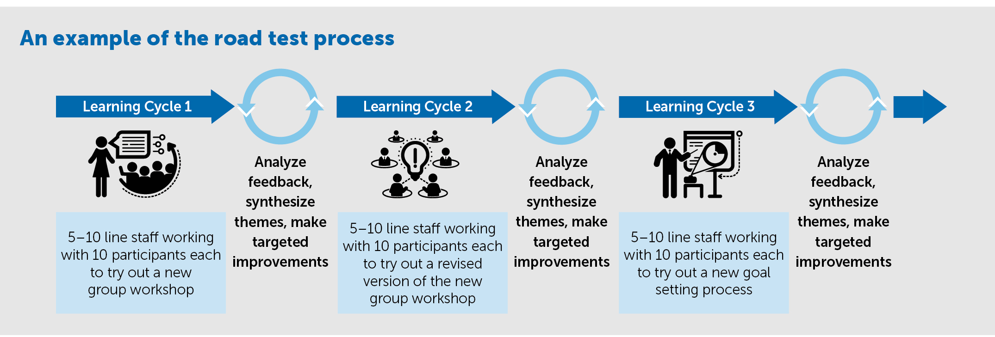

When should we do a road test? How do we know if we are ready for a road test?
You will be ready for a road test when you can clearly articulate the strategies and tools you want to try out and why you think these strategies and tools will help. Be clear about what specifically you think the strategies and tools will change in the short term in terms of attitudes and behaviors of staff and customers. For example, perhaps you think a goal-setting tool will improve customers’ engagement with staff.
To get ready, you will need to carefully and critically consider which elements of CalWORKs 2.0 will help your county bolster its CalWORKs program and/or address specific challenges related to participant engagement or outcomes. The Learn, Innovate, Improve (LI²) process, described in Section A below, can help you do this.

Who should be involved in the road test?
Planning team. Typically, a small group of key staff facilitates and coordinates road test planning. This group can usually benefit from obtaining the input of select program leadership, supervisors, and staff.
Implementation team. During the road test, we recommend only 5 to 10 staff members actually test out the new strategies or tools.
Data collection and analysis team. This could take a variety of forms, but often county research staff, data teams, and/or administrative staff help with data collection and analysis. This is usually not a highly labor-intensive process and can often be done by one person if needed.
Review team. At the conclusion of the road test, a team of staff should review the data collected and plan for the future. The review team often includes all of the members of the planning team. We also suggest that the implementation team (that is, all staff that tested out the tools during the road test) participate in reviewing the data and planning future work.

Sections of this guide
- Section A briefly describes LI² .
- Section B describes the steps of planning and implementing a road test.
- Section C summarizes the resources available to help counties plan and implement road tests.
- Section D includes some tips for success.
- The appendix includes resources, including templates and tools, for you to use as you plan and implement the road test.

A. Learn, Innovate, Improve (LI²)
A road test implies you are at the point where you want to test something new. Prior to testing something new you should thoughtfully consider your county’s motivation for change and how the CalWORKs 2.0 culture change and related tools and resources can facilitate that. Learn, Innovate, Improve (LI²) is one diagnosis and design process you could use (see figure 2).
Figure 2. Learn, Innovate, Improve (LI²)
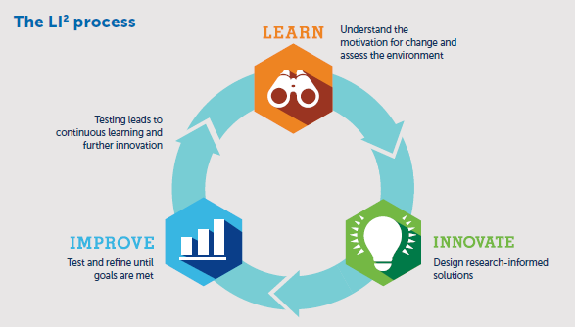
The basics of each stage in the LI² process are described very briefly below. For much more information about LI², check out the “Learn, Innovate, Improve (LI²): Enhancing Programs and Improving Lives” brief, published by U.S. Department of Health and Human Services, Office of Planning, Research, and Evaluation.
- LEARN: The first phase focuses on clarifying your county’s motivation for shifting to CalWORKs 2.0, identifying any specific issues or problems you think doing so will address, and understanding contextual factors that may support or inhibit implementation of CalWORKs 2.0. During this phase, you will want to:
- Complete the CalWORKs 2.0 county self-assessment, by carefully and objectively evaluating your county on the key elements of CalWORKs 2.0
- Map out how customers move through your program currently (this will help determine when and how to use some of the customer-facing tools supporting CalWORKs 2.0)
- INNOVATE: The second phase focuses on prioritizing implementation of CalWORKs 2.0 strategies and tools, as part of a broader culture shift. The CalWORKs 2.0 conceptual model and the tools developed to support it draws upon and is informed by research evidence, behavioral and social science, and practice wisdom. That said, not all the tools are relevant or fit well with the existing service delivery process in all counties. During this stage, counties should:
Carefully consider which strategies or tools to implement. You could focus on tools that you think will be most helpful to clients or staff, those that are the most similar to something you already do (making incremental change), or those that represent the largest shift. It all depends on your preference for how you advance toward full implementation of CalWORKs 2.0.
- Create a road map for change to guide the road test. The road map for change specifies:
- Strategies: Which new strategies and tools you will use and with whom (e.g., clients, staff).
- Targets: Which cognitive or behavioral changes among program staff or clients the new strategies and tools will target.
- Outcomes: What you hope would change as a results of adopting the new strategies and tools.
- Contextual factors: Other things going on in the program environment that might be expected to shape the strategies, targets, and/or outcomes.
An example road map for change and template are available in the appendix.
- IMPROVE: The third phase (Improve) encompasses the road test process —described in the remainder of this brief. This phase can also involve increasingly more rigorous research methods to strengthen the design or implementation of new strategies or tools and determine their impact on key outcomes of interest.
- Use this manual to help you plan and implement a road test.

B. Road Test Steps
Road tests generally follow six steps, each of which is described below. The appendix of this guide contains resources such as templates, tools, and examples from other counties that might be useful as you embark on road testing strategies and tools. Table 1 summarizes the road test steps and the resources available in this guide.
Table 1. Overview of road test steps and corresponding resources in this guide
Road test steps | Templates and examples
1. Plan for a road test | Webinar  Work plan (includes detailed description of tools/strategies, learning questions, and schedule)
2. Plan for data collection | Work plan (includes data collection plan)  Staff survey  Customer survey  Interview questions for staff
3. Train and prepare staff
4. Conduct road test
5. Analyze data | Example presentation
6. Review data, revise strategies, and plan for the next learning cycle | Example presentation

1. Plan for a road test
Ensure participating staff understand basic information about road tests
It’s important for all staff involved with the road test planning, implementation, and analysis to understand the basics of a road test. Start the process by ensuring everyone understands what a road test is and isn’t, and the purpose of a road test. Ask staff to watch this webinar that covers basic information about road tests (staff will need to register to view it).
Create a work plan
The work plan, created by the planning team, can be a guiding document throughout the road test process. Road tests may involve coordinating the efforts of several different staff members, who might not normally interact with one another. Communicating information about the road test and ensuring everyone is on the same page is important to success. A work plan can help ensure all the key information is summarized in a single document.
Create the work plan as you continue with the steps listed below. Once complete, the work plan will contain:
- Detailed description of how you will implement the strategies and tools for the road test
- Learning questions
- Schedule
- Data collection plans
Appendix resource: Work plan template
Clearly describe the details of how your county will implement the strategies and tools during the road test
Decide and describe in detail who, how and when you will use the strategies and tools. The planning team will need to make these decisions based on what makes sense for your county, drawing heavily on your work before the road test, including county self-assessments, a map of your case flow, and insights from staff at all levels.
For conducting the road test, the planning team will need to be very specific about the details and share this information with the entire road test team. A table can help summarize this information in the work plan so that everyone knows the detailed plan. Table 2 shows an example of detailed plans for testing out three tools and one strategy. The table appears as a template in the work plan in the appendix.
Table 2: Example detailed description of how to implement strategies and tools
 | Goal-Plan-Do –Review  (tool) | CalMAP  (tool) | Triage Tool  (tool) | In-person meetings (strategy)
What | Short-term goal-setting tool for use with customers | Tool for quickly assessing a customer’s current situation | Tool for gathering high-level information about a customer | Meeting monthly with customers in-person
When | During every interaction with customer during road test | During OCAT assessment | Before OCAT assessment | Monthly
Who – Staff and clients | 5 staff members in each office  Each staff member works with 3 to 5 customers of their choice | 2 staff members  Use with 10 different customers during the road test | 4 eligibility workers  Use with 10 different customers during the road test | 5 staff members in each office  Each staff member works with 3 to 5 customers of their choice
How | Staff member will approach customer with tool; customer can refuse to participate | Introduce and give CalMAP to customer before OCAT, conduct OCAT, then ask the customer to fill in the CalMAP and have a conversation with the customer about his or her current circumstances | Ask customer to fill out the tool; customer can refuse to participate | Ask customer to attend meetings in person; call customer before meeting as a reminder
Next steps | Identify the staff to participate  Develop training for staff | Ask Megan and Kesha to participate | Ask for volunteers from staff to participate  Train staff | Identify staff to participate

Appendix resource: Table template (in the work plan template)
Create learning questions to focus each cycle of a road test
Learning questions guide and shape the collection and analysis of formative feedback during a road test. The planning team should draft the learning questions. Simply put, a learning question specifies what you hope to learn from a road test cycle. In considering a learning question, it is important to remember that a road test is not designed to reliably answer questions of effectiveness or impact (that is, does this strategy cause that outcome or change?). Rather, a road test focuses on the quality of the implementation of a strategy and seeks to understand its feasibility and usability, as well as contextual factors that might positively or negatively affect implementation. A road test offers a preliminary look at the links between a specific strategy and the targeted changes. In other words, it examines whether the expected changes are showing up among staff or clients, even if it cannot definitively determine the cause.
Example learning questions:
- How do customers respond to the CalMAP?
- How much time does using the Goal-Plan-Do-Review add to meetings?
- Do staff think the tools help them build stronger relationships with customers?
- What do staff need to do to fully integrate the tools into their work?
- How can staff/customers effectively and efficiently use the tools?
Appendix resource: Learning questions table template (in the work plan template)
Develop a schedule
Creating and sharing a schedule can help the planning team with coordinating the road test and road test team members. To create the timeline and schedule, consider your answers to these questions:
- How much time will we need to plan and prepare for the road test?
- How much time do we need to train staff?
- How much time do we need to test our strategies or tools?
- When do we want to start the road test?
- How much time do we want to have between learning cycles? How much time do we need to analyze the data?
Table 3 shows some example road test steps and a timeline. Use the table template in the work plan template in the appendix to create a similar table with the specific plans for your county.
Table 3. Example road test timeline and schedule
Road test schedule | Month 1 | Month 2 | Month 3 | Month 4 | Month 5
Staff training | Training 1 |  | Training 2 222
Road tests (6 weeks each) |  | Ongoing |  | Ongoing
Data collection | Ongoing |  |  | Ongoing
Weekly check-ins with staff | Planning | Implementation |  | Planning | Implementation
Analyze data; revise tools/implementation |  |  | Review |  | Review

Appendix resource: Schedule template (in the work plan template)

2. Plan for data collection
Determine what kind of data you need to answer your learning questions
There are two main types of data: quantitative and qualitative data (see Table 4). Quantitative data are numbers, counts, and percentages and are good for summarizing countable or categorical information like how many minutes it took to use a tool. Qualitative data are personal quotes or comments and are good for explaining why or how something is happening. The planning team will need to determine which type of data will help answer your learning questions. You may be interested in both kinds of data.

Table 4. Two types of data
 | Quantitative data | Qualitative data
What is it? | Numbers, counts, percentages, scales | Quotes, comments, stories
Why use it? | Better for countable or categorical information | Better for exploratory purposes; “why” and “how” questions
Advantage | Easy to analyze | In-depth information
Disadvantage | Difficult to know the “why” behind the numbers | More staff time to collect  Can be difficult to analyze

Determine who can answer your learning questions
Next, the planning team should think about who can answer your learning questions and who can give you the data you want. These are the people from whom you will need to collect data. You might consider collecting data from customers, frontline staff, and/or supervisors, depending on your implementation plan.
Determine the best way to collect the data
A variety of methods are available to gather feedback to answer the learning questions, and some are better for collecting certain types of data. Table 5 summarizes various methods and their advantages and disadvantages. With the learning questions and the type of data you need in mind, the planning team consider which approach will work best for what you hope to learn.
Table 5. Methods for collecting data
Method | Type of data collected | How to collect | Resources needed to prepare (level of effort) | Resources needed to collect (level of effort) | Resources needed to analyze data (level of effort)
Surveys | Quantitative (best) or qualitative (okay) | Electronic or paper form completed by staff and/or clients | Moderate | Electronic: low  Paper: high | Quantitative: low  Qualitative: high
Observation | Quantitative or qualitative | Electronic or paper form completed by staff about a co-worker | Moderate | Moderate | Quantitative: low  Qualitative: high
Administrative data |  | Little additional effort | Low to moderate | Low to moderate | Quantitative
Interview | Qualitative | Staff interview each other | Low | High | High
Focus group | Qualitative | Staff meet with other staff | Low | High | High

Create a data collection plan
After you decide the methods you want to use for collecting data, you’ll want to create some specific plans for when and how to collect data. Table 6 shows an example data collection plan. The work plan includes a template for the planning team to create a data collection plan. It may be useful to involve the data collection and analysis team in the planning as well.
Table 6. Example data collection plan
Data collection method | When will it be collected? | How will the data be collected? | Who will collect the data from the respondent? | Who will store the data/how will it be stored? | Who will do the data entry?
Staff survey | After each interaction with customer | Electronic/online | Staff complete form themselves | Stored online | N/A
Customer survey | After each interaction with tools | Paper | Staff hand form to customer; customer returns form to front office | Administrative team | Administrative team
Interviews with staff | Twice; once in the middle of the road test and once at the end | Electronic notes | Supervisors | Supervisors | Supervisors will take notes during the interview
Focus group with customers | Once at the end of the road test | Electronic notes | Supervisors | Supervisors | Supervisors will take notes during the focus group

When filling in the data collection table, remember:
- Timing is everything. As you plan the timing of a survey or an interview, consider a frequency (biweekly, after each staff–client meeting, or maybe just once during the learning cycle) that aligns with the use of the new strategy. For example, if you are road testing a new client assessment process, it might make sense to ask for staff feedback after each use; on the other hand, if you are road testing a weekly client support group, a midpoint and a final feedback questionnaire completed by clients might be more appropriate.
- Collecting feedback should be as minimally burdensome as possible. Staff and customers already have a lot going on at work and in their lives. Using freely available online survey tools will enable you to customize and deploy web-based questionnaires to staff and clients; many of these tools also automatically organize the data graphically or in a spreadsheet, which may help you analyze the information more quickly.
Appendix resources: Data collection plan template (in the work plan template)
Determine the types of feedback questions you need to ask and create data collection instruments
The data collection and analysis team should determine the types of questions and then create the data collection instruments (surveys, interviews, etc.). Every question asked—whether on a form, in an interview, or posed to a group—should answer one or more of the learning questions for the road test. Gathering helpful feedback to answer your learning questions relies on asking the right questions. Meaningful feedback questions are marked by a few key characteristics, including the following:
- They are short and specific.
- They account for a range of relevant perspectives (for example, frontline staff, supervisory staff, clients, external vendors).
- They address implementation considerations related to time (how long did this take?), process (how did you use this tool?), and response (how did the client react to this process?).
There are two main types of questions: closed questions and open-ended questions. Closed questions include multiple-choice questions, yes/no questions, scale questions, and some fill-in-the blank questions. Open-ended questions do not have pre-identified responses; instead, respondents provide a short answer. Closed questions are more common in surveys, while interviews and focus groups tend to use open-ended questions. For each learning question, consider whether closed or open-ended questions will answer your learning question and draft feedback questions accordingly.
Be careful if you plan to collect sensitive data about customers. Sensitive data can include personally identifiable information, including names, addresses, and birth dates. These types of data should be collected and stored securely. Be especially careful about collecting or storing these data online.
Appendix resources: Example surveys for staff and for customers; example interview questions for staff (these are real-life examples that other counties have used)

3. Train and prepare the implementation team
Train the implementation team on the strategies or tools you will road test
Train the staff who will be implementing the new strategies and tools. Effective training is key to ensuring the road test will generate useful information about the implementation of your strategies and tools. Trainings will vary widely based on the strategies and tools. This guide is focuses on the general road test process, and so this document will not go into more detail about training.
Inform implementation staff of data collection process and procedures
Use the training time to inform the implementation team about your learning questions and data collection plans. The learning questions will help the implementation team see why you are collecting certain data. Describe the data collection plans and be sure staff understand their role in data collection. For example, the implementation team might need to give surveys to customers to fill out and fill out an online survey themselves. Be sure to show staff the data collection instruments (for example, surveys, interviews) so that they know what kinds of questions are included.

4. Conduct road test
Now you’re ready to conduct your road test. Begin using the strategies or tools and begin collecting data. Throughout the road test, and especially in the beginning, it might be useful for the planning team to:
- Offer supports to the implementation staff. Staff might have questions as they begin implementing a new tool or strategy. Create a space for staff to ask questions and brainstorm possible solutions. Consider holding a weekly meeting with staff participating in the road test to have these conversations.
- Check that the data are being collecting properly. As needed, remind staff to fill out surveys or ask customers to fill out surveys. The data collection and analysis team may want to check to see whether you are collecting the number of surveys you expect. Check that key information (such as case numbers or other tracking information) is being properly documented.

5. Analyze data
Once you have collected feedback from relevant stakeholders such as supervisors, staff, and clients for the designated learning cycle period, it is time to analyze and interpret the information. Recall that the road test is not meant to answer questions related to causal impact or effectiveness, nor is it capable of doing so; therefore, the analysis step should not focus on interpreting data in this way. Rather, analysis should seek to identify strengths and challenges with respect to the implementation process as well as opportunities and concrete suggestions for improvement.
Quantitative and qualitative data will need to be analyzed and summarized differently. The appendix includes a presentation with some examples of how to analyze the data and summarize it in tables and reports.
Quantitative data are often summarized in two ways:
- Frequencies are used for multiple choice questions, yes/no question and scale questions. They can be presented as percentages (50 percent of staff) or counts (5 staff). For example, 73% of staff agreed that using the tool make it easier for them to communicate with the customer.
- Averages are used to summarize numerical data. For example, the average age of customers was 24. It may also be used to include a range alongside an average. For example, customer ages ranged from 19 to 32.
The goal of qualitative data analysis is to pull out the common ideas across the responses. To so this, put all the responses in one place. For each question, read all the responses and notice any ideas repeated in multiple responses. If possible, organize the responses into these repeated ideas. For example, perhaps one set of responses suggest that using the tools helped staff learn more about the client’s needs, while another set of responses suggest using the tools streamlined the process of learning about the client’s needs. As needed, identify additional common ideas and categorize the responses. Repeat this process for each qualitative question, then consider common ideas across questions. Write down these high-level common ideas.
The data collection and analysis team may include county research staff, data teams, and/or administrative staff. The data analysis is usually not a highly labor-intensive process and can often be done by one person if needed.
Appendix resource: Example presentation

6. Review data, revise strategies, and plan for the next learning cycle
Review and reflect on the data
Once the data collection and analysis team has identified the themes, trends, and key takeaways from the road test feedback, the summary information (graphically, written, and/or orally) should be shared with the review team.
Consider these thought questions in examining the feedback:
- What seems to have worked consistently well and not so well? What was inconsistent?
- What, if anything, was surprising, given expectations about how the new strategy would work?
- Does the feedback suggest that staff or client attitudes, behaviors, or skills are changing?
- How might we build on and use our strengths (aspects that have worked well)?
- How might we address or resolve the challenges that arose (aspects that have not worked well)?
Appendix resource: Example presentation
Revise implementation of strategies and tools as needed
Use this discussion as an opportunity to engage staff in brainstorming concrete, practical solutions to the challenges and issues identified. Based on the suggestions offered, determine what changes to the strategies and tools are reasonable. Consider how and why these revisions will help your county move toward your goals. As you revise the strategy, be sure to document the changes by updating any materials (e.g. the road map for change).
Newly introduced or revised strategies or tools, based on the decisions made following an initial learning cycle, might warrant additional road testing. In some cases, you might decide to abandon a particular strategy altogether.
Plan for next learning cycle
The final stage might be to plan for another learning cycle or road test. To do so, revisit the specific strategies or tools you will try out during the road test. Like before, you should set new or revised learning questions, make a schedule and make plans for data collection.
Appendix resource: Example presentation

C. Road Test Assistance Available to Counties
Besides this manual, other supports are available to counties that want to conduct road tests.

Road test webinars
- Using a Road Test to Improve Human Services Programs
- Overall summary of road tests
- Click here to view the webinar on-demand at any time (you will need to register)
- Planning and Implementing a Road Test
- Planning for a road test, data collection, and staff training (first four steps of the road test process)
- Click here to view the webinar on-demand at any time (you will need to register)
- Completing a Road Test: Data analysis and reflecting on feedback
- Analyze and review data, revise strategies, and plan for next learning cycle (last two steps of the road test process)
- Click here to register for this April 25th webinar or use this same link to view the webinar on-demand at any time after April 25th (you will need to register)

Road test office hours
- Lindsay Cattell from Mathematica is available to answer your questions about road tests.
- Call her anytime at: 510-830-3723

Additional help
- Email Lindsay Cattell (lcattell@mathematica-mpr.com), your cluster facilitator, or calworks2.0@gmail.com with any questions.

D. Tips for Success

1. Commit to active leadership and efficient coordination
Active leadership and efficient coordination from the planning team are two critical ingredients for a successful road test. The planning team may include a few different staff members in different roles. First, a designated point person—ideally with some managerial responsibilities—needs to oversee the process at a high level, ensure staff meet timelines, and engage proactively with staff to communicate clear expectations about their participation. Secondly, a coordinator must manage the day-to-day details of a road test: ensuring that staff have access to surveys, maintaining a schedule, and addressing questions in a timely fashion. This role is appropriate for a member of the program staff team with strong organizational skills, or a member of an external research team. Leading and coordinating a road test requires dedicated attention, organization, and time management.

2. Articulate a timeline, including opportunities for discussion, to foster staff buy-in and ensure everyone is on the same page
Given the fast-paced nature of a road test, clear and consistent communication is the key to a smooth process. Consider creating a calendar to organize the schedule for each learning cycle, specifying dates and the steps for providing feedback. Considering engaging staff at multiple levels early in the road test process to gather their feedback and generate their support for the changes. Be clear about who is providing feedback and how and when to do so. Ensure that clear processes are in place for quickly responding to staff questions about implementing the new strategy or providing feedback.

3. Keep in mind what a road test is and is not
Road testing is an iterative process toward program improvement. However, the road test is not meant to be an in-depth research study; collecting and analyzing formative feedback should not be a cumbersome or lengthy process. Nevertheless, programs should consider partnering with external researchers if they do not have internal capacity.

Appendix: Resources

Work plan template
Detailed description of strategies or tools
This table describes which strategies or tools we will integrate into our program during the road test, how and when the integration will happen, and who will be involved. It also lists next steps.
 | Tool #1 | Tool #2 | Tool #3 | Strategy #1 | Strategy #2 | Strategy #3
What

When

Who – Staff and clients

How

Next steps

Learning questions (what we want to learn from the road test)
Our learning questions
#1:
#2:
#3:
#4:
#5:

Schedule
The responses to these questions, will help us create a schedule:
- How much time will we need to plan and prepare for the road test?
- How much time do we need to train staff?
- How much time do we need to test our strategies or tools?
- When do we want to start the road test?
- How much time do we want to have between learning cycles? How much time do we need to analyze the data?
Road test schedule | Month 1 | Month 2 | Month 3 | Month 4 | Month 5
Example task 1 | Meeting 1 |  | Meeting 2
Example task 1 |  | Task – ongoing |  | Task – once a week

Data collection plan
Data collection method | When will it be collected? | How will the data be collected? | Who will collect the data from the respondent? | Who will store the data/how will it be stored? | Who will do the data entry?

Road map for change template
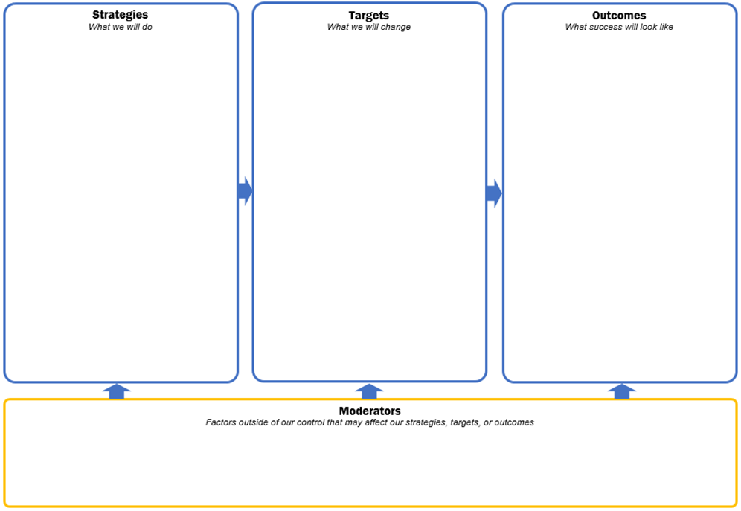

Examples from other counties
Road map for change
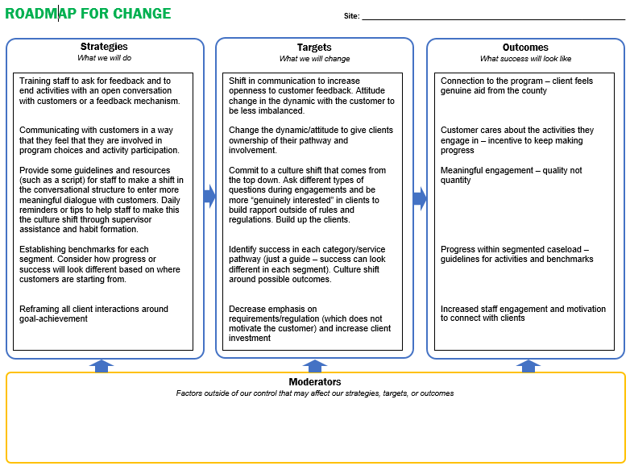
Staff survey
PART A - Basic information about the meeting |  | Complete this section for each meeting
1 | Staff member’s first name
2 | Date of meeting | MM / DD / Year
3 | How long did the meeting last? | # minutes
4 | Meeting type | Initial assessment  Orientation  Regular check-in  Workshop  Training/class  Other_____________
5 | What tools did you use during this meeting? | CalMAP  GPDR  My Road Map/Potholes and Detours  QOL Index  Didn’t use any of these tools
6 | Was this the first time you met with this customer during the road test period? | Yes  No [Skip to Part C]
PART B – Background information about the customer |  | Complete this section for the first  meeting only  Make correct skip patterns
7 | How long have you worked with the client? | # months
8 | How long has the customer received TANF cash assistance? | # months
9 | How would you describe the customer’s current engagement with your program? |  Fully engaged
 |  |  Partially engaged
 |  |  Not engaged
 |  |  Currently in sanction status
 |  |  New customer
10 | What best describes the customer’s current status or situation? |  Sanctioned
 |  |  Work ready
 |  |  In crisis
 |  |  Stable, but not work ready
 |  |  New customer
 |  |  Other ______________

PART B – Background information about the customer (continued) |  | Complete this section for the first  meeting only  Make correct skip patterns
11 | How would you describe the customer’s race/ ethnicity? |  American Indian / Alaska Native
 |  |  Hispanic / Latino
 |  |  Asian
 |  |  Native Hawaiian / Other Pacific Islander
 |  |  White
 |  |  Black / African American
 |  |  Other / Unknown
12 | What best describes the customer’s gender? |  Female
 |  |  Male
13 | What is the customer’s age? | # years
14 | How many children live with the customer? | # children
15 | Is the customer part of a two-parent household TANF case? |  Yes
 |  |  No
PART C - Feedback about the use of the tool during the meeting |  | Complete this section for each meeting
16 | Did the customer seem to understand the purpose of the tool and how it use it? |  Yes
 |  |  No
17 | How did the customer interact with the tool? |  Wrote on it
 |  |  Read it
 |  |  Held it
 |  |  Did not engage with it
20 | How long did the interaction with the tool last? | # minutes
21 | Did using the tool add time to your meeting with the customer? |  Yes
 |  |  No
22 | Did using the tool change the services you will offer this particular customer or the activities you will refer them to? |  Yes
 |  |  No

PART C - Feedback about the use of the tool during the meeting  (continued) |  | Complete this section for each meeting
For the following statements, please indicate the extent to which you agree or disagree with each.
23 | The customer seemed excited about and motivated by the tools. | Agree  Neutral or unsure  Disagree  Did not use this tool
24 | The tools made it easier for me to communicate with the customer. | Agree  Neutral or unsure  Disagree  Did not use this tool
25 | Using the goal-setting tools seemed to increase the customer's willingness to engage with me. | Agree  Neutral or unsure  Disagree  Did not use this tool
26 | I liked the script for using the tool. | Agree  Neutral or unsure  Disagree  Did not use this tool
27 | The tools made it easier for me to communicate with the customer. | Agree  Neutral or unsure  Disagree  Did not use this tool
28 | The tools were helpful in today's meeting. | Agree  Neutral or unsure  Disagree  Did not use this tool
25 | Is there anything unclear or confusing to you about using this tool?
26 | What change, if any, to the tool would have made your meeting today better?
27 | Feel free to provide any additional comments or reflections about your experience using the tool with this customer.
PART D – Did not use a tool |  | Complete this section for each meeting when no tool was used
28 | Why did you choose not to use the tool with the customer(s)?

Customer survey
Survey questions |  | Response options
1 | What tools did you use in your meeting today? (Circle all that apply) | Picture of CalMAP  Picture of My Road Map  Picture of Potholes and Detours
For the following statements, please indicate the extent to which you agree or disagree with each.
2 | It was easy to use the tools. | Agree  Neutral or unsure  Disagree
3 | I liked using the tools. | Agree  Neutral or unsure  Disagree
4 | The tools helped me. | Agree  Neutral or unsure  Disagree
5 | I liked the script for using the tool. | Agree  Neutral or unsure  Disagree
6 | Breaking my goals into smaller steps motivates me. | Agree  Neutral or unsure  Disagree
7 | The tools made it easier for me to communicate with the case manager. | Agree  Neutral or unsure  Disagree
8 | I don't want to use the tools. | Agree  Neutral or unsure  Disagree
9 | I'm excited to work with the case manager. | Agree  Neutral or unsure  Disagree
10 | I trust the case manager and feel like I could be honest with him/her. | Agree  Neutral or unsure  Disagree
11 | How long have you received TANF cash assistance? | # of months
12 | What did you like about the tools?
13 | How could the tools be improved?

Staff interview questions
Respondent
1 | Respondent, role
2 | Date (road test cycle)
General
3 | What do you think about the tools overall?
Process
4 | How are you using the tool during in-person meetings with customers? How do you introduce the tool? How do work with customers to use the tool?
5 | How, if at all, do the tools help streamline the work with customers?
6 | Do you use the tools with customers at every meeting or only some meetings? Which meetings and why? How much time passes between customer appointments when tools were used?
7 | Does the tool add time to the interaction with customers? If so, was the extra time worth it?
8 | To what extent have the tools changed your day-to-day work? How are you tracking the tools in client files?
Customer Experience
9 | To what extent have the tools changed the customers' experiences working with you?
10 | To what extent has the tool changed what services are provided? To what extent has the tool changed what activities you refer customers to?
11 | Thinking about the customers’ experience of using the tools with you, is this is a positive experience for them?
12 | What type of short-term goals have you seen customers set? What type of long-term goals have you seen customer set? Please share any examples that you can think of!
Training and Support
13 | What challenges have you faced using the tools?
14 | What additional supports or staff training would be useful to improve use of the tools?
15 | What steps or part of the script worked particularly well in using the tool? What was particularly challenging?
Changes Moving Forward
16 | What changes would you like to see made to the tools?
17 | What would you like to see changed about how the tools are being used with customers?
Example presentation summarizing road test results
