CalWORKs 2.0 Frontline Staff Guide
July 2018

Strategic Initiative Team

This page has been left blank for double-sided copying.

CONTENTS
Foreword By County Leadership vii
Information about this Guide ix
Section 1: CalWORKs 2.0 1
A. Goal-achievement framework 2
B. Intentional service selection 5
C. CalWORKs 2.0 tools 7
Section 2: CalWORKs 2.0 Tools and How to Use Them 9
A. Step-by-step process for meeting with customers 9
B. Triage tool 11
C. Quality-of-life index 13
D. CalMAP 15
E. Goal-storming activity 19
F. Goal, Plan, Do, Review/Revise (GPDR/R) Worksheet 20
H. My Road Map/Potholes and Detours 24
1. My Road Map 24
2. Potholes and Detours 25
I. Postcard reminder 29
J. Pocket reminder 31
K. Business process tools 32
1. 24-month counter 32
2. County resource map 34

This page has been left blank for double-sided copying.

NOTE TO COUNTY LEADERSHIP
You can customize this guide to reflect your county’s approach to implementing CalWORKs 2.0. Here are some ways you might want to modify this guide before distributing it to staff:
- Edit or rewrite the “Foreword by County Leadership” to reflect your county’s priorities and reasons for implementing CalWORKs 2.0.
- Modify the tools to meet your county’s needs (for example, add your counties’ name to the tool or change the phrasing of a question in a tool).
- Provide additional guidance about when and how you envision staff using the tools.
- Add your expectations about staff’s use of the tools.
- Remove sections describing tools that your county will not use (the tool sections are modular, so removing one section should not affect others).
- Remember that the use of these tools is OPTIONAL. Select only the tools that will help you move toward your county’s goals and that will fit best into your existing processes and case flow.
- Revise language to match your county’s preferences (for example, this guide uses the word customer throughout, and perhaps your county prefers to use client).
Be sure to delete this page and other Notes to County Leadership throughout the guide before distributing it to your staff.

This page has been left blank for double-sided copying.

Foreword By County Leadership
Note to County Leadership (delete before sending guide to staff)
This is a placeholder. We strongly suggest your county’s leadership write an inspirational letter to staff that describes:
- Why your county chose to implement CalWORKs 2.0
- How you are hoping to shift service delivery and program culture
- Any new or different staff expectations
- Any county-level changes

Dear CalWORKs staff member,
Twenty years ago, California was at the forefront of implementing work programs for our families receiving cash assistance. In the coming months, we will again embark on an effort to lead the country in a new approach to delivering services to our CalWORKs families. This effort, which we refer to as CalWORKs 2.0, combines all we’ve learned over the past 20 years with new evidence on ways to deliver services more effectively to families whose lives are negatively affected by living in poverty.
Our goal is to strengthen the work that you do every day, with an eye toward improving outcomes for our families, especially those we have failed to reach using our current approach. Our new CalWORKs program will focus on setting and achieving goals, from the county level all the way down to the customer level. This new approach requires a shift compared to how we’ve delivered services and measured progress in the past. Under the new framework, measures of success will be broadened beyond the WPR to include customers’ progress on their goals and skill-building.
We are proud to be part of an initiative that puts us at the forefront of using science to inform the way we deliver our services. We recognize that change is never easy and we would like to personally thank you in advance for giving this initiative your all. Our internal CalWORKs 2.0 team is here to help you make the transition. Together, we will work to build on the great work that you already do to help our families set and achieve goals that are meaningful to them and within their reach.
Thanks again for implementing this important work!
[Insert names of CalWORKs County Leadership]

This page has been left blank for double-sided copying.

Information about this Guide
Description: This guide is for frontline staff. It includes two sections:
- A background section on CalWORKs 2.0, including the goal-achievement framework underlying it
Directions on how to integrate CalWORKs 2.0 into your work with customers, including detailed descriptions of tools that help facilitate a family-centered goal-achievement approach to serving families
Purpose: This guide describes CalWORKs 2.0 and provides instructions for using the tools.
When to use this guide: When you are learning about CalWORKs 2.0 and when you are implementing CalWORKs 2.0 with customers.
How to use this guide: Read through this guide when you first receive it. Make sure you understand the principles behind successful goal achievement in the background section before turning to any of the tools. Once you have a basic understanding of effective goal achievement, read about the tools and when and how to use them. After you’ve read it once, keep the guide handy while working with customers. You can refer to the graphic on page 8 to help yourself decide which tool might be appropriate to use, depending on the nature of your interaction with customers. If you want to be reminded how to use a certain tool, re-read the text on that tool in Section 2 and refer back to the website training videos.
What successful use of this guide would look like: You can describe the CalWORKs 2.0 principles to co-workers and customers and how it differs from your work in the past. You understand the principles behind successful goal achievement and can apply them broadly (that is, for any type of goal). You have a good understanding of the different CalWORKs 2.0 tools and when to use them. You refer to the guide whenever needed to make decisions about how and when to use specific tools with customers.
How to get more information: Visit the CalWORKs 2.0 Next Generation website (http://calworksnextgen.org/). There you can:
- Refer to training videos to see how the tools are ideally used with customers
- View webinars that provide a deeper background on the science behind CalWORKs 2.0 and the goal-achievement framework
- Use the Peer Forum to chat with colleagues in other counties about all things CalWORKs 2.0.

This page has been left blank for double-sided copying.

Section 1: CalWORKs 2.0
The CalWORKs program has made significant changes over the past 25 years in response to economic, budgetary, and political forces. Some of these changes have expanded the options available for helping customers and even resulted in customer success. However, there is room for additional improvement. The current compliance-oriented, directive case management approach has had limited success. Recognizing this, the County Welfare Directors Association of California launched an initiative to incorporate emerging research evidence on brain science, behavioral science, and best practices on how adults learn and build critical skills.
CalWORKs 2.0, a new framework for delivering CalWORKs services, emphasizes goal achievement and intentional service selection, and considers the circumstances and needs of the entire family.
Known as CalWORKs 2.0, this new approach focuses on helping people set and achieve their goals, which requires an environment with flexibility and a shift from directive case management to customer-led case management focused on goals. The redesigned approach will help families set goals that are aligned with program aims while taking into account families’ strengths and the obstacles they face. With CalWORKs supports and services, some customers are able to begin immediately, but others need time to resolve crises and address significant challenges before they can progress. CalWORKs 2.0 emphasizes the importance of engaging in activities on the way to full employment. While this is a fundamental shift for some counties, other counties may already be implementing some of these concepts into their current work.
The design of CalWORKs 2.0 draws from emerging research in several complementary fields:
- Adult capabilities: Long-term exposure to the stresses of poverty affects adults’ core capabilities (such as organizing, planning, self-control, and monitoring). Core adult capabilities are best improved through supportive relationships that empower people to make choices that are meaningful to them.
- Goal achievement: Working on goal achievement can ultimately have a positive effect on self-sufficiency. Adults are more likely to achieve goals when (1) they set goals that are meaningful to themselves; (2) the goals are specific, short-term, and within their reach; and (3) plans are in place to address roadblocks before they occur.
- Behavioral science: Living in poverty imposes a “bandwidth tax” that limits people’s ability to see and plan for the future. Programs can increase success by streamlining requirements, removing unnecessary hassles, and ensuring that communications focus only on the most important information.
- How adults learn: Adults need to do something with new information in order to learn. Learning happens when people focus on what is most relevant to their life now. Adults are more likely to make changes in their life when staff engage in supportive (rather than directive) relationships.

A. Goal-achievement framework
In a goal-achievement focused program, families set individual goals that are meaningful to them and aligned with program aims, but are realistic given their strengths and challenges. When customers are working on goals that are meaningful to them and within their reach, they may be more likely to participate and stay engaged long enough to progress. In contrast, when customers are required to participate in activities that do not directly address their current circumstances, they are unlikely to follow through. The clear messaging of each interaction should be: “CalWORKs is here to help you set and achieve your goals.”
The message for customers is: “CalWORKs is here to help you set and achieve your goals.”
The CalWORKs 2.0 goal-achievement framework is built on a four-step process that, if practiced regularly and with fidelity, will build skills and make setting and achieving goals easier and more effective. Any meeting with a customer can cover one or more steps. The four steps are always in the same order:
- Goal: Set a goal—something that customers wants to accomplish and is within their reach.
- Plan: Create a road map for how to achieve the goal and identify obstacles and solutions.
- Do: Put the plan into action.
Review/Revise: Assess what was achieved and what wasn’t; make a new plan, modify an existing goal, or set a new one.
The framework relies on the idea that successful small steps will lead to better long-term outcomes. Using the CalWORKs 2.0 tools, customers can set and achieve goals and benchmarks (such as showing up for appointments, calling and connecting to service referrals, completing job readiness training, attending job fairs, and attending mental health counseling) on the way to meeting longer-term goals like full-time employment. Applying a customer-driven goal-achievement approach is more motivating for customers than a compliance-driven approach and will help customers stick with their planned activities.
While working with customers, there are many ways to do your work through a goal-achievement lens:
- During an intitial meeting, customers can reflect on their strengths and challenges, set goals, and make plans to achieve their goals.
- Workers and customers can check in about the goal progress and review or revise the goal.
- All interactions with customers and all work-related activities are suitable for the goal-achievement process.
GOAL-ACHIEVEMENT PRINCIPLES
GOAL SETTING
Goals need to be personally meaningful and motivating.
- Visualizing the outcome makes the goal feel real and builds motivation to achieve it.
- Goals must be challenging, but still within reach—goals that are too easy are un-motivating, and goals that are too hard are abandoned out of frustration.
- Goals must be specific and have a clear target and timeline.
- To develop a goal habit, set (and review goals) daily or weekly.
- If needed, reframe CalWORKs activities as opportunities to pursue goals that are meaningful to the customer.
GOAL PLANNING
- Write down plans to make them stick.
- Commit to goals by sharing them with others, an action that holds us accountable.
- Break long-term goals into shorter, more manageable goals or steps; short-term goals are more motivating than longer-term goals.
- Be specific and include the details of when you will complete each step.
- Encourge the customer to think about the support and resources needed to reach the goal.
- Identify obstacles that may get in the way of achieving the goal and develop solutions for each obstacle.
GOAL DOING
- Help customers achieve their goals by:
Walking customers through their action plan at the end of the planning session
- Helping customers develop their own reminder system
- Providing regular reminders
- Providing opportunities to practice working on their goal
- Reducing program burden on customers
- Helping customers address and manage stress
- Providing lots of encouragement and feedback
GOAL REVIEWING AND REVISING
- Review: How did it go?
- Revise: What did you learn? What will you do moving forward?
- Create a learning environment:
- Be strengths-based: What went well?
- Emphasize the learning: What did you learn about yourself or your obstacles?
- Be forward-looking: What can I do differently next time?
- Convey these messages to build skills:
- Success is starting!
- There is no failure only feedback.
- We rarely get goals or plans right the first time we try.

Why this approach to goal achievement is different
Most human service programs touch on goal-setting and planning with customers along with activities such as removing barriers (for example, childcare referral), job search, and training referrals. Research suggests that a focus on these common activities is likely not enough to accomplish real change. Instead of requiring every customer to do the same activities at the same pace, the Goal, Plan, Do, Review/Revise (GPDR/R) framework focuses on empowering customers to set and achieve their own goals. With use, interactions between staff and customers can become more relational and less transactional. Here are highlights of how each stage of the GPDR/R process differs from current practice.
Goal | - Customers set goals, not the program or staff  - Staff act as facilitators, not fixers  - Staff guide customers beyond generic goals to personally meaningful goals within the customer’s control  - Staff help customers build confidence with success in achieving feasible short-term goals  - Staff suggest ways customers can use program activities and services to help achieve their goals
Plan | - Staff guide customers to develop specific, yet simple plans (including what, when, where, and how)  - Staff help customers identify strategies to overcome potential obstacles before they happen  - Staff work with customers to write their plans down and rehearse them
Do | - Staff provide support and encouragement when customers are doing their plans  - Staff design opportunities for customers to support and encourage each other  - Staff offer opportunities for customers to build and practice skills they need to remain focused on goals and do their plans  - Program components with frequent contact (job search, work experience or subsidized employment) offer skill building opportunities related to goal achievement
Review/Revise | - Staff focus customer check-ins on assessing how things went and how it relates to moving forward  - Plans are viewed as living documents that change as customers learn more about their strengths and become clearer about what matters most to them

B. Intentional service selection
For goal achievement to be successful, counties must provide services in a reimagined service environment that takes into account a family’s circumstances, strengths, challenges, and goals. Through Intentional Service Selection (ISS), workers consider each customer’s unique circumstances and goals as a starting point for developing their welfare-to-work plan. Depending on the starting point, each customer has a different pathway to work. ISS means tailoring services and activities to customers in a way that will motivate them to participate in the program and eventually transition into employment.
This sometimes translates into “ramping up” participation over time. Under ISS, some customers may not meet the work participation requirements right away. By taking customers’ unique needs and circumstances into account, workers and customers are developing a plan that has the highest chance of success and sustainability over time.
ISS PRINCIPLES
All interactions with customers
Prior to the meeting, review the customer’s file and case information.
Use safe and effective communication:
Always communicate respect for the customer.
Remember that choice is key to motivation.
Express empathy through reflective listening: paraphrase, summarize, and prompt customers for detail.
If you sense resistance, don’t assume you know why the customer is resistant. Instead, ask questions that allow the customer to share what he or she is thinking.
Support the customer in taking the lead.
Encourage optimism and forward thinking.
Facilitate a meaningful conversation with customers.
Intake, assessment, and appraisal interactions
Try to draw out details from customers, listen to their situations and priorities, and ask about their goals.
As the customer feels comfortable, discuss areas of need related to key work readiness factors, such as:
Physical health
Mental health
Safety
Housing
Child care
Transportation
Note the areas of need the customer describes as most urgent (not the areas that you think are the most urgent).
Discussing activities and referrals
Present options to the customers, explain how they relate to observed needs, and collaboratively derive a plan.
Collaboratively and fairly assess their readiness to start work-like activities.
Be open to helping them construct a plan that builds skills steadily, perhaps increasing required hours each week, rather than immediately starting with all required hours.
Allow customer choice in what activities he or she begins with.
Focus on activities that are the most appropriate, given the goals the customer has articulated.
Be clear about program requirements, but do not be directive about how the customer is to meet them. Provide as many options as possible within the scope of what is available.
Do not lead with work-like activities, unless that is where the customer wants to begin or the activities do not present areas of significant need.
Connect customers to any referrals or activities available (within the CalWORKs regulations) to directly address their needs.
Always ask yourself the questions:
Does this service or activity build skills or address customer needs?
Does this service or activity meet the expressed goals of the customer?
Can I describe this activity to customers in a way that clearly demonstrates how CalWORKs helps meet their expectations and goals?
Monitoring the customer’s progress
Celebrate success.
Start by prioritizing what the customer wants to discuss and avoid being directive in suggestions for moving forward.
Use a structured approach to meetings (for example, following the GPDR/R framework described above).
Be responsive; model key skills (such as organization, planning, self-control) during interactions with the customers.
Maintain a positive conversational tone.
Frame setbacks or challenges as feedback opportunities, not failure.
If no progress was made, or if the customer faced a setback, ask whether something about his or her situation changed and use new information to adjust the customer’s plan, as appropriate.
Modify plans based on any new challenges or new goals.

C. CalWORKs 2.0 tools
The goal achievement process is the foundation of CalWORKs 2.0 and should be the focus of interactions with staff. But when working through the process, it can be helpful to have a way to document the discussions in each stage. Several tools are available for you to use as you work with customers (1) to model for them and teach them how to successfully set and achieve goals, and (2) to take the customers’ goals and current circumstances into account as you chart a path for them in the CalWORKs program. The tools, and how and when to use them, are described in detail in Section 2 of this guide. The following figure can be used as a quick-reference guide.
As you prepare for a meeting with a customer, refer to this figure to determine which tool might be appropiate to use with the customer. The figure does not list all possible types of interactions with customers, and the tools can also be used during other types of customer interactions. At first, it may be time consuming to introduce and use the tools. It may also feel awkward. With practice, you will become more comfortable with the tools, and using them should feel natural. As needed, discuss any issues with your supervisor.
Figure 1. Suggested tools for different customer interactions
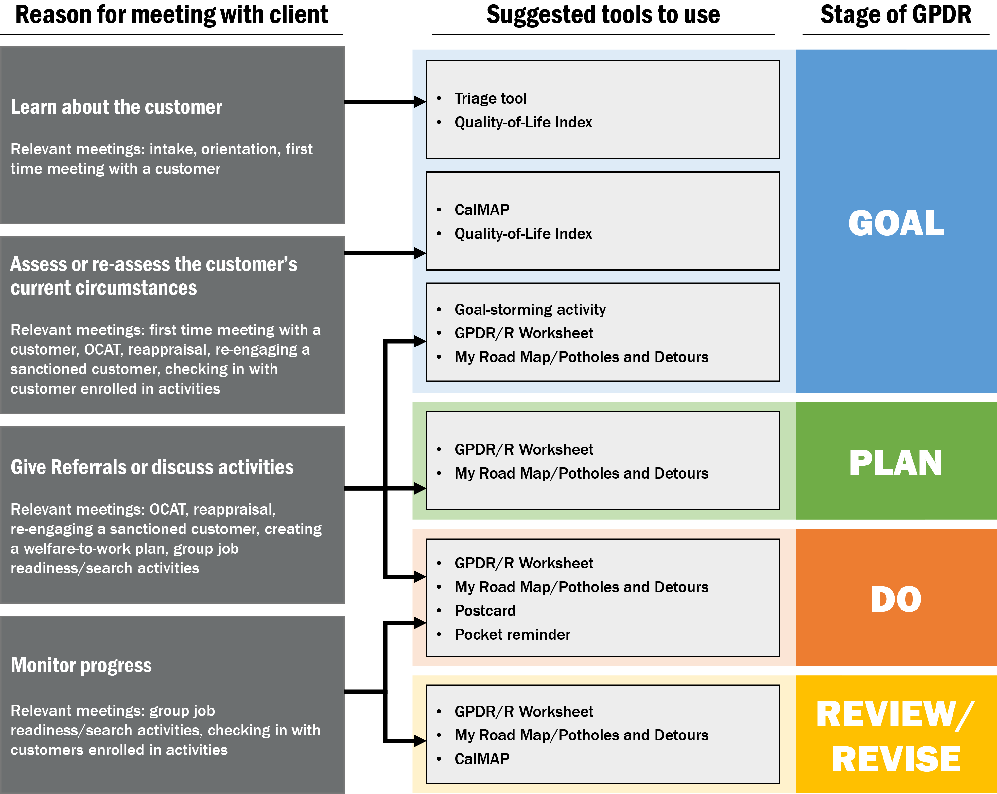

Section 2: CalWORKs 2.0 Tools and How to Use Them
Note to County Leadership (delete before sending guide to staff)
All these tools are OPTIONAL. Counties should pick which tools to use in their own implementation of CalWORKs 2.0. To decide which tools to use, use the county-level guide and county-level tools to carefully consider your county’s needs, goals, existing processes, and case flow. Then select the tools that will help you move toward your county’s goals and that will fit best into your existing processes and case flow. Some counties may already have tools and processes that fulfill a similar function to the CalWORKs 2.0 tools. In these situations, counties should select tools carefully and avoid using multiple tools for the same purpose.
Counties should also modify the tools to fit their needs. For example, counties may want to add a space to the tools for staff to write down the customer’s case number or other tracking number.

This section describes the CalWORKs 2.0 tools and presents detailed guidance on how to use them. The four-step goal achievement process should be the focus of your work with customers. The tools are designed to simply help you document the process laid out in Section 1. For each tool, use the general process that follows. More details about how to use the individual tools are described in the following sections. Using the tools should help streamline your meetings with customers.

A. Step-by-step process for meeting with customers
- Do the following before the meeting:
a. Determine the purpose of the meeting.
b. Identify which stage or stages of the GPDR/R process the meeting will focus on. If you aren’t sure about the correct stage, start with the goal setting stage.
c. Decide which tools will help you document the GPDR/R process by referring to Figure 1 above.
- Begin the conversation by discussing the purpose of the meeting with the customer.
- If needed, introduce the customer to the GPDR/R process. Refer to the information in Section 1 of this guide.
- Facilitate a conversation with the customer focused on the stage or stages of the GPDR/R process you identified as the focus of the meeting.
- Provide a hard copy of the tool to the customer.
- If the customer has not used the tool before, introduce the tool to the customer by describing its purpose and how to use it. See the sections below for this information about each tool.
- Answer any questions the customer may have about the tool.
- Use the tool to summarize your conversation with the customer. If needed, discuss more details. See the sections below for more information.
- Depending on the purpose of the meeting, ask probing questions during the conversation. For example:
a. What are your hopes and dreams for the future?
b. What are your strengths?
c. What has been challenging in the past for you?
d. What do you need to be successful?
e. Would you tell me more about that?
- Either the customer or the worker fills in the tool.
a. The tools may be either completed by the customer and reviewed by the worker, or completed by the worker in conversation with the customer.
b. If the customer is able, we recommend the customer complete the tool, because this encourages the customer to build ownership of his or her goal and the process for achieving it.
c. For customers who have limited ability to read or write, or who otherwise need assistance filling out forms, it may be more appropriate for the worker to fill in the tool.
- Give customers a copy of the tool to take with them. Keep a copy for yourself in the case file.
- As necessary in future meetings, revisit the tool to re-assess the customer or monitor progress:
a. Provide the customer with a copy of the tool he or she previously completed.
b. Ask the customer to update the tool with any new information and have a conversation with the customer about any changes. If there are extensive changes, ask the customer to fill out a new tool.
c. Celebrate any progress with affirmation and praise; reassure the customer if he or she has experienced any challenges.
d. Complete the tool, and again, give the customer a copy of the tool and keep a copy in the case file.

B. Triage tool
Purpose: The triage tool collects key information from customers that program staff need to know to best direct customers to specialized programs or to make urgent service referrals. The tool is designed for counties with specialized staff. The triage tool should be modified, by adding or deleting questions, to collect the information your county needs to assign customers to specialized staff.
Description: The one-page triage tool has a series of questions for customers to fill out. There is a place for the customer’s name, his or her signature, and the date.
When to use:
- Goal setting: The triage tool can help you learn quickly about customers to connect them to emergency services and set appropriate goals. For example, you may ask the customer to fill out the triage tool during intake or immediately following eligibility determination (and before administering OCAT) to help manage crises immediately. It may be implemented as part of the orientation process to quickly determine what worker might be the best fit for a customer. This tool can also be used by frontline staff members in their first meeting with a customer.
How to use: Print out the triage tool and ask customers to fill it out. Explain that the tool will help you learn about them. When introducing the tool to customers, you may find it useful to say: “The triage tool is designed to help me get to know you better and identify which programs and services we offer may be able to help you.
Note: Several of the triage tool questions are very similar to those asked in OCAT. If using this tool after the OCAT assessment, the worker who administers OCAT should review the customer’s triage tool responses and incorporate them into the OCAT platform so that similar questions are not re-asked.
What successful use would look like: All customers are quickly and systematically referred to specialized programs—such as the Family Stabilization Program or Housing Support Program— or assigned to specialized workers as appropriate.

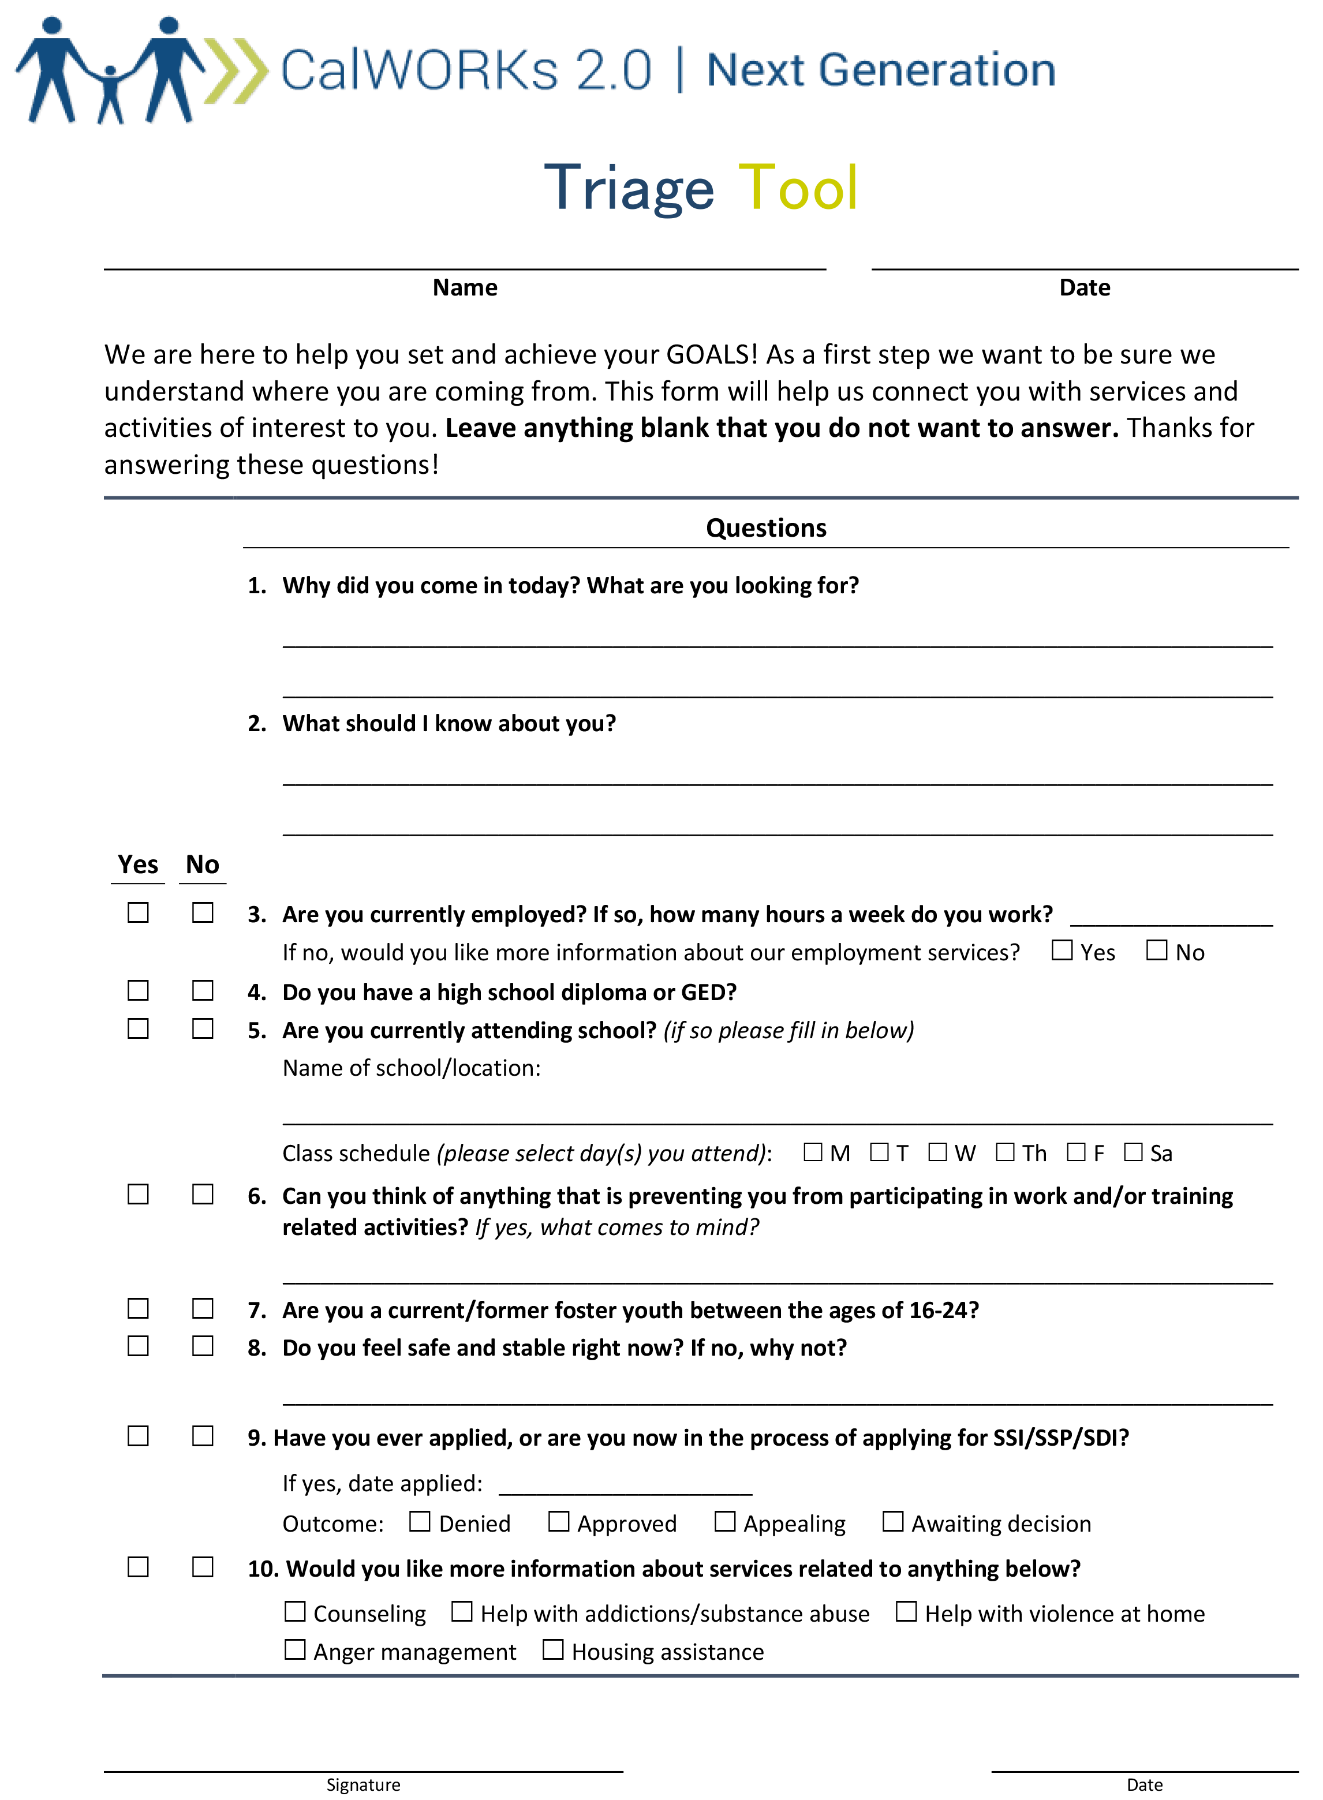

C. Quality-of-life index
Purpose: The quality-of-life index provides a validated benchmark for quick learning about how a customer currently feels about his or her quality of life. This method of measuring meaningful change at the individual level (comparing people with themselves, but not with others) over time has been tested in many nations and cultures.
Description: The one-page quality-of-life index is a simple 10-item visual scale measurement. For each of 10 items, customers place an X at the place on the line that best describes their current situation.
When to use:
- Goal setting: Use the quality-of-life index when you want to assess customers’ current situation and use that information to help them set an appropriate goal.
- The quality-of-life index can be used at any time, including before the OCAT.
- It may be particularly useful if you have concerns about a customer’s social or emotional well-being and support system.
- By asking customers to fill it out on a regular basis, you create a standardized history of customers’ perceived quality of life over time.
How to use: Print out the quality-of-life index and ask customers to fill it out. Ask customers to share some information about why they responded the way they did. Be aware that they may not want to discuss some topics and that this is okay. Allow them to lead the conversation and share information they feel comfortable sharing.
- Using it with new customers: Introduce the quality-of-life index as a way to get to know them. Say something like: “The quality-of-life tool will help me understand your current circumstances.” You may want to pay particular attention to questions #1–#7, because the answers can give you a sense of what referrals may be most useful. Alternatively, ask them to explain more about how they answered question #10 and why.
- Using it with ongoing customers: Introduce the quality-of-life index as a way to check in about their overall well-being. Say something like: “The quality-of-life tool will help me understand your current circumstances.” Throughout your work with customers (such as at case management visits, reappraisal appointments, or renewal), you can revisit the index to check on their well-being.
What successful use would look like: Workers have information about customers’ overall well-being. Customers are able to reflect about their well-being over time. Workers and customers have the information needed to consider goals that may be appropriate for the customer.

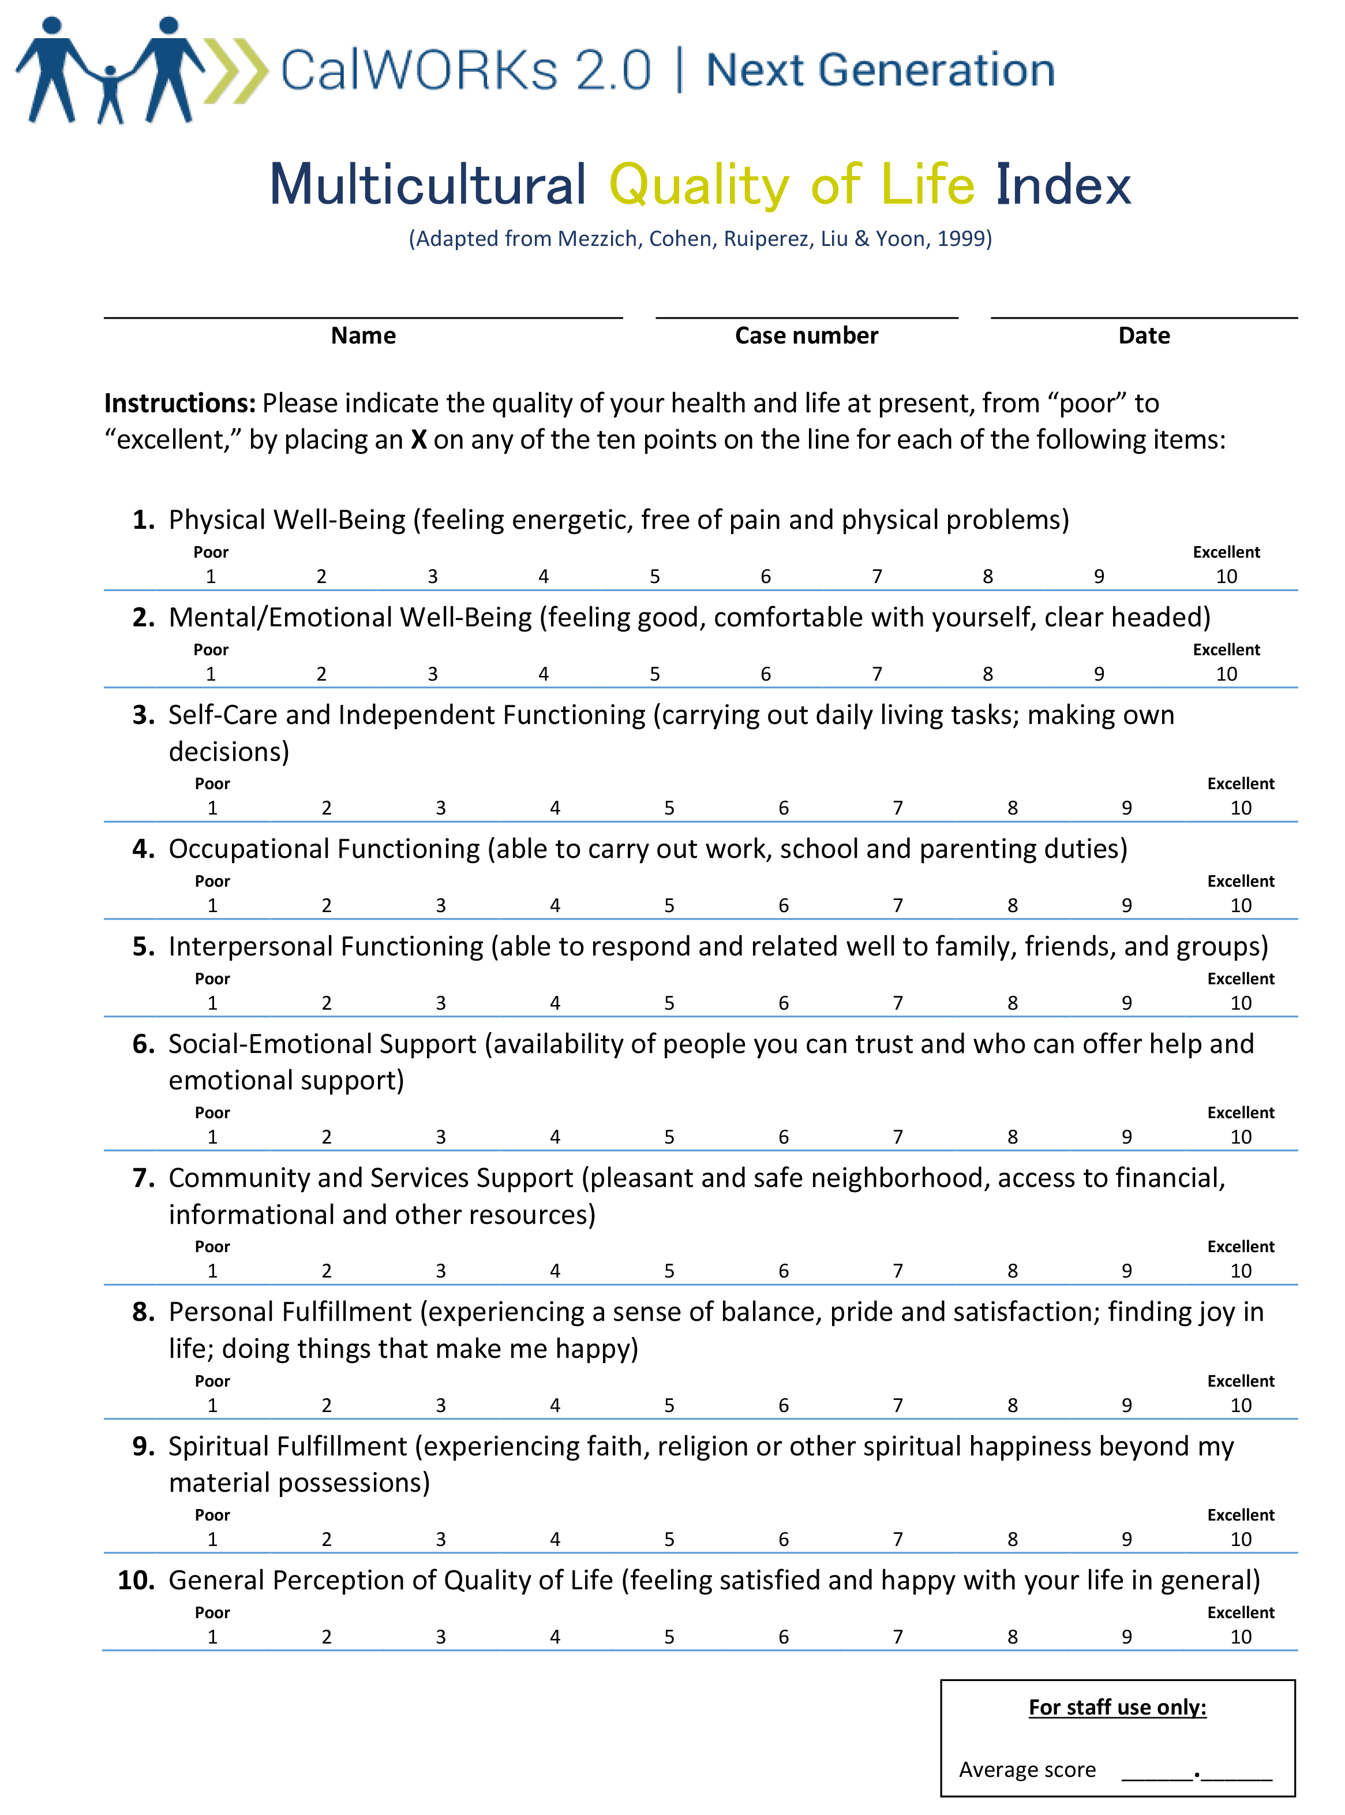

D. CalMAP
Purpose: The CalMAP presents a holistic “at a glance” visual representation of customers’ areas of strength and need and can be created in just a few minutes (unlike the OCAT). Having a better sense of where customers are and the urgency of their challenges can help you prioritize services and opportunities. The CalMAP also gives customers a way to reflect on their current circumstances and, by updating the CalMAP over time, track their progress across a number of life areas.
Description: The CalMAP summarizes customers’ strengths and needs in a variety of life areas in an easy-to-understand, one-page format. The first column of the CalMAP contains three life areas, which are further subdivided in the second column. The remaining columns contain descriptions of the degree of need or strength for each life area:
- Area of significance, which may need immediate or specialized services
- Area of need, which can be addressed through regular CalWORKs services
- Stable—there is no immediate need, but the situation could use improvement
Thriving—an area of strength
When to use:
- Goal setting: Use the CalMAP to learn about customers so you can help them set appropriate goals. You can use the CalMAP before, during, or after the OCAT assessment.
- If you are meeting with a customer for the first time, you can use the CalMAP to learn more about your customer’s perspective on key priorities before doing a deeper dive using OCAT.
- If the OCAT is completed first, the customer’s responses can be used to complete the CalMAP, and OCAT Summary Report recommendations can be recorded in the CalMAP Action Plan column.
- For customers that completed an OCAT some time ago and are returning from sanction, time-off aid, or good cause, CalMAP serves as a quick, comprehensive assessment of current circumstances that can be completed more quickly than a new OCAT appraisal.
- Goal reviewing/revising: The CalMAP can also be used to monitor a customer’s progress on goals by asking the customer to fill it out on a regular basis. For example, the CalMAP can be used every few months when customers are receiving services to help them reflect on their life and goals in a focused way and on their ability to succeed at work and visualize their progress.
How to use: Give a hard copy of the CalMAP to the customer.
- Introduce the tool by saying something like: “The CalMAP shows how someone is doing in some key life areas. I’d like to talk through each life area with you now, and together we can identify which category best describes your current situation.”
- While you have a conversation about each life area, ask customers to mark an X or circle the column (area of significant need, area of need, stable or thriving) that best reflects their current situation.
  - During the conversation, use trauma-informed approaches, such as promoting safety, supporting customer control, and modeling healthy relationships.
- In the action plan column, add notes that describe next steps or services.
- Both you and the customer can use the filled-in side of the CalMAP (full version) as a reference during the conversation to help place the customer’s comments in the appropriate column.
- If using the CalMAP after the OCAT has been conducted, have the OCAT findings nearby during the conversation.
- Focus on facilitating a meaningful conversation and avoid a back-and-forth question-and-answer process.
A few counties have used the CalMAP to track a customer’s progress in key life areas over time. To do so, these counties are calculating a CalMAP score. On the CalMAP, the columns are worth 1 to 4 from left to right (area of significant need is worth 1, area of need is worth 2, stable is worth 3, and thriving is worth 4). Assign a value to each row and sum up to arrive at a final score, which will range from 11 (significant need in all eleven life areas) to 44 (thriving in all eleven life areas). Higher scores mean the customer is doing better. The CalMAP is designed to be conversational, so do not score the CalMAP in front of the customer.
What successful use would look like: Customers and workers have a clear understanding of the customer’s current circumstances and areas of strength and need. Customers feel comfortable sharing important information. Over time, customers make progress on life areas of need and move toward the right (on the CalMAP) in more life areas.

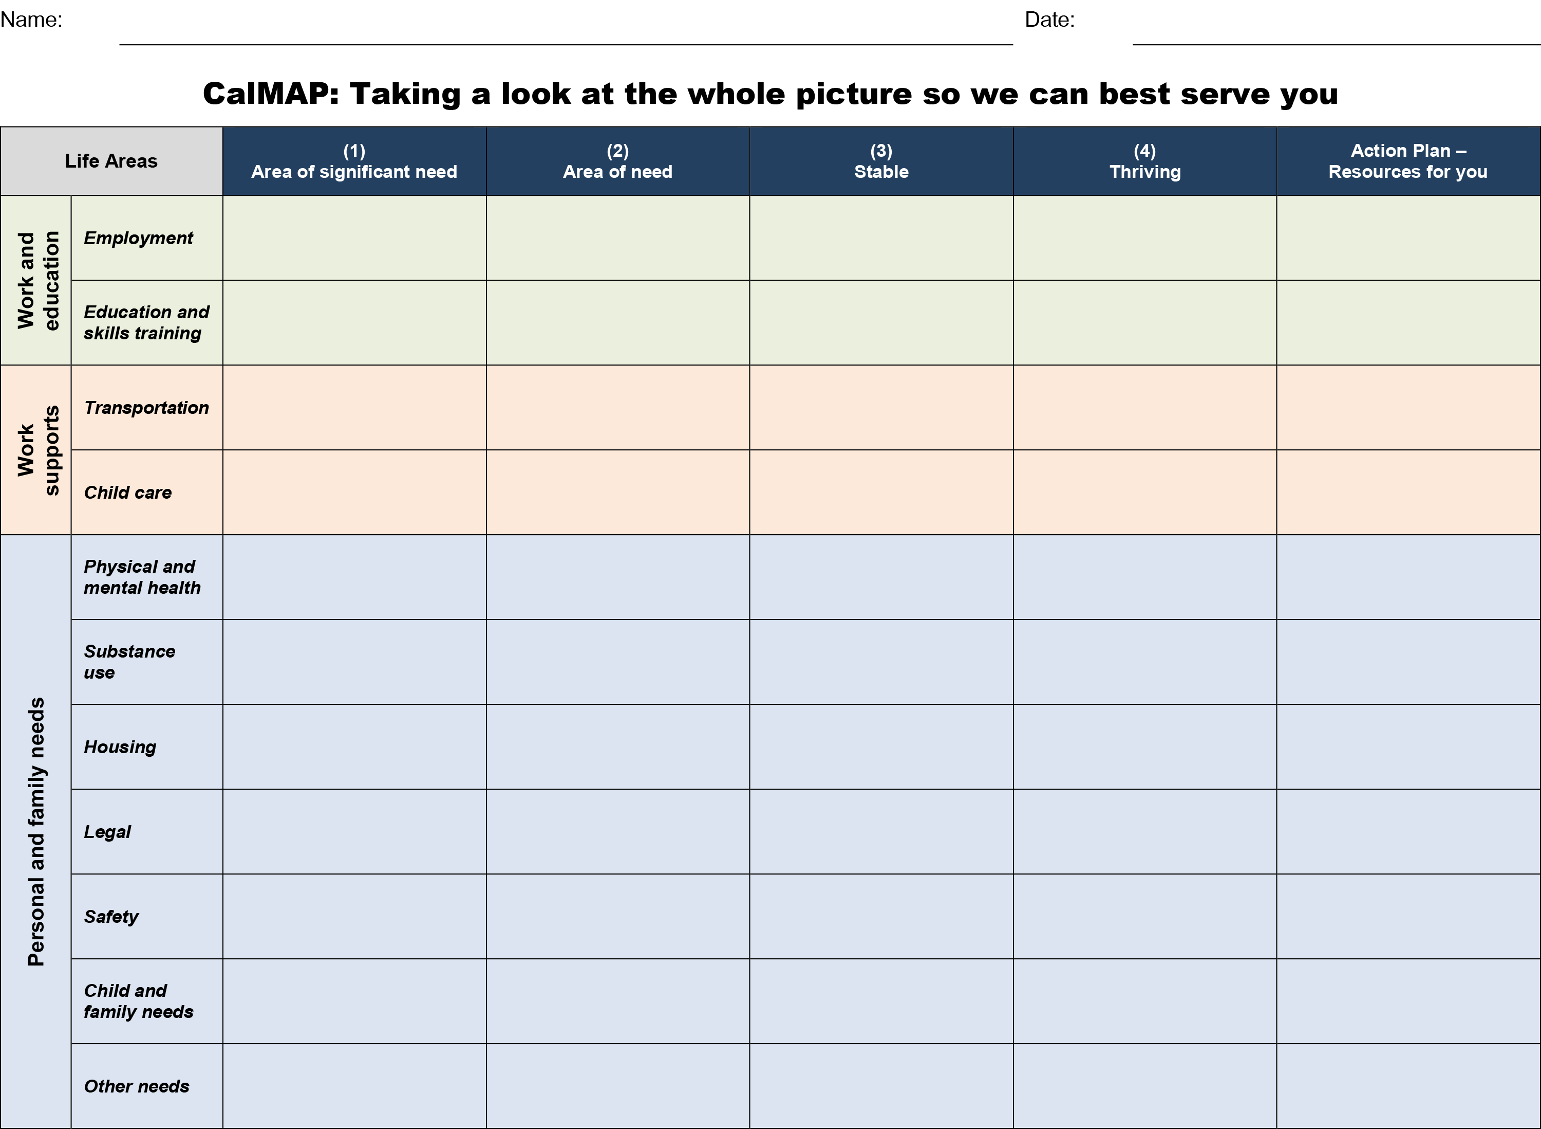

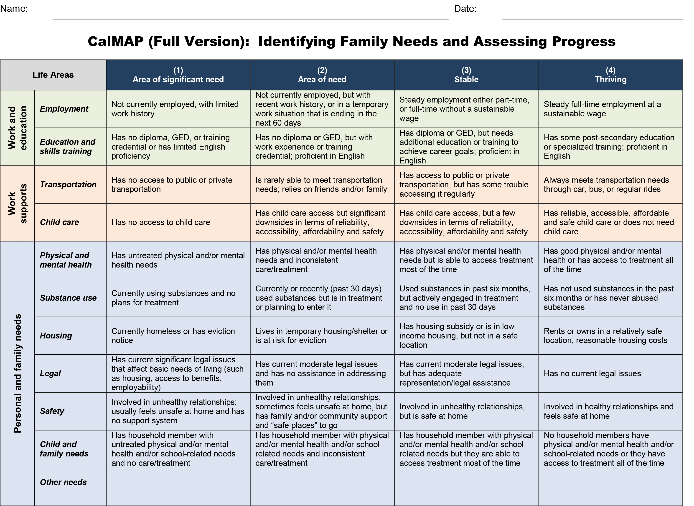

E. Goal-storming activity
Purpose: Goal storming helps customers identify a goal. Successful goal achievement requires a personally meaningful goal. CalWORKs customers may be unable to clearly see a different future for themselves or, more importantly, be unaware of goals that matter to them. Some may never have been asked what their personal goals are. As a default, they follow the program goals that are explicitly or implicitly defined for them. Goal storming gives customers the freedom to explore an alternative, hopeful view of their lives and begin working with their CalWORKs worker to generate ideas for realizing that long-term vision.
Description: There is no tool corresponding to this activity. All you need are sticky notes. During the activity, customers will generate ideas in three core areas: (1) what they want their future life to be like, (2) potential action steps, and (3) the resources needed to achieve the written future.
When to use:
- Goal setting: Use the goal-storming activity when the customer is having a hard time identifying a goal.
How to use: Follow the steps below to help customers brainstorm their hopes, dreams, and goals for the future. This goal-storming activity can be used with customers individually or in a group.
- Tell customers that it can be hard to identify and prioritize our goals. Let them know that this activity will help them through this process.
- Give customers a set of sticky notes and a pen/pencil/marker.
- Invite customers to write down how they would like their work and life to be different within a designated period of time—one change per sticky note. Keep the time horizon no longer than six months. Give them three to five minutes for the task.
- If customers are having trouble identifying their goals, encourage them to think about the following: education, housing, physical and mental health, employment, children, and family. You could also offer customers the CalMAP or the quality-of-life index to help them get started by thinking about these life areas.
- From the pool of potential changes, ask customers to prioritize two or three changes (goals) that they would like to achieve. These should be challenging but achievable with effort.
- Now, ask customers to select the one goal that is most meaningful to them.
- Ask customers why that goal is meaningful to them and how their life might be different if they achieve it.
- If in a group setting, invite customers to share with each other why the goal is meaningful to them. Don’t require everyone to share with the group.
What successful use would look like: Customers are able to describe what they’d like their future to look like and have a good understanding of the steps and resources needed to achieve that future. Customers have ideas for goals.

F. Goal, Plan, Do, Review/Revise (GPDR/R) Worksheet
Purpose: This simple worksheet combines all the available research evidence on how to most effectively identify, plan for, and accomplish goals. It also imbeds executive functioning skills development in the process of following the steps. This worksheet helps a customer identify one meaningful short-term goal and is the core of the CalWORKs 2.0 goal-achievement tools. By short-term goal, we mean a goal that can be accomplished either the same day that you meet with the customer or within a few days.
Description: The GPDR/R worksheet is a two-page document with sections for each of the four stages of goal achievement.
When to use: The GPDR/R worksheet is for short-term goals, meaning those goals that do not have multiple steps and can be used during any interaction with a customer and for any stage of the GPDR/R process. We recommend this tool for when there is frequent interaction between staff and customers, such as if they are attending a week-long job search workshop. Using the GPDR/R worksheet may help the customer build on the success of completing short-term goals.
- Goal setting: After you have a good sense of the customer’s current circumstances, use the GPDR/R worksheet to help the customer set short-term goals. The best goals are specific, meaningful to the customer, and achievable with some effort. This may begin as early as the first customer engagement and should be repeated throughout service delivery.
- Goal planning: Customers can also write down their plans to achieve their goals. Goal achievement is more likely when a person writes down any intermediate steps and identifies potential challenges and corresponding solutions.
- Goal doing: Customers can follow the plan on the GPDR/R worksheet to help them stay on track.
- Goal reviewing/revising: When a short-term goal has been set, check in with the customer about progress on the goal at all follow-up and check-in appointments. Ideally, this would be as frequently as weekly or even daily for customers looking for work, and even more frequently for individuals and families in crisis. Established customers with good goal-setting habits, those working in unsubsidized employment without issue, or those enrolled in an education or training program may be okay with less-frequent goal review.
How to use: Print a copy of the GPDR/R worksheet and give it to customers for them to write on. Introduce the worksheet by saying something like: “We all have ideas, or goals, for how we’d like our life to change. The GPDR/R worksheet is a place to write down goals, figure out a plan to achieve goals, and then check in about whether the goal was achieved.”
- Using for the first time with a customer: Start by sharing that for many people, setting and achieving goals is difficult. But emphasize that customers who follow the four-step process outlined here will increase their chances of success. Step customers through filling out the worksheet. Refer to the goal-achievement principles on page 3 for more information about each step. This process can be used with daily job search goals, daily life goals such as getting children to school on time, and other short-term goals that may require more effort to achieve. If customers are having a hard time identifying a goal, use the goal-storming process to identify goals.
- Using with customers that already filled out a GPDR/R worksheet: Check in with the customer about progress toward the goal. Start by reminding the customer that we rarely get things right on the first try, and that plans and goals are made to be revised. Then review with the customer about what happened and what the customer learned. Be sure to have a copy of the filled-out worksheet.
What successful use would look like: While beginning to use the GPDR/R worksheet, customers are able to set goals, identify potential obstacles and challenges, and reflect thoughtfully on what they’ve learned about setting and achieving goals. After using the worksheet for a little while, customers become quicker and more comfortable with the goal-setting process and see progress on their goals.

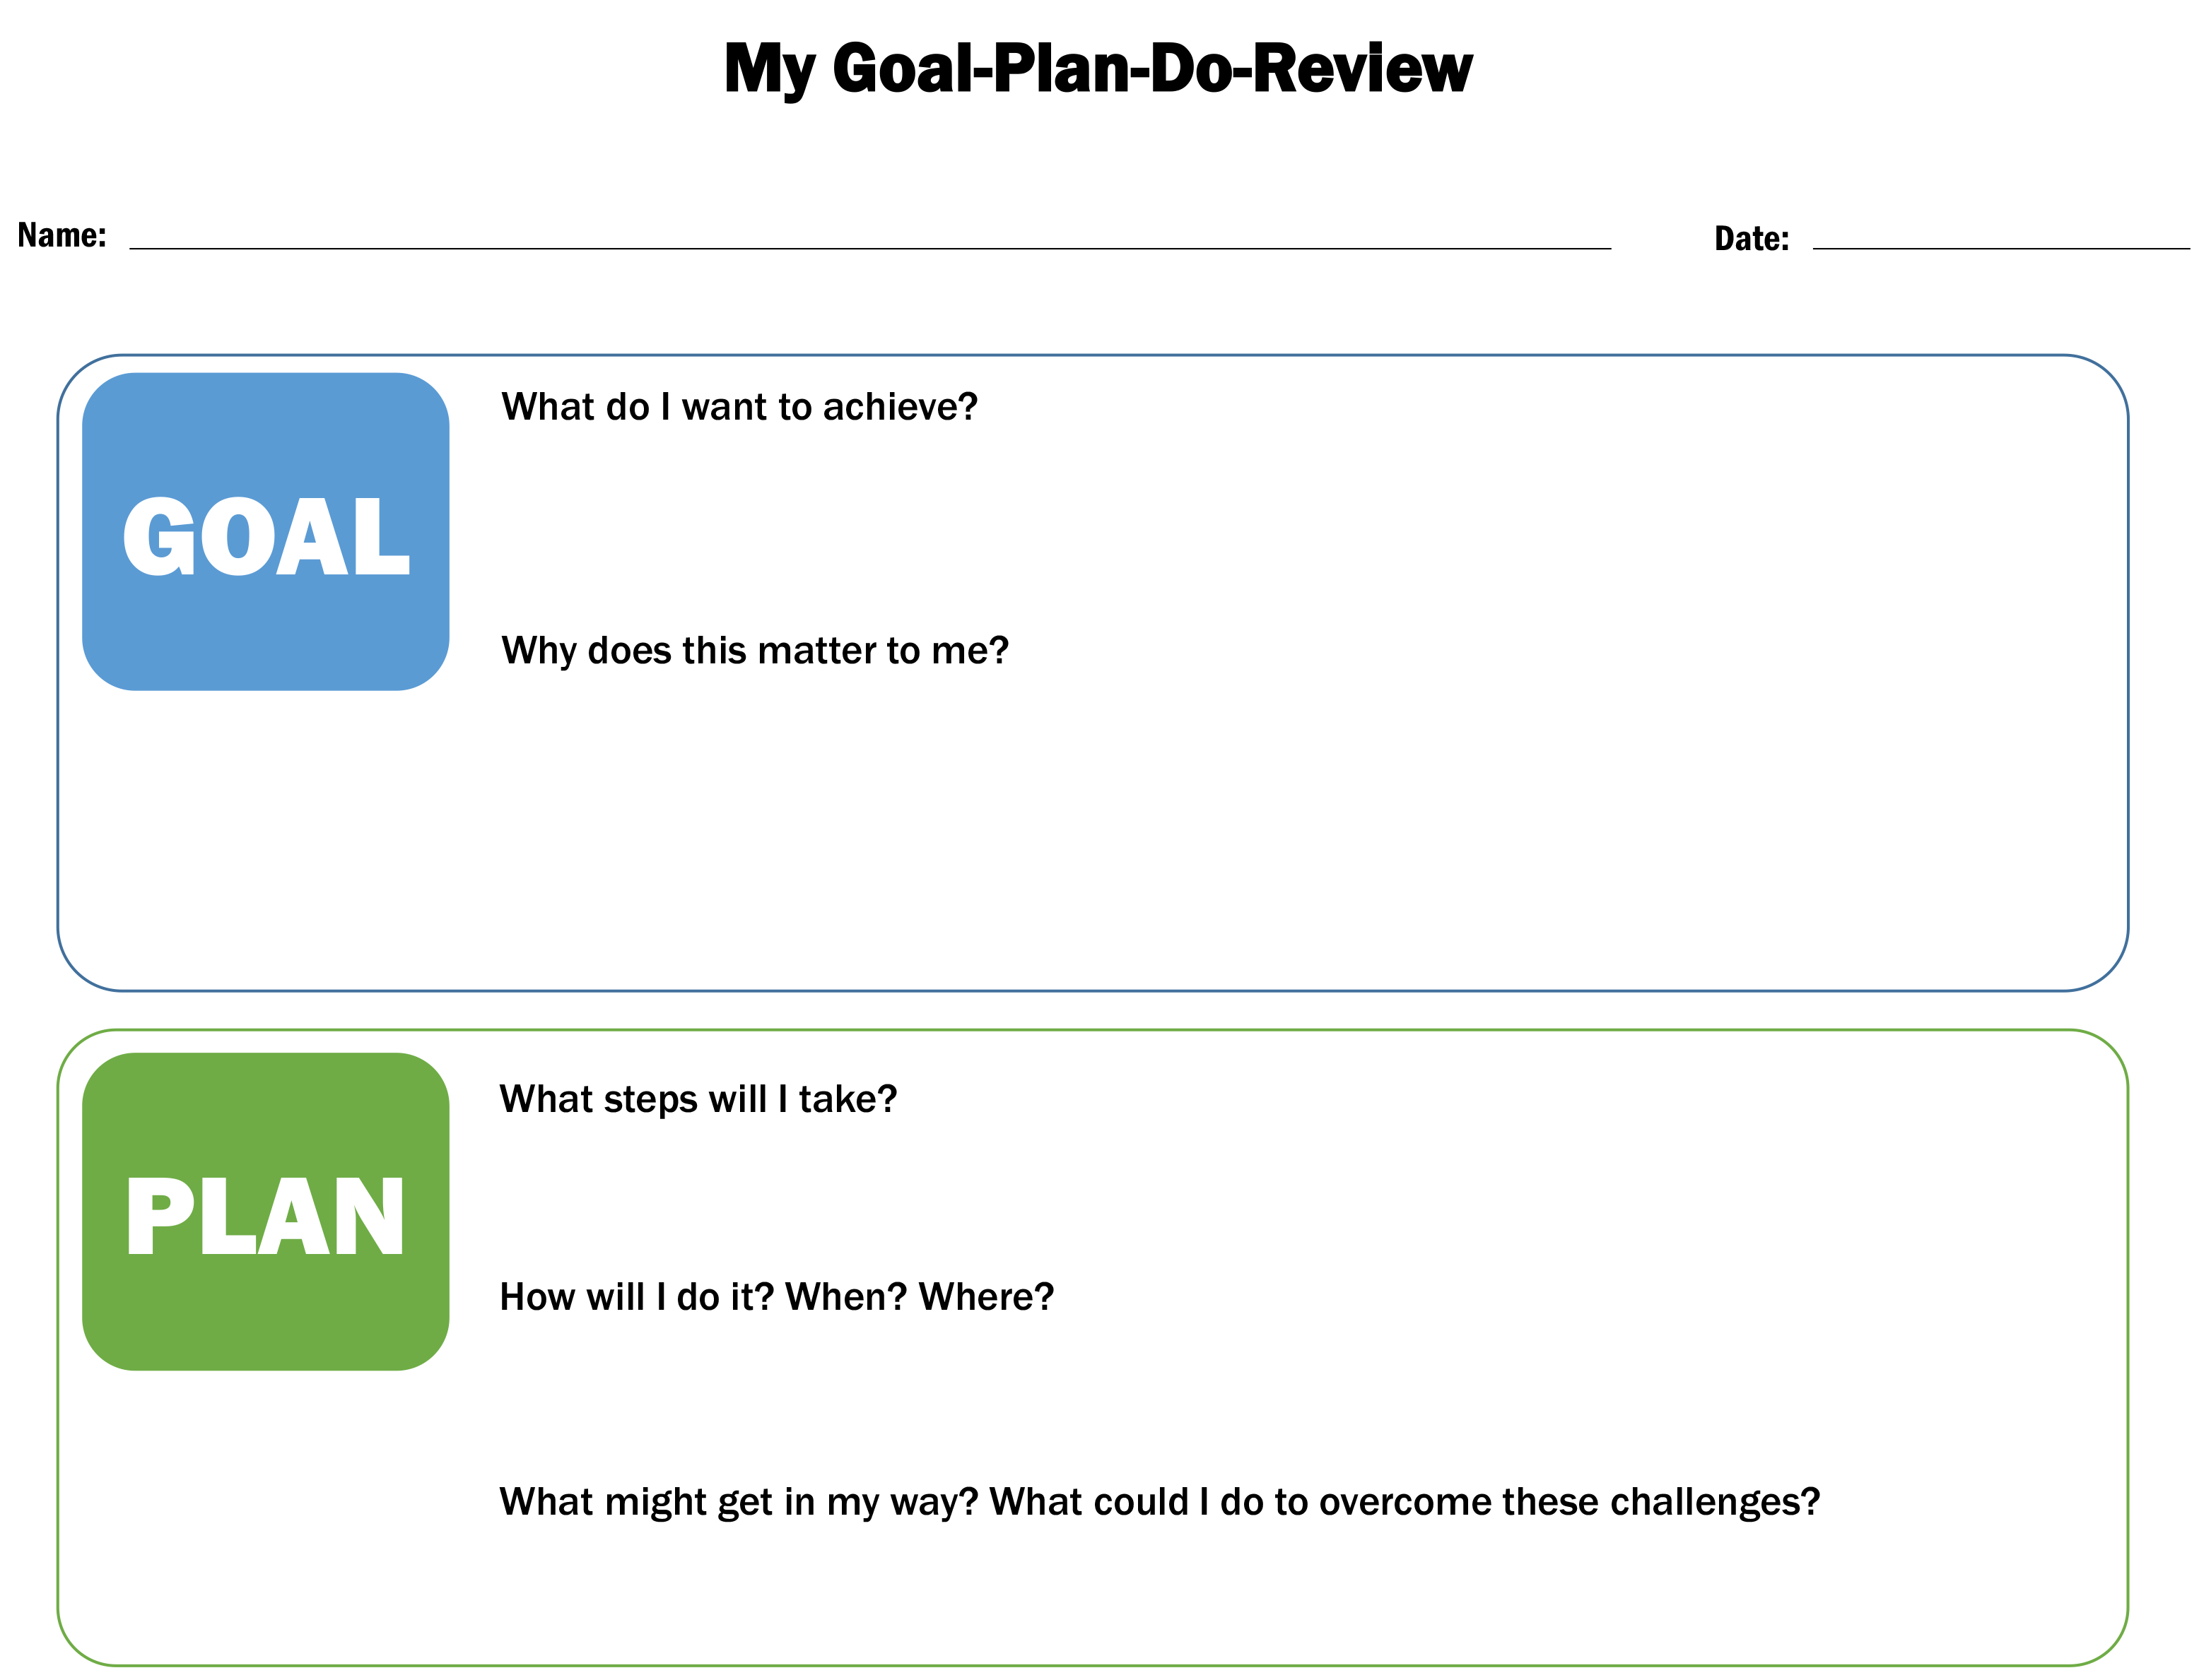

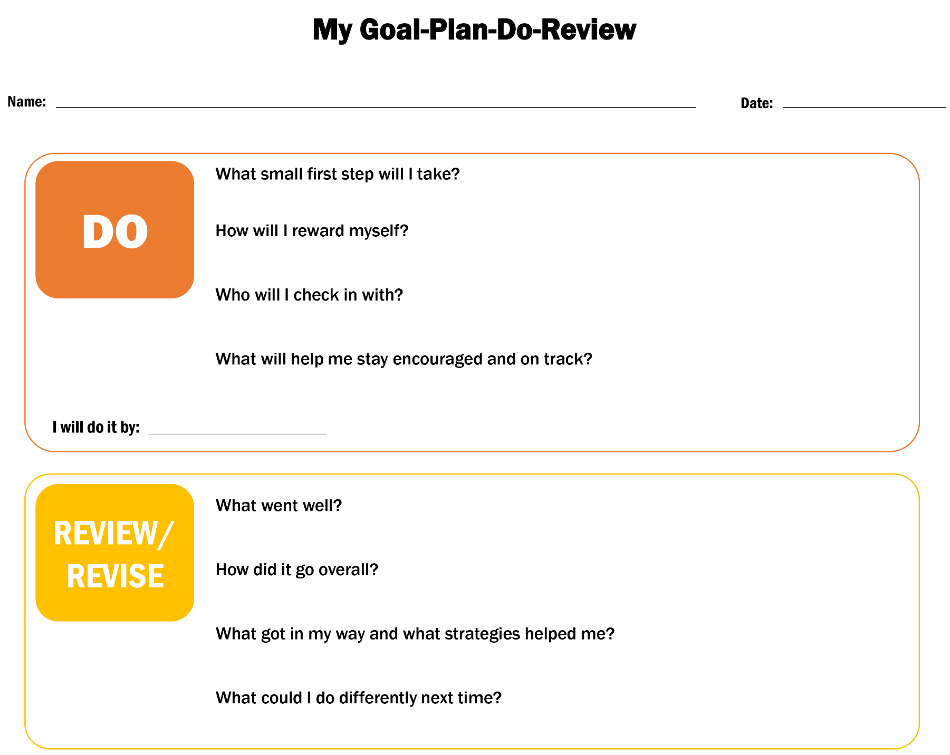

H. My Road Map/Potholes and Detours

1. My Road Map
Purpose: My Road Map aids workers and customers in thinking logically through necessary intermediate steps (action steps) to achieve long-term goals (three to six months) or complicated goals that need to be broken down into multiple steps. You can help customers refine their goals, but it is important for customers to lead the process of choosing goals that are most meaningful to them at present. My Road Map includes a place for customers to write down concrete plans to achieve the intermediate steps. This exercise helps customers articulate the small (daily) tasks and resources needed to achieve their ultimate goal.
Description: My Road Map shows a road leading to a single ultimate goal (at the top). Leading to the ultimate goal are three action steps where the customer can write down specific plans.
When to use: My Road Map is for long-term or complicated goals. Use My Road Map first, and then use Potholes and Detours.
- Goal setting: After you have a good sense of the customer’s current circumstances, use My Road Map to help the customer set long-term or complicated goals.
- Goal planning: Use the My Road Map tool, to help customers to make plans to achieve each action step.
- Goal doing: The My Road Map serves as the customer’s to-do list.
- Goal reviewing/revising: When My Road Map has been finalized, check in regularly with the customer about his or her progress on the action steps.
How to use:
- Introduce this tool by saying something like: “It’s easier to achieve long-term or complicated goals if the big goal is broken into a series of small goals. It also helps to make specific plans to achieve these small goals.”
- Drawing on the customer’s goals, select a most important goal. This goal becomes the Where I’m Headed (or ultimate) goal. Invite the customer to write or summarize that goal in the box on My Road Map.
- Ask the customer to why achieving this ultimate goal is important to him or her.
- Next, help the customer identify and prioritize action steps needed to complete the ultimate goal. Each action step should be a challenging yet achievable milestone toward reaching the ultimate goal. The customer should write the action step in the colored portion of each action step box.
- For each action step, help the customer identify how long the customer needs to complete the task, when the customer will do the task, where the customer will do the task, how the customer will get there and what the customer will need to take. Ask the customer to write down this information in each action step box.
- When customers have finished filling out the My Road Map, review the entire worksheet with them. Ask probing questions to ensure that they have specific, actionable plans to achieve their action steps.
- When the My Road Map is complete, introduce and use the Potholes and Detours tool.
What successful use would look like: Customers are able to set long-term or complicated goals, and intermediate steps to achieve their ultimate goal. Customers are able to make concrete plans to achieve intermediate steps. Customers make progress on their goals and, in the long run, ultimately achieve their final goal.

2. Potholes and Detours
Purpose: The Potholes and Detours exercise is meant to help you facilitate a conversation with the customer to identify potential obstacles and solutions. Plans are most likely to succeed when we have developed strategies for challenges we might encounter while pursuing our goals, such as transportation or child care falling through at the last minute.
Description: An important step in goal achievement is the careful consideration of potential obstacles (potholes)—circumstances that may arise and get in the way of goal achievement—coupled with brainstorming solutions to those potential obstacles (detours). These solutions can be actions for the customer to take toward preventing, addressing, or working around the potential obstacle.
When to use: Immediately after completing My Road Map.
- Goal planning: Use the Potholes and Detours worksheet to help the customer plan for potential obstacles and identify potential solutions.
- Goal reviewing/revising: When the My Road Map is in place, check in regularly with customers about any challenges they are facing. Use Potholes and Detours to review any challenges and revise plans as necessary.
How to use:
- After customers have used the My Road Map, introduce Potholes and Detours as another tool to help them accomplish their goals. Emphasize that this is a critical part of the goal-achievement process. Anticipating things that might get in their way will prepare them to respond quickly and avoid getting derailed.
- Invite customers to consider possible challenges or obstacles that could arise as they execute their My Road Map.
- Use sticky notes to brainstorm the various scenarios, including personal fears or challenges (such as lack of motivation), family situations, or other issues (such as transportation and child care).
- This should not be about cataloguing factors that originate with the customer, such as time management skills.
- Review the set of possible challenges and obstacles with the customer and identify the three that seem most likely to crop up. Invite the customer to write these down in the Pothole boxes on the worksheet.
- Next, consider each Pothole in turn and invite customers to brainstorm how they could prevent, address, or work around the challenge or obstacle. As customers identify a concrete plan for each Pothole, invite them to write down the plan in the corresponding Detour box on the worksheet.
- When the worksheet is complete, review the three Potholes and Detours with the customer and affirm that everything makes sense for supporting the customer in completing his or her My Road Map.
What successful use would look like: Customers are able to identify likely obstacles and reasonable solutions or strategies for dealing with them. Customers make progress on their progress goals and, in the long run, ultimately achieve their final goal.

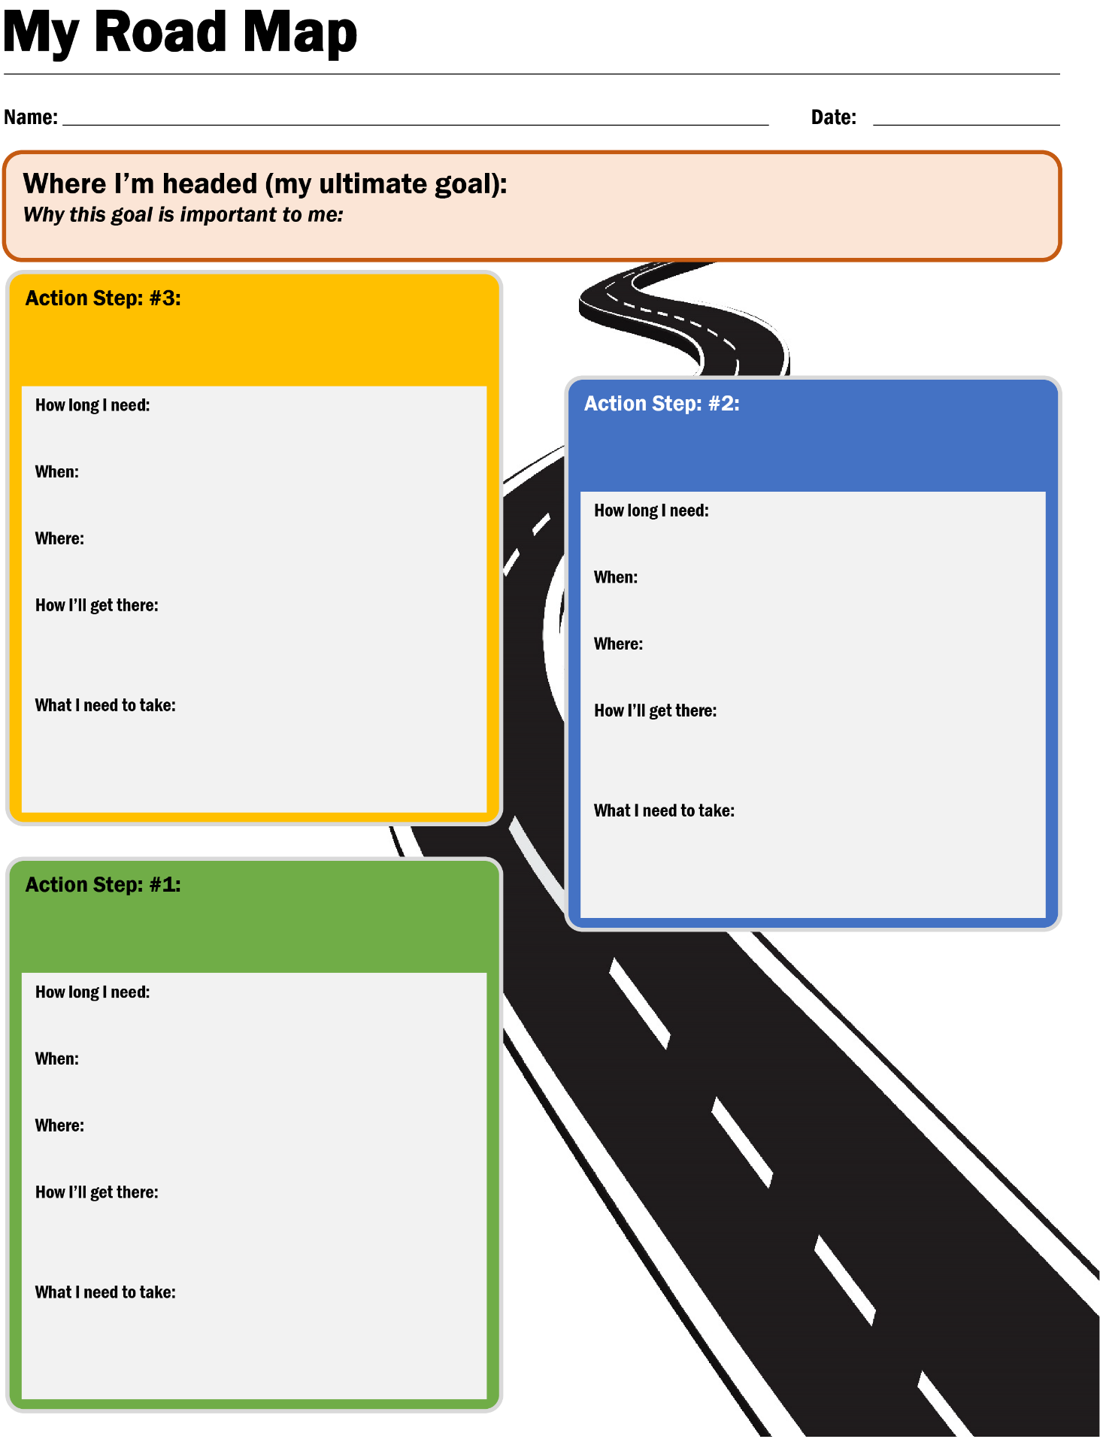

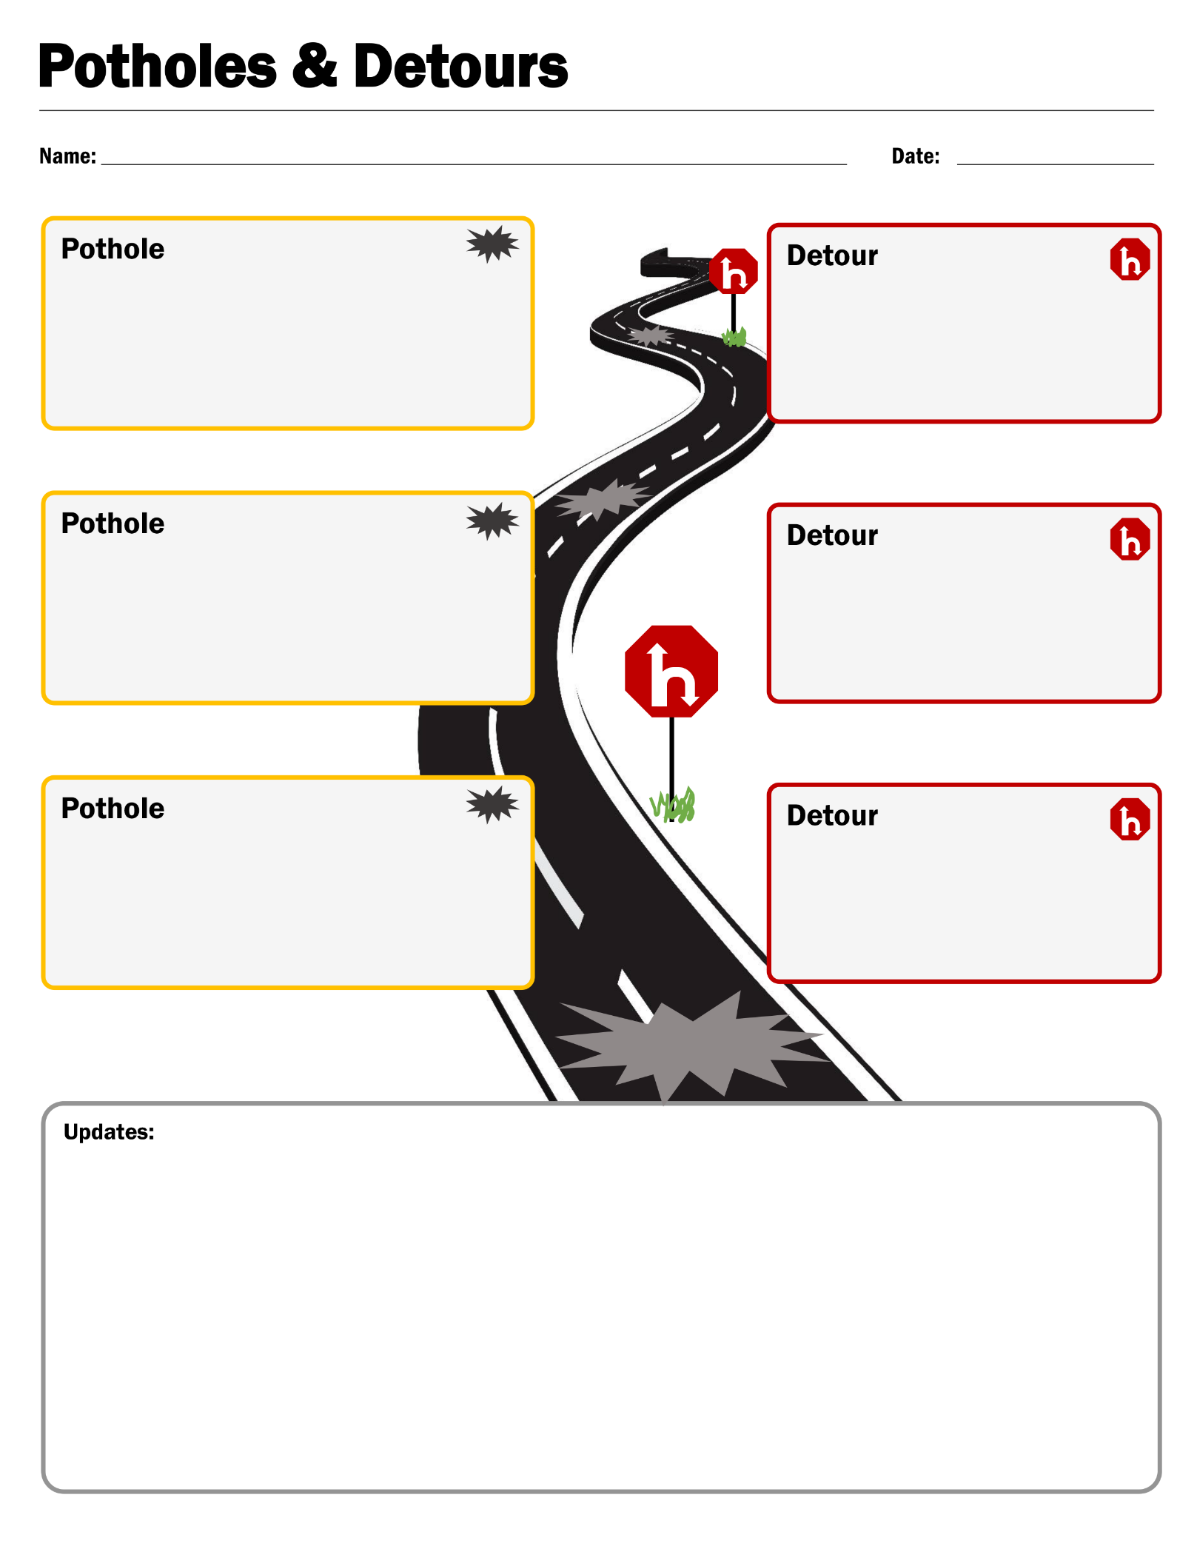

I. Postcard reminder
Purpose: Customers will benefit from being reminded of their goals and upcoming appointments. Behavioral science research suggests that simple prompts can improve attendance at appointments. This postcard is designed with a simple, engaging layout to remind customers about the appointment and their goal. The postcard also reinforces planning skills by encouraging customers to consider in advance how they will get to the appointment and who will take care of their children during it.
Description: The postcard has the GPDR/R worksheet on the front and information about an upcoming appointment on the other side. There is also space on the back for customers to consider how they will get to the appointment and how they will handle child care.
When to use:
- Goal doing: After customers have set a short-term goal with the GPDR/R worksheet, use this postcard to remind them of their goal. It might be particularly helpful to use with customers who have a history of missing appointments.
How to use: Fill in the date of the appointment and the customer’s name and address. Add postage and drop in the mail.
What successful use would look like: The postcard arrives a few days before the appointment. Customers arrive on time for the appointment and are prepared to discuss their goals.

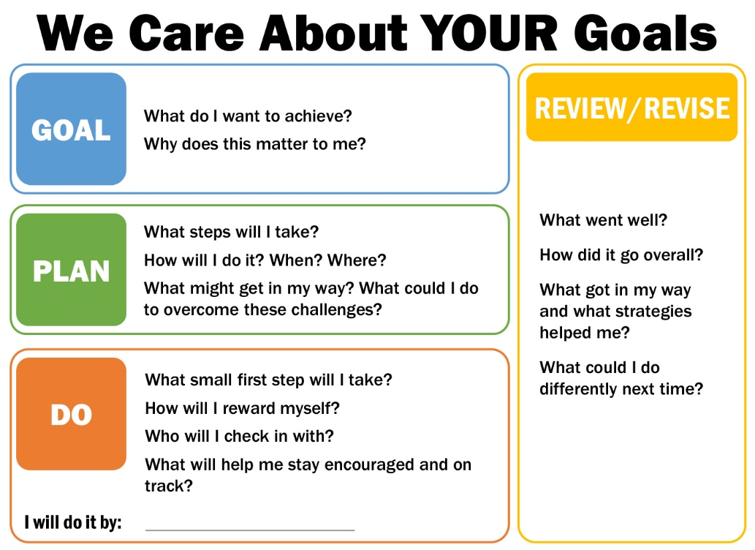
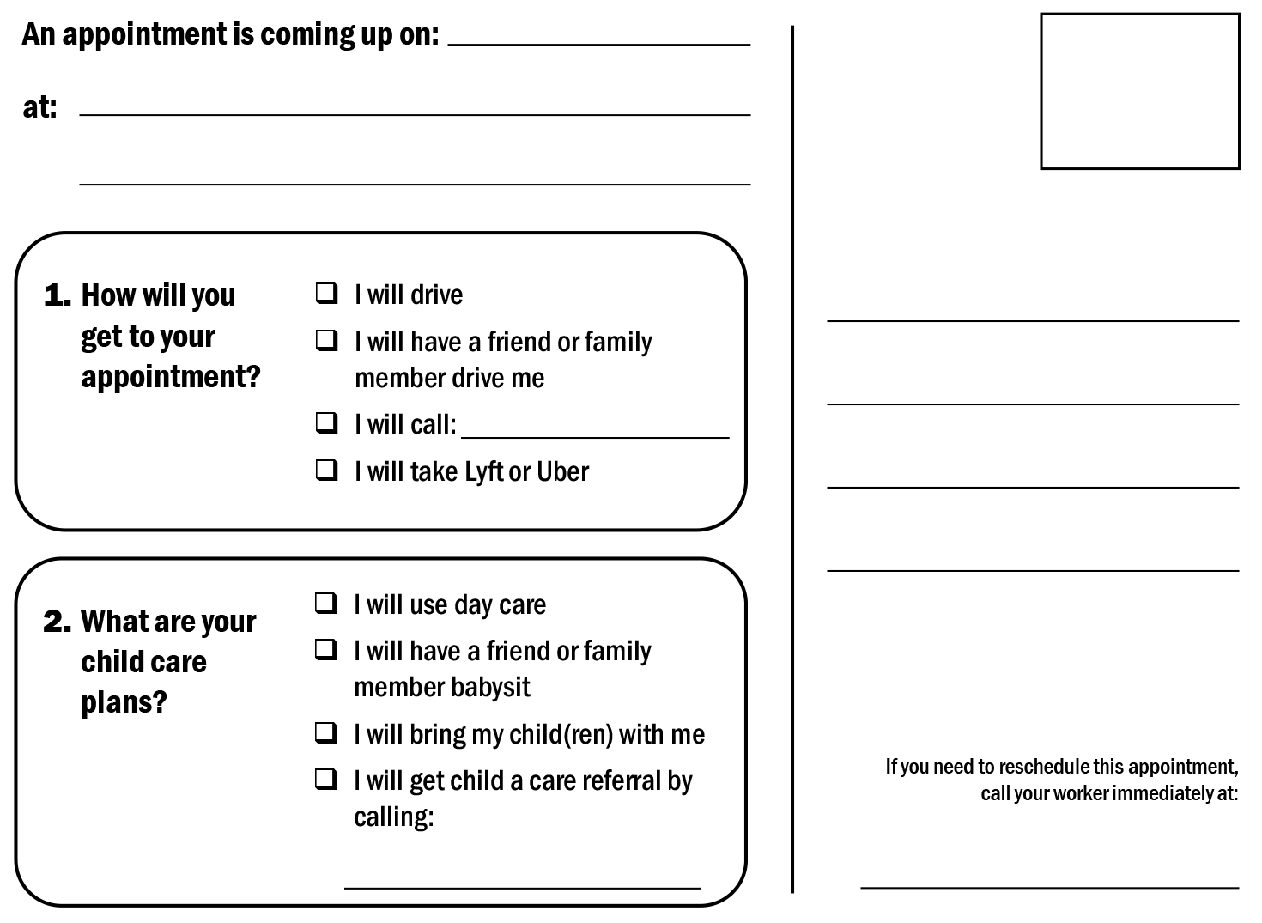

J. Pocket reminder
Purpose: A physical, portable object can help remind customers about their long-term goals. Customers can carry this pocket reminder or put it in a prominent location so that they see it often. This card is another gentle reminder of the goal. Repeated reminders can help customers make progress on their goals.
Description: One side of the business-card-sized pocket reminder shows the GPDR/R worksheet, and the other includes a message from the county.
When to use:
- Goal doing: After a customer has set a short-term goal with the GPDR/R worksheet, use this reminder to encourage the customer to make progress on the goal.
How to use: Print out a reminder and hand a copy to the customer. If customers choose, they can write their goal on the GPDR/R side. But the customer does not need to fill out the GPDR/R side; it can simply act as a reminder to the customer about the goal.
What successful use would look like: Customers think about and work on their goals often when they are not with the frontline worker. Customers make progress on their goals.
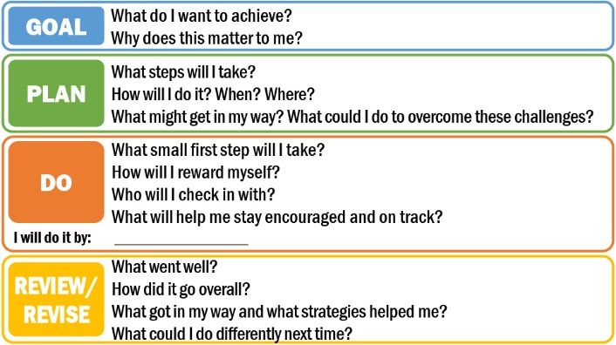
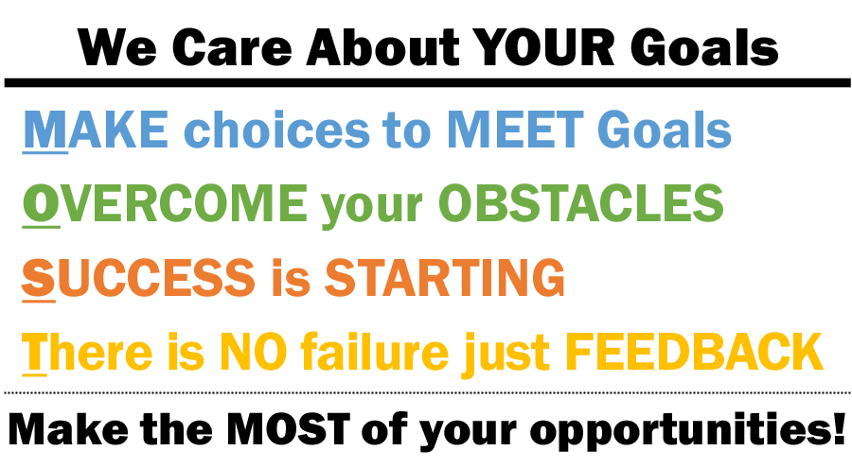

K. Business process tools
Two business process tools can help you as you work with customers. These tools are not designed to be used with customers, but rather for you to use as you consider which services and resources to offer customers and monitor their progress.

1. 24-month counter
Purpose: The 24-Month Counter is a spreadsheet designed to calculate how many months customers have accumulated on their 24-month time clock for receiving aid.
Description: The 24-Month Counter is an Excel spreadsheet with months in the columns and eligible time clock stoppers in the rows.
When to use: Use the 24-Month Counter when you want to understand the services and supports that will be available to the customer in the future and use that information to help the customer set appropriate goals. When you first meet with the customer, create and save a new sheet. Update the file each month to keep track of the number of months left.
How to use:
- On the “Select Customer Name” sheet, either enter a new customer name by clicking “Add Customer” or open a customer’s information by clicking on his or her name and clicking “Show Month Counter.”
- If a customer meets the time clock stop criteria for any row, place an “X” in the cell corresponding to that row, under the column for the month in question. When you enter the “X,” the counter will automatically update the customer’s 24-month time clock, and that month should not count.
- If the customer does not meet any of the criteria for any of the possible time clock stoppers listed in rows 10–39, mark an “X” for that month in row 9: “No exemptions.” This month will count, which will be reflected in row 43 (“How many months count?”).
What successful use would look like: At any time, you can easily look up how many months each customer has left on his or her 24-month clock.

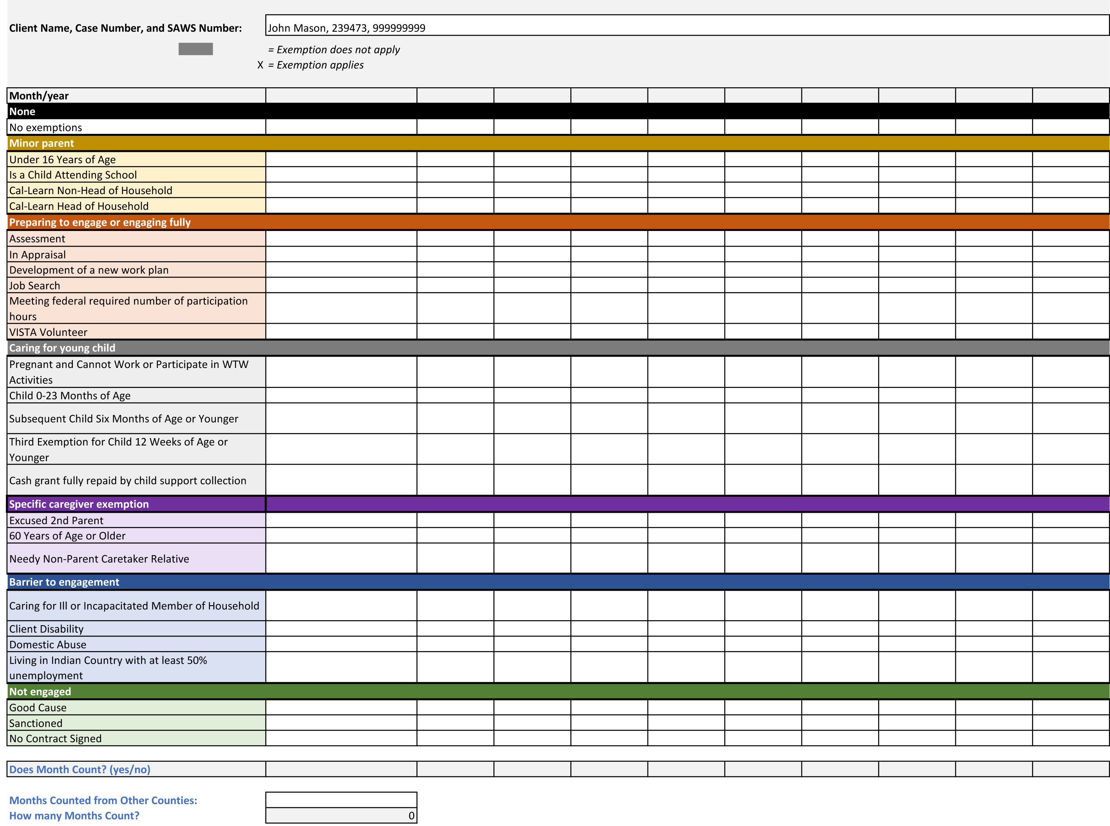

2. County resource map
Purpose: The County Resource Map is designed to make it easy for you to identify the resources available in your community to address families’ needs. Program administrators and managers in your organization are responsible for initially populating the resource map, and updating it regularly.
Description: The CalWORKs Resource Map is an Excel file that automatically suggests activities, resources, and services for customers. The resources available to support a family are determined by the length of time a family has been receiving assistance and the geographic region of the county. When you enter these two pieces of information into the County Resource Map, it will provide you with a list of available resources for each of six service areas: (1) employment, (2) education and skills training, (3) child care, (4) work supports, (5) personal and family needs, and (6) housing.
When to use: Refer to the County Resource Map after a customer has set a goal and you are helping the customer identify the resources and services that will bring success. The map can also be used any time you are making or re-assessing a customer’s service referrals.
How to use: On the top left of the spreadsheet (in cell A1-B1), select the amount of time a family has been on CalWORKs. If your county is divided into regions, select the appropriate geographic region in cell A2-B2 and then click the “Update Region” button on the upper right. Once this is done, the spreadsheet will display a list of available resources in each of the six service areas, color-coded to highlight the ones most relevant for the family’s current circumstances. Reference the color-coded legend in the bottom-right corner of the worksheet to understand which services have been identified as applicable and available to the family given program requirements.
What successful use would look like: You are familiar with the services and resources available in your county. You are able to connect your customers with the best services and resources available to meet their needs.
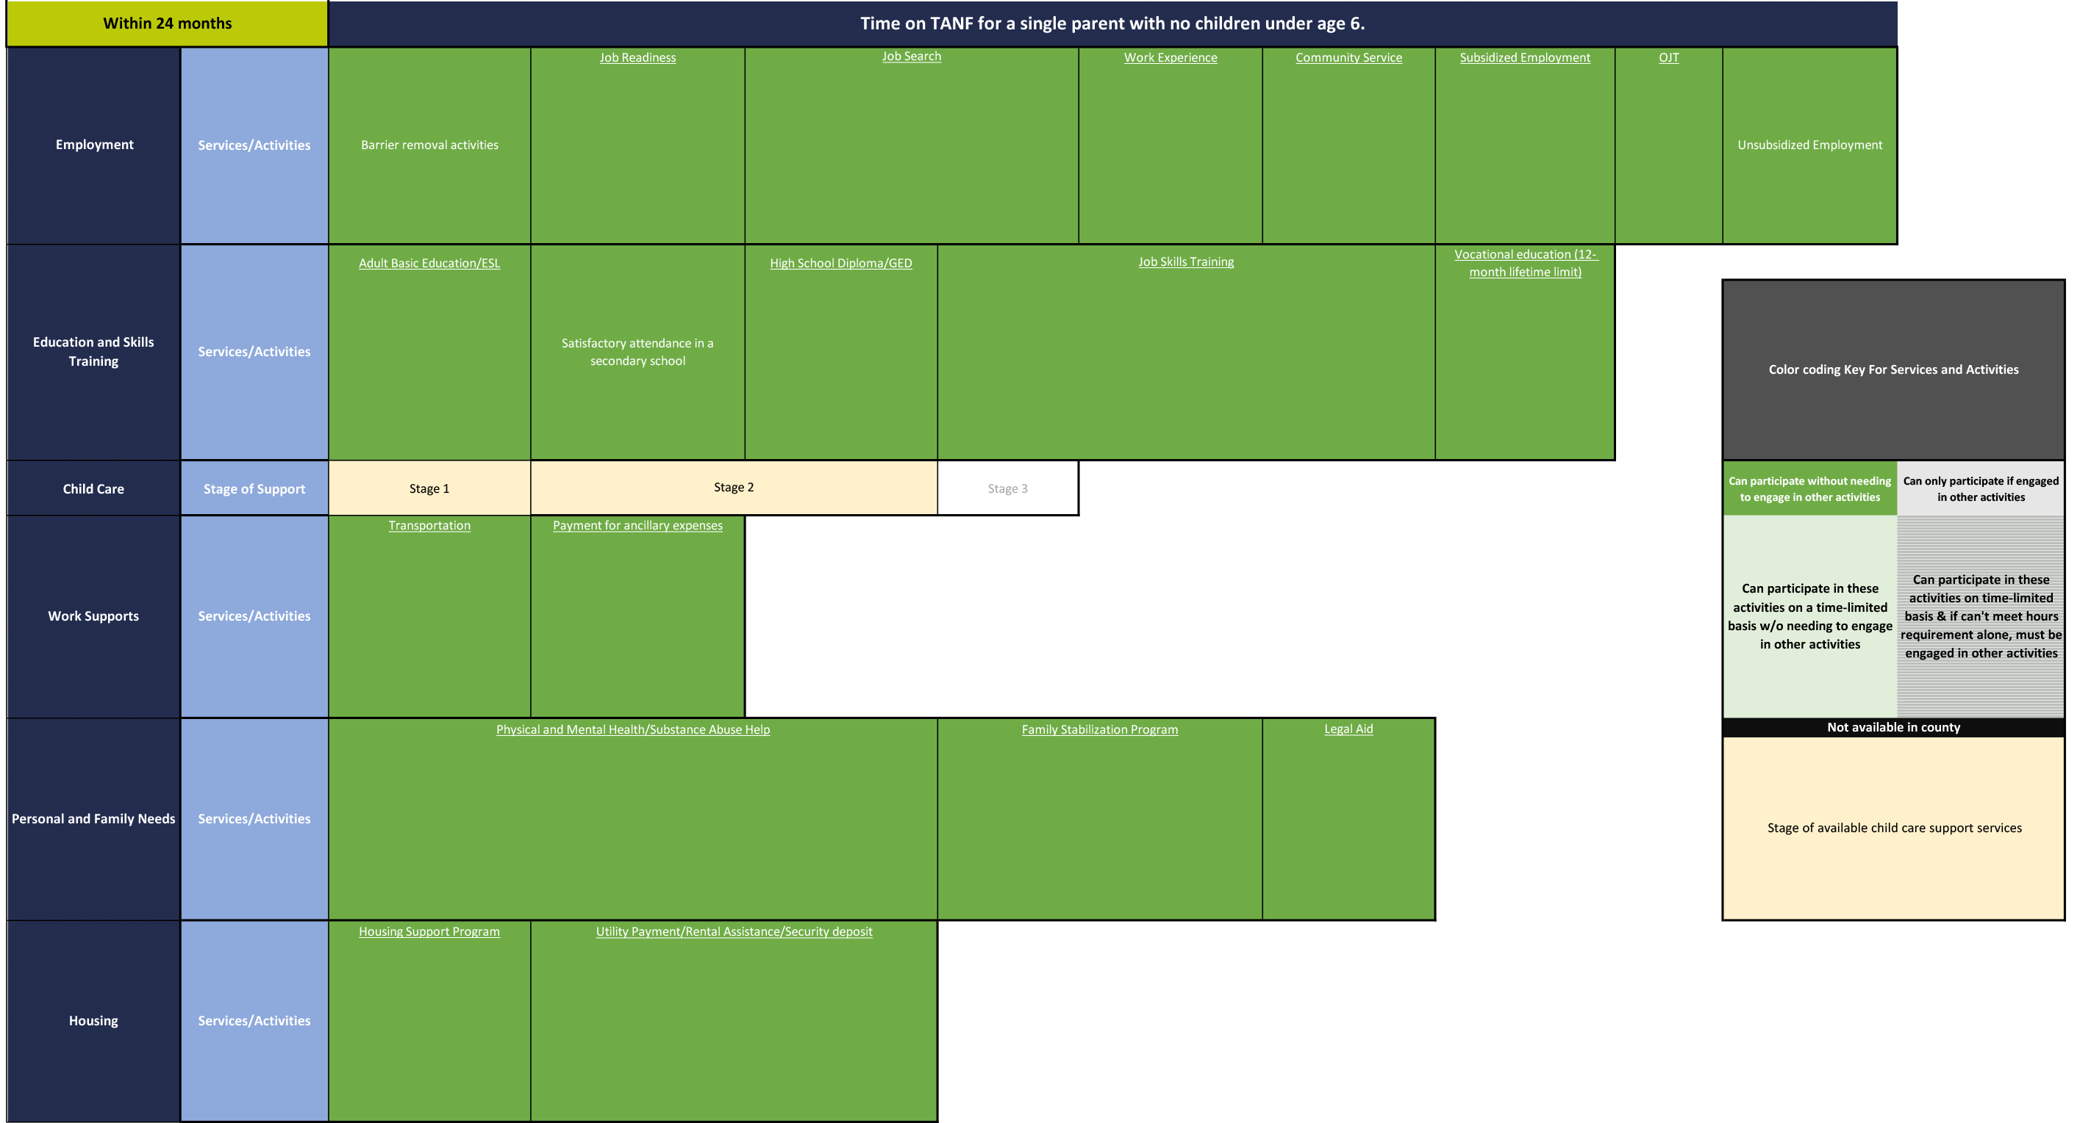

www.mathematica-mpr.com

Improving public well-being by conducting high quality,
objective research and data collection
Princeton, NJ ■ Ann Arbor, MI ■ Cambridge, MA ■ Chicago, IL ■ Oakland, CA ■ SEATTLE, WA ■ TUCSON, AZ ■ Washington, DC ■ Woodlawn, MD

